
BOOKREVIEW

Tell them yourself, it’s not your day to die
including interview Frank Butler

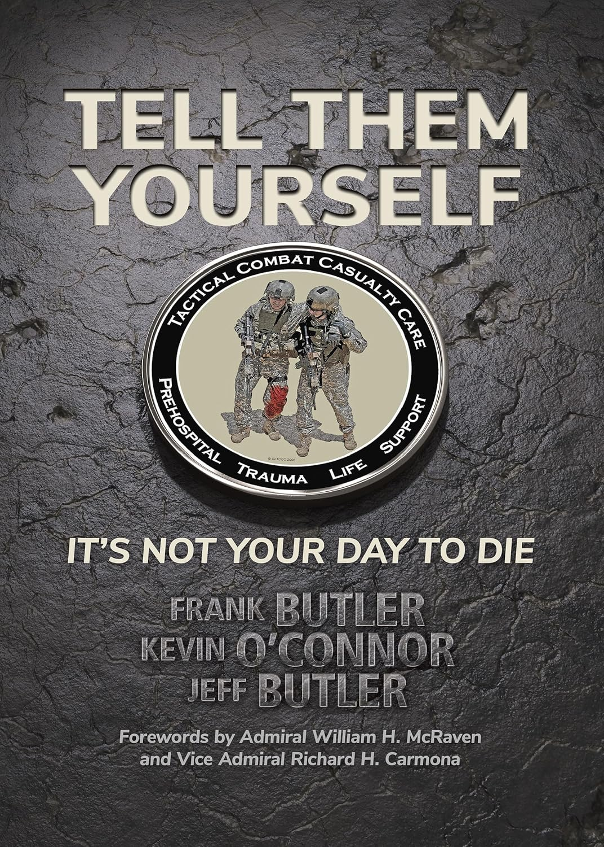
Authors: Frank Butler, Kevin O’Connor, Jeff Butler
Publisher: Breakaway Media, LCC, 2024
Language: English
Hardcover: 284 p.
ISBN: 979-8-99-022570-1
- Captain (Ret) Frank Butler, was a Navy SEAL platoon commander before he went to medical school. He was the Founder of Tactical Combat Casualty Care (TCCC), for which he received the USSOCOM Medal from Admiral Bill McRaven. He was also awarded the “Lifetime Military Service Award” from the American College of Surgeons and recently received the “Presidential Citizens Medal” from President Joe Biden.
- Col. (Ret) Kevin O'Connor was Command Surgeon for DELTA force in Afghanistan (2002) and Iraq (2003) and returned to Afghanistan with the 75th Ranger Regiment in 2005. O'Connor served on the White House Medical Staff for 14 years and was the 16th Physician to the President of the United States.
- Jeff Butler is a former Navy SEAL platoon commander turned CIA officer. He is currently a Battalion Chief in the Springfield, Missouri Fire Department.

Where the title of the book comes from
A U.S. Soldier on a night patrol hears a gunshot and feels a sharp pain in the right side of his body, and yells, “I’m hit.”
The unit medic quickly moves to the casualty’s side.
The wounded Soldier thinks of the family waiting at home and says to the medic: “Doc – will you please tell my family that I love them.”
The medic responds, “Hey – shut up! I’ve got this. You’re gonna be fine, and you’re going home to your family – you can tell them yourself. It’s not your day to die.”
Far beyond any other battlefield trauma care program in history, Tactical Combat Casualty Care has enabled America’s combat medics to make good on that promise.

Tell Them Yourself is the extraordinary account of how a small group of world class trauma experts joined forces with America’s best combat medics to rewrite the rulebook in battlefield medicine – and then to sell these revolutionary new concepts to a disbelieving medical world.

Tell Them Yourself provides the reader with an insight into the history of Tactical Combat Casualty Care, the most successful battlefield trauma care program in history.

Very little changed in prehospital combat casualty care for over 100 years after the U.S. Civil War, despite studies from the Vietnam conflict that showed that the vast majority of combat fatalities occur before the casualty ever reaches the care of a combat surgeon. Training for combat medics in 1992 was still conducted based on civilian courses such as Emergency Medical Technician- Advanced [EMT-A] and the Advanced Trauma Life Support [ATLS] courses. Realizing that these courses discouraged tourniquet use, despite the fact that that bleeding to death from extremity wounds was estimated to have caused between 3000 and 4000 preventable deaths in Vietnam, the Navy SEAL Biomedical Research Program began an extensive review of battlefield trauma care in 1992. This was the impetus from which the first Tactical Combat Casualty Care (TCCC) Guidelines emerged in 1996. ¹ The guiding principle of TCCC was to provide a set of evidence-based, best-practice prehospital trauma care guidelines that combine good medicine with good tactics. TCCC is now the standard for battlefield trauma care in the U.S. military, NATO, and most other developed countries.

In Tell Them Yourself, the authors describe the long road that has led to where we are now. The book includes many combat examples of TCCC in action. The reader is taken on that journey, in which many barriers had to be overcome and many previous medical dogmas were refuted. The question often posed by COL (retired) Bob Mabry kept coming up: “Who owns battlefield medicine.” As the book describes, medical leaders may develop concepts and advise their line commanders, but it is line combat commanders who have the final authority to dictate what happens on the battlefield, including the care of the wounded.

Evidence-based medicine is considered the Gold Standard in medicine, but double-blinded, controlled trials are not feasible in battlefield settings. That is why the best possible use of all available published battlefield trauma care evidence must be reviewed by the Committee on TCCC and considered in the light of the combat experiences of medics, corpsmen and pararescuemen.

At the start of the war in Afghanistan, only a few U.S. Special Operations units had adopted TCCC. By 2004, when CAPT Butler assumed the duties of Command Surgeon for the U.S. Special Operations Command, there was no comprehensive information on how U.S. service members had died in combat and what might have been done to save them. CAPT Butler asked COL John Holcomb, then the Commander of the U.S. Army Institute of Surgical Research, to undertake a study to answer those questions for special operations troops that had died in Afghanistan and Iraq. COL Holcomb assembled a tram that included such luminaries such as Dr. Howard Champion, CAPT Jim Caruso, COL Rocky Farr, and MSG Sammy Rodriguez. This research team found that most special operations deaths had resulted from non-survivable injuries, but there were some deaths that could have been prevented with simple TCCC interventions such as tourniquets and hemostatic dressings.

When presented to the Commander of the U.S. Special Operations Command, these findings helped to fast-track TCCC training and equipment to all special operators going into combat. As other U.S. military units became aware of the lives being saved on the battlefield by TCCC in special operations forces, TCCC concepts gradually spread throughout all deployed U.S. military units.

The founding of the Joint Trauma System in 2004, also led by COL Holcomb, provided the infrastructure needed to track the care and outcomes of all U.S. casualties. This enabled researchers like COL Brian Eastridge to document the fact that 24% of all U.S. combat prehospital fatalities had died from survivable or potentially injuries and COL Russ Kotwal to report that the 75th Ranger Regiment, which had adopted TCCC in 1997, had no preventable or potentially preventable prehospital combat fatalities. This dramatic contrast in lives saved became the prime moving force for TCCC to be designated as the U.S. military standard.

In the civilian sector, the concepts of TCCC were translated slowly into use. TCCC had an early connection with Dr. Norman McSwain and the National Association of Emergency Medical Technicians (NAEMT). Dr. McSwain believed in the need for a better relationship between military medical professionals and their civilian colleagues and ensured that Tactical Combat Casualty Care was included as an additional chapter in the PHTLS textbook from the 4th edition onwards. But as late as 2008-2009, the use of tourniquets, which had by then become a military standard, was virtually non-existent in the civilian sector. In 2013, however, in the aftermath of the horrific Sandy Hook mass shooting incident, the leadership of Dr. Lenworth Jacobs and Dr. McSwain accelerated the use of tourniquets in the civilian sector. The Hartford Consensus, led by Dr. Jacobs and supported strongly by the American College of Surgeons, came up with the THREAT acronym (2013)^{2,3} that stressed Threat suppression, Hemorrhage control, Rapid extrication to safety, Assessment by medical providers, Transport to definitive care. With the support of the White House, the Stop the Bleed program soon followed (2015)⁴. These programs encouraged the use of tourniquets and hemostatic dressings by all potential first responders. Individuals bleeding from large extremity vessels have only a few minutes before they bleed to death unless the hemorrhage is controlled.

All medical guidelines need to be periodically updated, and TCCC is no different. Tell Them Yourself describes how the Committee on TCCC (CoTCCC) was established in 2001 as a joint effort of the US Special Operations Command and Navy Medicine. The authors discuss in detail how the CoTCCC became integrated with the Joint Trauma System (JTS) and began to take part in the weekly JTS quality assurance trauma teleconferences. Combined with a monthly review by the CoTCCC of the prehospital trauma care medical literature and reviews of data contained in the Department of Defense Trauma Registry, the JTS quality assurance program has helped the CoTCCC to continually update TCCC recommendations as needed to reflect new evidence and experience.

The book also discusses in detail all of the new – or rediscovered - medical interventions that TCCC has pioneered. There are chapters devoted to tourniquets, hemostatic dressings, prehospital blood transfusions, the “combat airway”, tension pneumothorax, open pneumothorax, tranexamic acid (TXA), Triple Option Analgesia and other medical innovations led by TCCC.

The authors have succeeded in providing a very complete overview of the development of Tactical Combat Casualty Care. The many combat examples make the book very interesting and the complete bibliography at the end provides the reader with a very large database with which to review the evidence that supports TCCC recommendations.

For anyone interested in prehospital trauma care, according to former USSOCOM Commander Admiral William H. McRaven, this book is a must-read. In his words: “I have never been more honored to recommend a book to the reader.”

Tell Them Yourself – It’s Not Your Day to Die can be ordered at: JSOMonline, WERO of Amazon.

Maarten Leeflang MD, former SOF medic trainer
Ryan Woets, former SOF medic

_________
References:
- Leeflang M., Woets R.: How Tactical Combat Casualty Care (TCCC) Has Influenced Battlefield Trauma Care Worldwide. Nederl Mil Geneesk T 2021(74);3:141-147.
- Leeflang M., Woets R., Veltman C.M.N.: History of MARCH, CABCD, THREAT and S-CAB Acronyms. Prioritizing massive hemorrhage in military and civil trauma care. Nederl Mil Geneesk T 2021(74);5:210-216.
- https://www.stopthebleed.org/resources-poster-booklet/compressing-zones/
- https://www.stopthebleed.org/

Interview with Frank Butler

By Maarten Leeflang MD, Former SOF medic trainer and Ryan Woets, Former SOF medic

What made you decide to write this book, together with the co-authors?
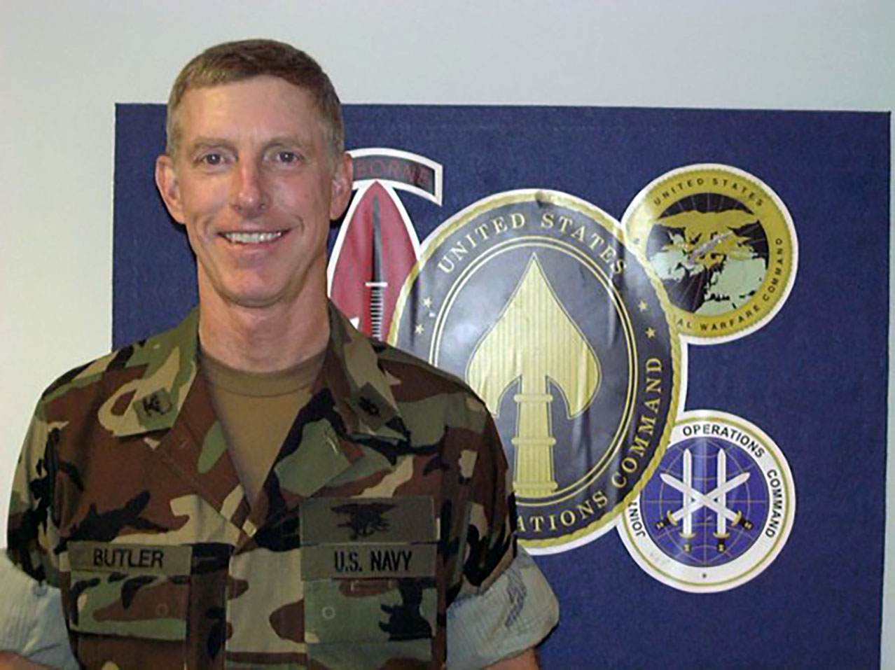
Captain (USN ret) Frank Butler, MD.
TCCC has been an unprecedented transformation in battlefield trauma care and has saved thousands of lives. How TCCC came about is a unique story that needed to be told and preserved.
Writing the book was also a great way to say “Thank You” to the many people and organizations that helped to develop TCCC and have it become accepted as the U.S. military and NATO standard for caring for our wounded combatants.

What would be the number one reason you would give if someone asks you: “why should I read this book”?
The acceptable number of preventable prehospital deaths in combat is zero. We know that historically many combat fatalities could have been prevented with better battlefield trauma care. Tactical Combat Casualty Care has now been documented to help combat units like the 75th Ranger Regiment - ones that train every member of the unit in TCCC - to achieve that goal.

Would you say the book is only of interest for those concerned with combat medicine?
Absolutely not. Trauma is the number one cause of death in persons aged 44 and younger in the United States. The same is likely true of most other developed countries. Sadly, many of these civilian trauma deaths could have been prevented if prehospital medical personnel and other first responders were trained and equipped to manage trauma patients using TCCC concepts.

What would you say is required for TCCC to remain the backbone of combat Medicine and for TCCC to maintain the qualities so hard fought for?
Since the end of the conflicts in Iraq and Afghanistan, both the focus and funding for combat casualty care have decreased.

The Committee on TCCC in the past had a full-time physician Chair to guide its activities. Beginning in 2019, that is no longer the case. There have been two outstanding Navy Emergency Medicine physicians (CAPT Brendon Drew and CAPT Travis Deaton) who volunteered to perform the duties of the CoTCCC Chair in addition to their assigned duties as the 1 Marine Expeditionary Force Surgeon. Both of these individuals are superb physicians and leaders, but they served in their CoTCCC role as volunteers in addition to their assigned roles in the Marine Corps. Each job inevitably takes time and attention away from the other. What is needed is the appropriate resourcing to provide for a civil service physician with TCCC experience to serve as the CoTCCC Chair.

For the CoTCCC to continue to achieve the unprecedented success that it has had over the past two decades requires the ongoing participation of trauma care experts and leaders from both the military and civilian sectors. The U.S. military needs to treat these tremendously talented individuals with a level of gratitude and appreciation that reflects the enormous gift of their time and expertise.
The Department of Defense also needs to preserve and optimize the methodology used by the Joint Trauma System and the Committee on TCCC in the past to identify needed advances in trauma care, evaluate their ability to enhance the lifesaving capabilities of combat medical personnel, and message these advances to all who could potentially use them to the advantage of their trauma patients.

Finally, military line commanders must realize that it is they who are truly responsible for the successful delivery of TCCC on the battlefield. Line commanders must value TCCC and the combat medics who deliver it as being just as important as their aircraft, tanks, and artillery. Otherwise the saying “Humans are more important than hardware” is just that - a saying.

What was your most poignant moment in the 25 years that you have been working with TCCC?
It’s a battlefield tourniquet story—sadly, a tragic one. In 2006, I got a phone call from a long-time military medical friend. Normally an outgoing, relaxed person, the caller was deadly serious on this call. His message was that there could be absolutely no relenting on the pressure that the CoTCCC had been applying to promote tourniquet use in the military. He related a heartbreaking story about an individual in whose case he was involved. This woman was a 28-year-old Army Captain and the mother of two small children. But she was not coming home to her husband and kids. She had just died from a gunshot wound—to the knee. No tourniquet was applied and she bled to death. It was another entirely preventable death.
Tourniquets are a battle that America’s military cannot afford to fight again.”

Why is the history of TCCC so important to those combat medical providers new on the scene?
The U.S. military has a bad habit of forgetting about advances made in trauma care once the nation enters a peace interval. We absolutely cannot allow that to happen with TCCC. We have to keep that flame burning in peacetime so that it will be ready if and when we find ourselves in another war.

You said in the TCCC book that advances in medicine and other areas are not inevitable. What did you mean by that?
Just reflect on that fact that the United States put a man on the moon before we figured out that it would be a good idea to put wheels on suitcases, so that you could roll them rather than having to carry the whole weight of the suitcase. It was a great idea - it just took a while for someone to think of it.
And even when an individual has a good idea that deserves to be implemented, there is definite risk to an innovator in pursuing his or her idea. Think of General Billy Mitchell and his prescient vision after WWI that airplanes would be the dominant strategic weapons system of the future. He was right on target about that, but his reward for conceiving and advocating for this vision was that he got court-martialed - and convicted - by a military bureaucracy that opposed it.

What do you think is necessary in training to maintain the quality that TCCC has reached?
The Committee on TCCC must continue to do a good job of ensuring that the TCCC Guidelines combine the best possible medicine with the best possible tactical awareness.

The Joint Trauma System must improve their ability to rapidly implement new changes in the TCCC Guidelines into TCCC training material.

TCCC must be taught within an educational infrastructure that has excellent quality control with respect to both curriculum content and instructor performance. It must also be able to accurately document the TCCC training that each individual in the military has received. The organization that has done that most successfully to date is the National Association of Emergency Medical Technicians.

Unit commanders must hold their medical and training staff directly responsible for ensuring that TCCC training is accomplished as required by current DoD instructions. In the words of the JTS Senior Enlisted Medical Advisor Sergeant Major Mike Remley: “Doers do what checkers check.”

How do you see TCCC developing in future?
- Improved capability to provide fluid resuscitation with either whole blood or dried plasma for all casualties who need it.
- Better technology or medications to stop or slow noncompressible torso hemorrhage for casualties with torso wounds.
- Better delivery of updated TCCC training materials for all who may need to care for combat casualties.
- Improved simulation techniques to better train medics on how to perform a surgical airway.
Tactical innovations that assist medics in caring for casualties on battlefields where hostile First-Person View (FPV) drones are present.
- Optimized use of drone technology to assist in providing battlefield trauma care.

Any final words of advice to those who follow in your footsteps?
The men and women who serve in combat units do so with the expectation that their unit medical personnel and the military medical trauma care system will take the best possible care of them if they are wounded in combat. That is a sacred trust that we must live up to every day.

