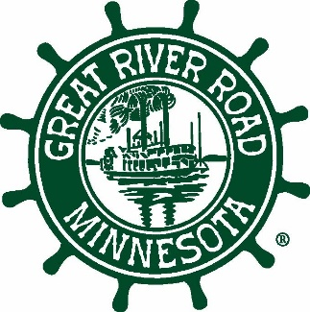

The Mississippi River in Minnesota
Eight Scenic Reaches to Explore

- Lake Itasca: The journey of this world-renown river begins at Lake Itasca. But there is more here than the point where the Mississippi spills out. The lake lies within the 32,000-acre Itasca State Park, the second oldest state park in America.

- Serpentine River: After percolating from Lake Itasca, the infant river follows a serpentine course to Brainerd, frequently twisting back on itself, leaving cut off lands and oxbows.

- Headwaters Lakes & Reservoirs: The headwaters region includes thousands of lakes. The largest contribute to America’s first reservoir system. Created by the Corps of Engineers over 100 years ago, the reservoirs provide a wide range of scenic views.

- Prairie River: From Brainerd to St. Anthony Falls, the Mississippi becomes the Prairie River, as it straightens out and islands replace oxbows. Here, the prairie runs up to the river’s banks, not bluffs.

- St. Anthony Falls: No place anchors the Mississippi’s significance in the Twin Cities like St. Anthony Falls - the river’s only major waterfall. Its physical power gave rise to Minneapolis, but its scenic power has drawn nationally known artists since the 1800s and still attracts modern day painters and photographers.

- The Gorge: Below the falls, the Mississippi drops into the 8.5 mile Gorge, stepping down 110 feet through three locks and dams, running between bluffs one-quarter to one-third of a mile apart. Nowhere does the river fall so quickly over such a short distance.

- The Big River: The Big River – the river of Mark Twain - begins at the confluence of the Mississippi and Minnesota rivers. It is characterized by a broad valley and a wide floodplain, with many side channels, backwater lakes and wooded islands.

- Driftless Area: Below Hastings, the Mississippi enters the Driftless Area, with its distinctive limestone bluffs. During the last ice age, glaciers bypassed the Driftless Area, creating a unique and nationally significant landscape.

Use the Plan Your Trip online mapping at www.mnmississippiriver.com for
Great River Road route details and information on 700+ things to see and do.

