Feb. 7, 2020

Dear Honorable Gov. Justice and Mr. Folk:

The people of West Virginia deserve to know the candidates who seek public office. To that end, I invite both of you to stand on stage with me on three separate occasions prior to the primary election in May to debate the issues that matter to Republican voters of our state.

I propose we meet at three sites: one in each of our congressional districts. I am confident we can arrange three moderated debates, and I suggest we host them well in advance of the Tuesday, May 12 primary election. This will allow early voters ample time to assess each of us and where we stand.

With the well-being of our state in mind, I look forward to hearing from you both.

Most sincerely,

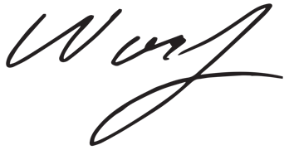

Woody Thrasher

Paid for by Woody Thrasher for Governor 2020

