Feb. 25, 2020

Dear Mr. Cary:

The people of West Virginia deserve to know the candidates who seek public office. To that end, I invite you to stand on stage with me in place of Gov. Jim Justice, who has not responded to a similar letter, on three separate occasions prior to the primary election in May.

I propose we meet at three sites: one in each of our congressional districts to debate the issues that matter to Republican voters of our state. I am confident we can arrange three moderated debates, and I suggest we host them well in advance of the Tuesday, May 12 primary election. This will allow early voters ample time to assess each of us and where we stand. Candidate Mike Folk has already agreed to do so.

With the well-being of our state in mind, I look forward to hearing from you.

Most sincerely,

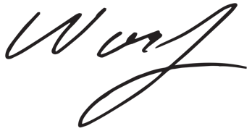

Woody Thrasher

Paid for by Woody Thrasher for Governor 2020

