F O R I M M E D I A T E R E L E A S E
29 September 2020
CONTACT: Elishia Ballentine: (334) 315-8019
elishia.ballentine@forestry.alabama.gov

Will Brantley Named Assistant State Forester

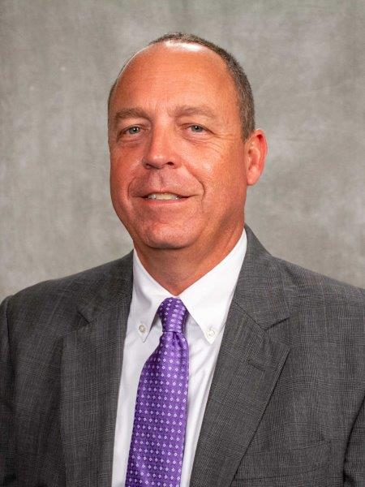
State Forester Rick Oates is pleased to name Will Brantley as new the Assistant State Forester of Alabama. For the last three years, Brantley has been serving as Director of the Forest Management Division with the Alabama Forestry Commission. The agency’s Commissioners approved the appointment at their meeting on September 10, 2020, and he officially assumed the role on September 16 following approval by Governor Ivey. This position has been vacant since Bruce Springer’s retirement in June.

With more than 25 years of experience in natural resources management, Brantley possesses a strong understanding of the issues and programs involving Alabama’s forests, lands, and waters. As Forest Management Division Director, he oversaw the implementation of various program areas including Forest Stewardship, Forest Legacy, Landowner Assistance, Urban and Community Forestry, State Lands, Forest Inventory & Analysis and Economic Development, Threatened & Endangered Species, and Best Management Practices for Water Quality. He also coordinated the recent update of the State’s Forest Action Plan, developed and received grant funding for a new agency program to enhance coastal forested watersheds and protect water quality, and pursued new agency revenue sources through multiple interagency agreements that help fund agency operations.
Will Brantley

Before joining the AFC in November of 2017, Brantley was employed with the State Lands Division of the Alabama Department of Conservation & Natural Resources for 16 years where he served in several capacities, including State Lands Assistant Director. His responsibilities with the State Lands Division included managing forested trust lands and implementing various statewide programs including the Land Sales & Leasing Act, the Natural Resource Damage Assessment program, and the Coastal Impact Assistance Program.

Previously, Brantley was natural resource planner for the Baldwin County Commission where he advised the County Commission on conservation and natural resource planning programs for wetland identification, coastal restoration, and stormwater management. Prior to that, he worked as a utility inventory arborist with Davey Resource Group in northern California.

A native of Greenville, South Carolina, Brantley earned his bachelor’s degree from Furman University and a Master of Science in Forest Resources from Clemson University. Will and his wife, Eve, reside in Auburn with their two children, Chloe and Hank.
###

