Collaboration Brings Campbell University Medical Students to Brogden Primary School

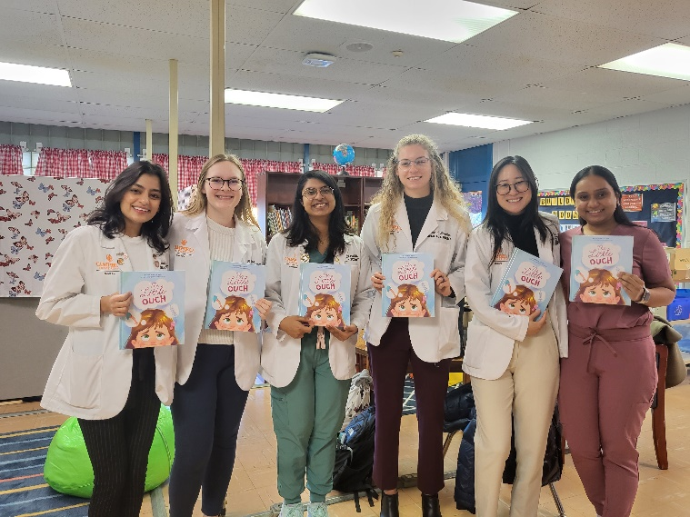
In an innovative initiative to enhance literacy and to promote all aspects of health among young students, a collaboration between Wayne County Public Schools, Communities Supporting Schools, UNC Health Wayne, and Campbell University is making waves at Brogden Primary Elementary School. UNC Health Wayne Foundation Director, Jacqueline Kannan, praised the partnership, saying "This is a great way to connect our medical students to our community. We are so grateful for Communities Supporting Schools and the work that they do to help our youth succeed in school. Health literacy for elementary students is crucial as it empowers them with the knowledge and skills to make informed decisions about their well-being, laying the foundation for a lifetime of healthy habits and responsible choices." Selena Bennett, Executive Director of Communities Supporting Schools, echoed Kannan's sentiments, stating, “This has been a wonderful opportunity to bring this group of medical students in to read to our students at Brogden Primary. Not only are they helping to teach lessons about health and nutrition, but they are instilling a love for reading!”
Aashana Patel (far left) with her team of fellow Campbell University medical student volunteers.
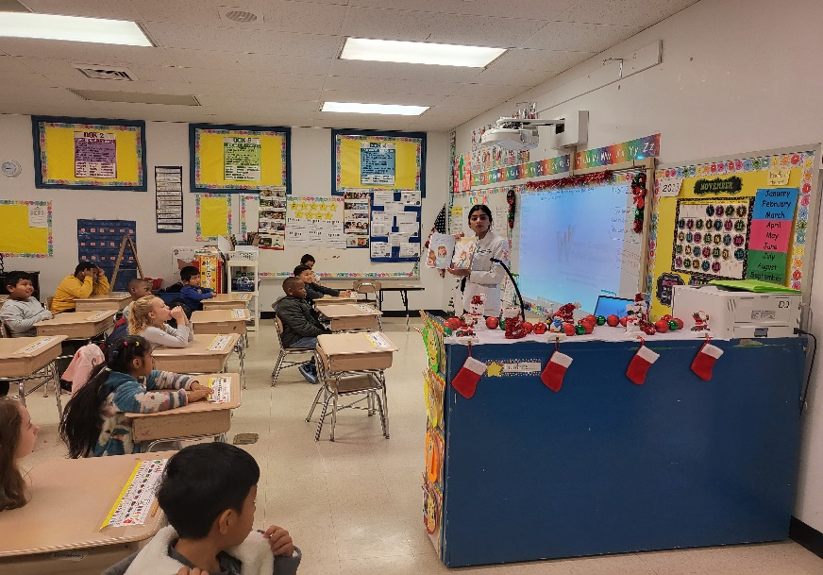
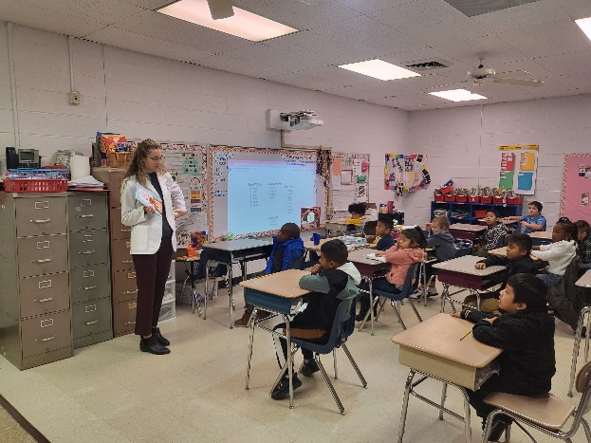
Leading the charge is Campbell University student Aashana Patel, who, along with the other partners, recognized the need to address low literacy rates in Wayne County. A unique aspect of the program is that it integrates literacy and healthcare education, aiming to empower students with essential knowledge and skills for making informed decisions about their well-being. "I wanted to bring together literacy as well as healthcare into the schools around here because [literacy rates] are so low," Patel explained. "Even if one of them picks up something from this, we may have a student that’s not diabetic or doesn’t have hypertension.” During their visits, Patel and fellow medical students engage students in short reading and content lessons, emphasizing crucial health topics such as hygiene, healthy eating, exercise, and healthy relationships. Patel highlighted the importance of instilling these lessons early, noting that simple practices can make a big difference, like that of hand washing after meals to prevent the spread of illnesses.
Reflecting on their recent reading selection, Patel shared insights from the book "Everybody," which promotes acceptance and celebration of diversity. "It’s important to send out the message like 'hey, that’s not a bad thing. That’s actually a good thing,'" Patel emphasized. "If you come together and celebrate your differences, then we may have a much better world." Nancy Lancaster, the Communities Supporting Schools Success Coach at Brogden Primary, underscored the significance of diverse role models in the medical field, particularly for students in underprivileged communities, stating, “It’s so good for our kids to see women in roles like this. Because a lot of them don’t see that at home…and women of color, different colors in medicine, because [...] they don’t see what they can become sometimes. This is a [high] poverty area and it’s so good to have somebody who has made it to come back and show them what they can do.”
Through the partnerships with Brogden Primary School teachers, Communities Supporting Schools Patel, Campbell University, and UNC Health Wayne, Patel’s team is able to cultivate a lasting, positive impact on the students at Brogden Primary. Through this collaborative effort, Brogden Primary Elementary students are not only gaining valuable health literacy skills but are also learning the importance of empathy and inclusivity, setting the stage for a healthier and compassionate future generation.

