Security Health Plan and Freespira offer relief for patients with panic attacks and PTSD symptoms

Patients who experience traumatic flashbacks, sleep disturbances or anxiety attacks may benefit from Freespira. Freespira is an at-home FDA-cleared medical device used to reduce or eliminate panic attacks and traumatic stress symptoms in 28 days. The treatment can be used alongside traditional medication or counseling therapies.

Freespira is available for eligible Security Health Plan members who are 13 and older and offers an alternative evidence-based, covered benefit. Below are some highlights of the treatment and some statistics of Security Health Plan members who have used the treatment as well as others who have used Freespira:

- Freespira works differently by addressing the underlying physiological factor of panic disorder and PTSD symptoms: dysregulated breathing arising from carbon dioxide (CO₂) hypersensitivity. The 28-day, at-home treatment pairs the FDA-cleared digital therapeutic with coaches who provide virtual training and weekly check-ins for patients.
- A study conducted with Allegheny Health Network patients found 91% had significant panic disorder symptom improvement a year after treatment. ¹
- In a PTSD study done at the VA, 89% percent of patients experienced significant reductions in PTSD severity measures post-treatment. In addition, half of the participants, including veterans and civilians, reported clinical remission scores six months post-treatment.²
- Freespira advisors, licensed clinicians and coaches will assist each patient through the authorization process and the treatment protocol.
- Security Health Plan members have experienced a significant reduction in PCL and PDSS response scores – see full clinical outcomes below.
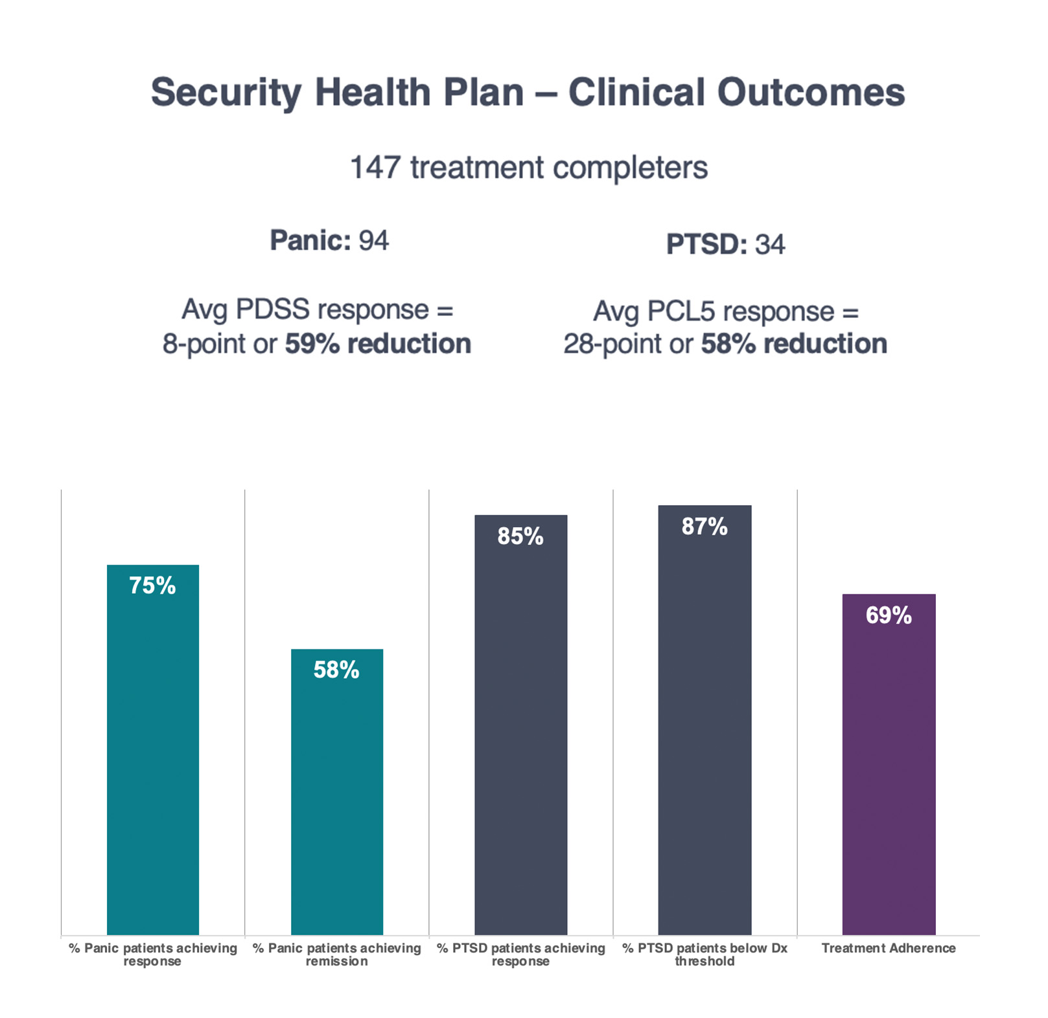

As a Security Health Plan provider, Freespira is immediately available to help you improve the lives of your patients with panic attacks and PTSD symptoms. To make a referral, visit freespira.com/for-providers/.

¹See Kaplan et al., https://doi.org/10/10007/s10484-020-0
²See Ostacher et al., https://doi.org/10.1007/s10484-021-09521-3

