Sunday, Nov. 12
Puffin Cultural Forum, 20 Puffin Way
12:00 pm Faith Ringgold: Tell It Like It is (67 min)
2:30 pm Shared Legacies & The Empty Saddle (95 min + 12 min))
5:00 pm Under G-d (24 min) & Hollywood’s Orthodox Jew Problem (15 min)

Hollywood’s Orthodox Jew Problem (15 min) Documentary
Directed by Allison Joseph
Talkback with Allison Joseph, Jew in the City; Mendy Pellin, Hasidic comedian
Moderated by Barry Lichtenberg

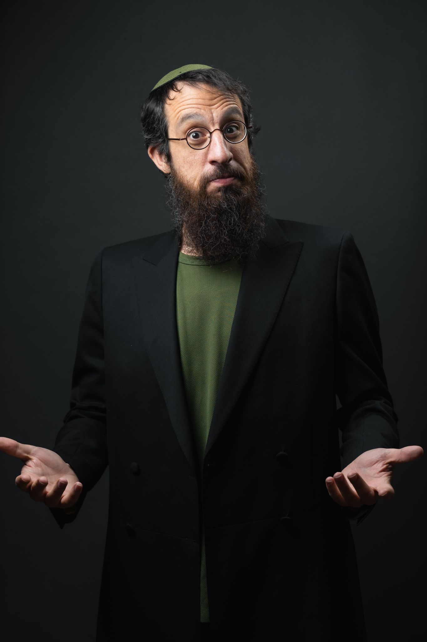
This documentary short is the first of a three-part film laying out Hollywood’s mistreatment of Jews. The first part focuses on the Orthodox Jewish community. The film illustrates the uptick in antisemitism that has been on the rise recently and how dangerous it is now to be Jewish.
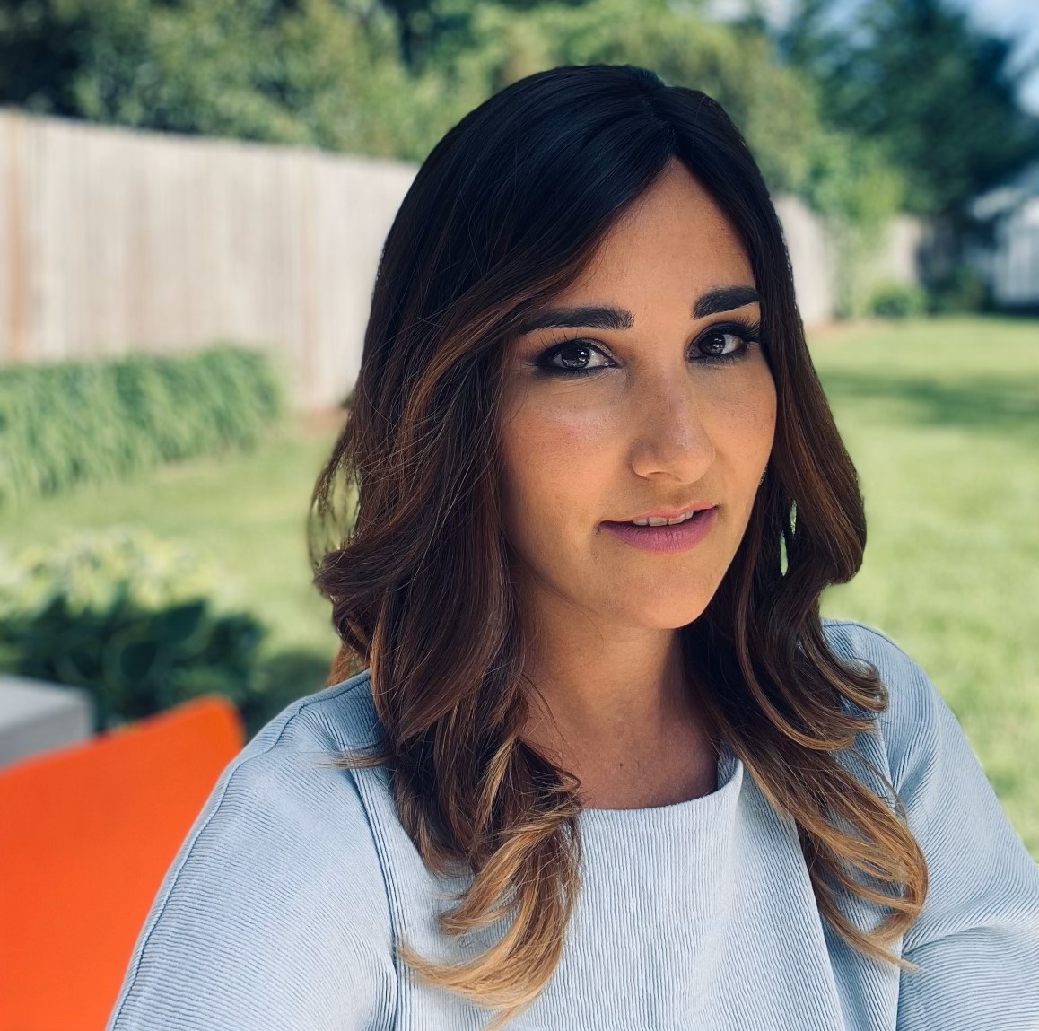
Allison Josephs

Mendy Pellin

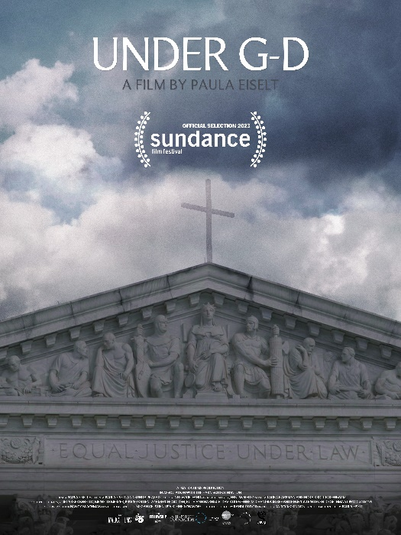
Under G-d (24 min) Documentary
Directed by Paula Eiselt
Sponsored by Teaneck Women Together
Talkback with Paula Eiselt; Dr. Michal Raucher, Director of Jewish Studies, Rutgers

Inspired by the lived experiences of Jewish women, lawsuits are currently being launched by rabbis, Jewish organizations, and interfaith leaders to challenge the overturning of Roe v. Wade. https://www.youtube.com/watch?v=M4aB-3Bxw3c



PAULA EISELT

