Friday, November 10

Teaneck Cinemas, 503 Cedar Lane
7:30 pm The Rebellious Life of Mrs. Rosa Parks (96 min)

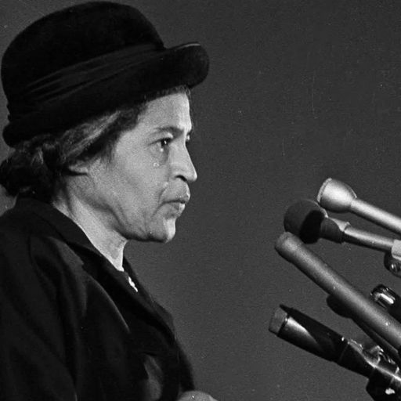
The Rebellious Life of Mrs. Rosa Parks (96 min) Documentary
Directed by Johanna Hamilton and Yoruba Richen
Sponsored by Bergen County (NJ) Chapter of The Links, Inc.
Talkback with civil rights activist Theodora Lacey

Delves deep into civil rights icon Rosa Parks' historic work and her role in the Montgomery Bus Boycott. Through interviews with those who knew her, powerful archival footage, and her own words, the film tells the story of Parks' extensive organizing, radical politics, and lifelong dedication to activism.
https://www.youtube.com/watch?v=1K40TyCuC-Q

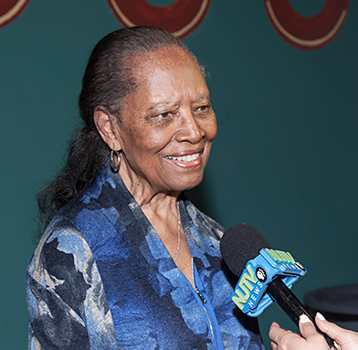
Theodora Lacey

