Sunday, Nov. 12
Puffin Cultural Forum, 20 Puffin Way
12:00 pm Faith Ringgold: Tell It Like It is (67 min)
2:30 pm Shared Legacies & The Empty Saddle (95 min + 12 min)
5:00 pm Under G-d (24 min) & Hollywood’s Jewish Orthodox Problem (15 min)

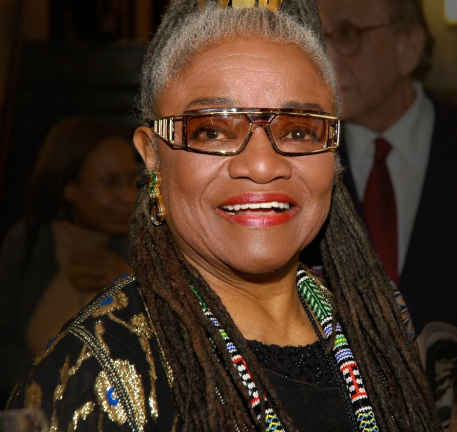
Faith Ringgold: Tell It Like It Is (67 min) Biography / History
Directed by Louise Lockwood
Sponsored by Woman’s Club of Englewood; Teaneck - Englewood & Vicinity Club (NANBPWC, Inc.); Northern NJ Community Foundation; YWCA Northern New Jersey
Talkback with Dorian Bergen, ACA Galleries; Dr. Michele Faith Wallace and Barbara Wallace, Ms. Ringgold’s daughters; Faith Ringgold will be in attendance.
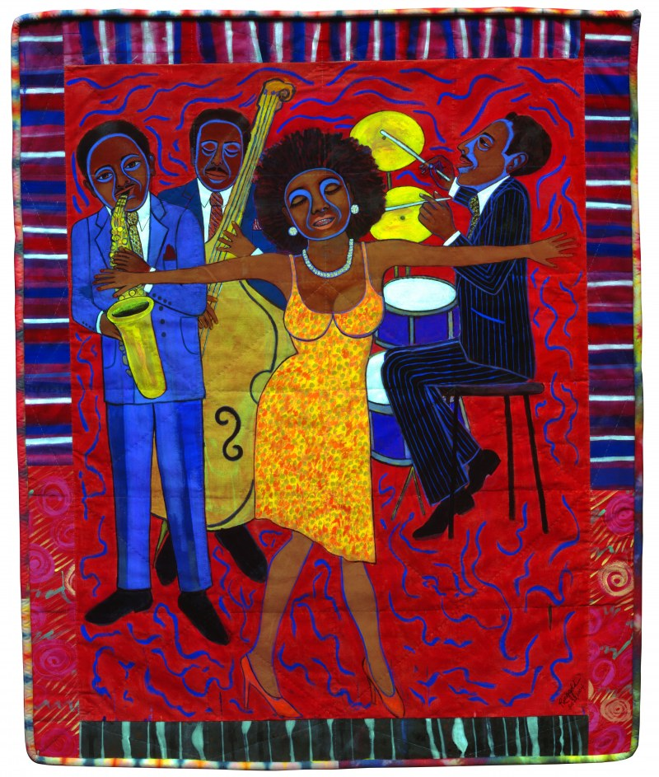
Harlem-born artist, author and activist Faith Ringgold painted some of the most truthful and empowering representations of African Americans during the civil rights and women’s movements of the 1960s and 1970s. At the time, the art establishment dismissed her seminal American People series as political art by a woman, and a black woman at that. Now in her 90s and a resident of Englewood, New Jersey, Ringgold is considered one of the most important African American artists, whose work is increasingly relevant today.

