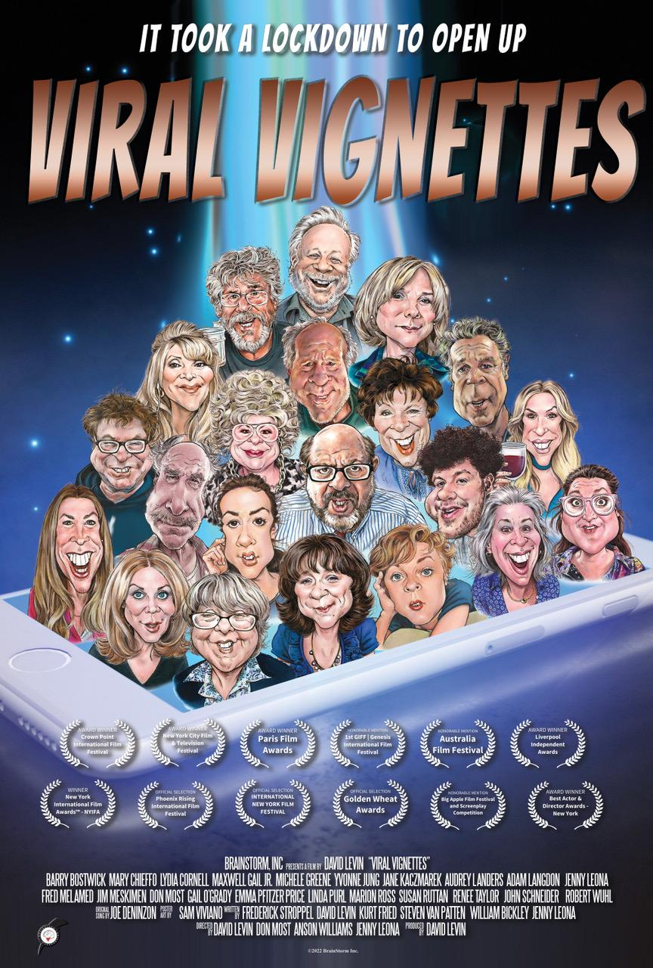
Saturday, Nov. 11
Teaneck Cinemas, 503 Cedar Lane
11:20 am La Syndicaliste (121 min)
2:00 pm Hungry to Learn (85 min)
4:25 pm Viral Vignettes (114 min)

Viral Vignettes (114 min) Comedy
Directed by David Levin
Sponsored by Steven Finkelstein of Russo Realty

Talkback with David Levin

Twelve one-act comedies that introduce us to 21 unique characters - stuck at home during the pandemic, trying to make sense of an unprecedented situation, filled with strangeness and unexpected humor.

Trailer: https://www.youtube.com/watch?v=2hxYduiRs7c

