Saturday, Nov. 11
Teaneck Cinemas, 503 Cedar Lane
11:20 am La Syndicaliste (121 min)
2:00 pm Hungry to Learn (85 min)
4:25 pm Viral Vignettes (114 min)

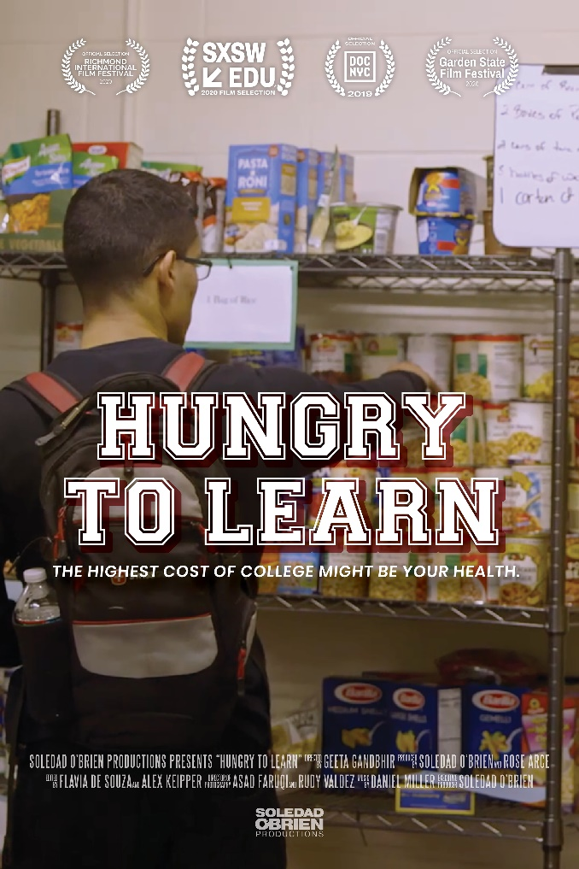
Hungry to Learn (85 min) Documentary
Directed by Geeta Gandbhir
Sponsored by Center for Food Action; Fairleigh Dickinson University
Talkback with Rashard Mills, FDU Campus Engagement & CFA Board Member; Lisa Pitz, CFA Hunger Free NJ; Sara Goldrick-Rab, featured in film & author of Paying the Price: College Costs, Financial Aid, and the Betrayal of the American Dream

The cost of college is forcing students to make choices between eating regular meals and paying for their education. Co-produced by Soledad O’Brien, this poignant film follows four college students as they navigate food insecurity in their attempt to change their lives for the better. Trailer: https://vimeo.com/390097098

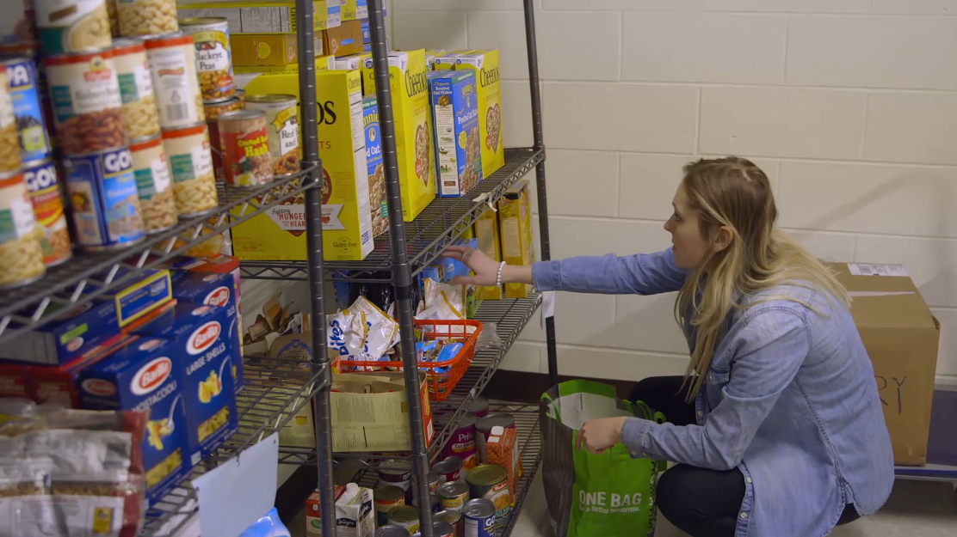
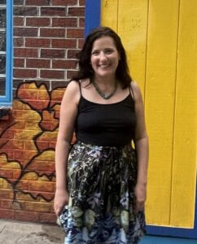

Sarah Goldrick-Rabb

