Sunday, Nov. 12
Puffin Cultural Forum, 20 Puffin Way
12:00 pm Faith Ringgold: Tell It Like It is (67 min)
2:30 pm Shared Legacies & The Empty Saddle (95 min + 12 min)
5:00 pm Under G-d (24 min) & Hollywood’s Jewish Orthodox Problem (15 min)

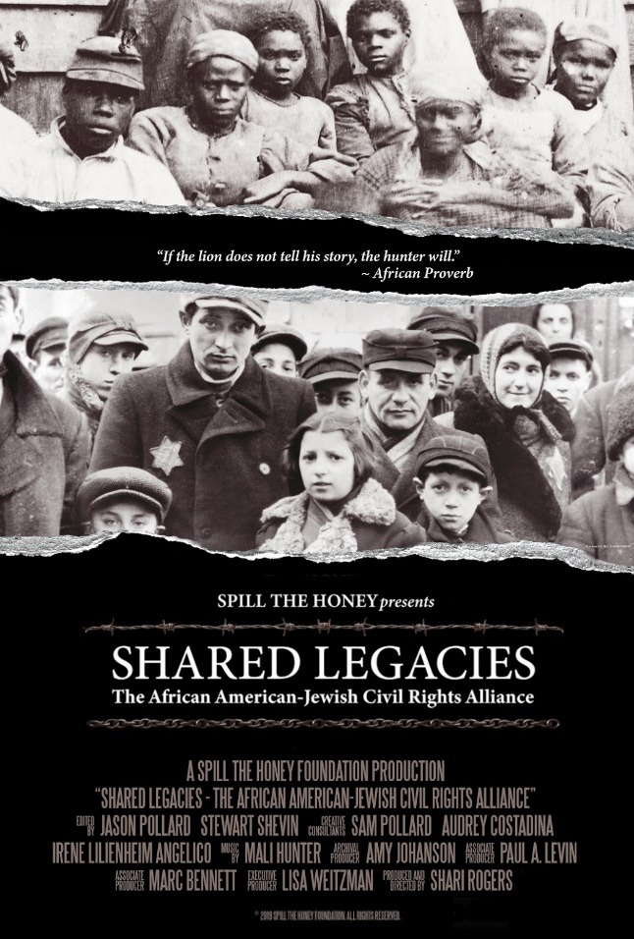
Shared Legacies (95 min) Documentary
Directed by Shari Rogers
Sponsored by Martin Luther King Birthday Committee; Jewish Historical Society of North Jersey; Teaneck Community Chorus

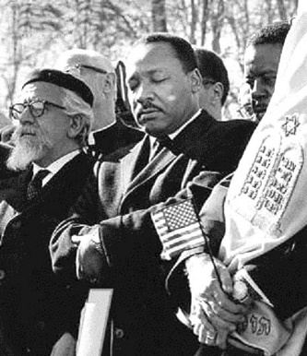
The historical ties between Black and Jewish Americans began long before the Civil Rights era. Shared Legacies explores this significant alliance, sharing eyewitness accounts, interviews with civil rights leaders, including the late U.S. Representative John Lewis, and a treasure trove of archival footage. The film is a tribute to the pursuit of what Dr. King called a “coalition of conscience” and a celebration of partnership, as well as an urgent call to action for today.
Trailer: https://www.youtube.com/watch?v=FcEu_1jDHiI

The Empty Saddle: Remembering Samuel Johnson (12 min) Documentary
Directed by Andrew Sherwood
Sponsored by Martin Luther King Birthday Committee; Jewish Historical Society of North Jersey
Talkback with Rabbi Steven Sirbu of Temple Emeth; Andrew Sherwood (director); Rev. Kerwin Webb
Moderator: Anthony Johnson
This film chronicles the work of the New Jersey Social Justice Remembrance Coalition in conjunction with the Equal Justice Institute to bring a historical marker to the Eatontown site of the 1886 lynching of Samuel “Mingo Jack” Johnson. Johnson’s killing is the only documented lynching in New Jersey history.
