Sunday, Nov. 12
Teaneck Cinemas, 503 Cedar Lane
11:30 am Alam (109 min)
2:15 pm Cinema Sabaya (91 min)
4:35 pm Four Winters (90 min)

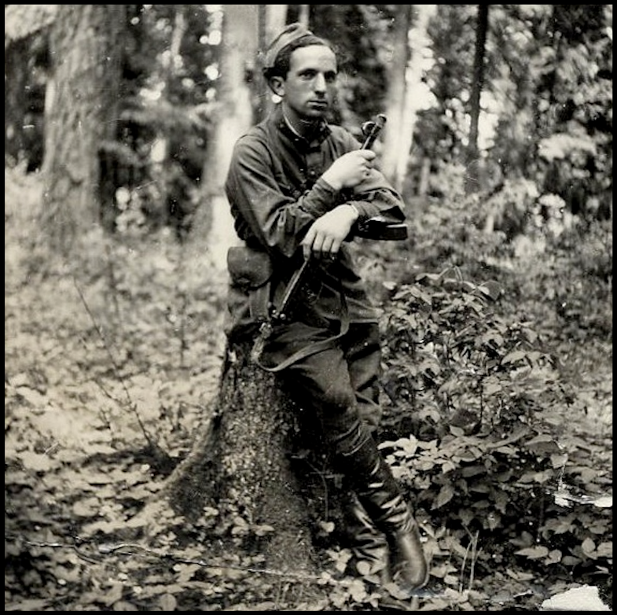
Four Winters (90 min) Documentary
Directed by Julia Mintz
Sponsored by Judith Distler; Phil Yucht; Jewish Community Council of Greater Teaneck
Talkback with Julia Mintz
Over 25,000 Jewish partisans fought back against the Nazis and their collaborators from deep within the forests of WWII's Eastern Europe, Ukraine, and Belarus. Against extraordinary odds, they escaped Nazi slaughter, transforming from young innocents to courageous resistance fighters. Shattering the myth of Jewish passivity, these last surviving partisans tell their stories of resistance. Trailer: fourwintersfilm.com/trailer


