Saturday, Nov. 11
Puffin Cultural Forum, 20 Puffin Way
12:00 pm Going to Mars: The Nikki Giovanni Project (102 min)
3:00 pm All the Beauty & The Bloodshed (122 min)

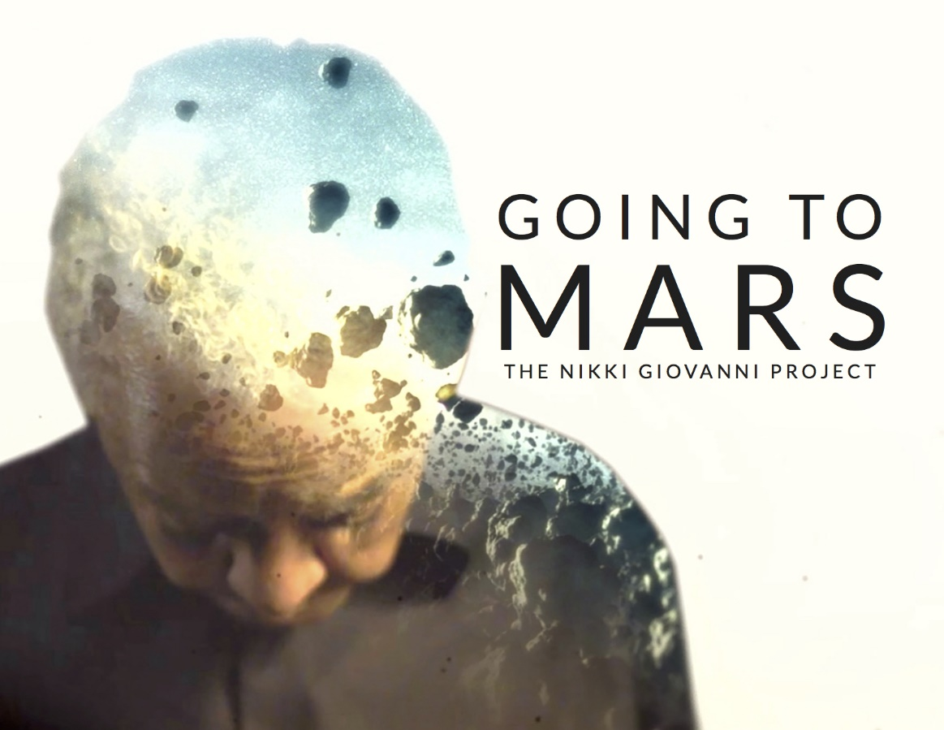
Going to Mars: The Nikki Giovanni Project (102 min) Documentary
Directed by Joe Brewster and Michele Stephenson
Sponsored by Delta Sigma Theta Sorority, Inc., Bergen County Alumnae Chapter

Through intimate archival footage and visually innovative treatments of Nikki Giovanni’s poetry, the film pushes the boundaries of biographical documentary film by traveling through time and space to reveal the enduring influence of one of America’s greatest living artists and social commentators. Trailer: https://youtu.be/F0xCXuMO7VI

