Saturday, Nov. 11 CENTERPIECE
Temple Emeth, 1666 Windsor Road
8:00 pm The Old Oak (113 min)
7:00 pm Light dinner and drinks served at Gala reception
Minimum donation: $35/person

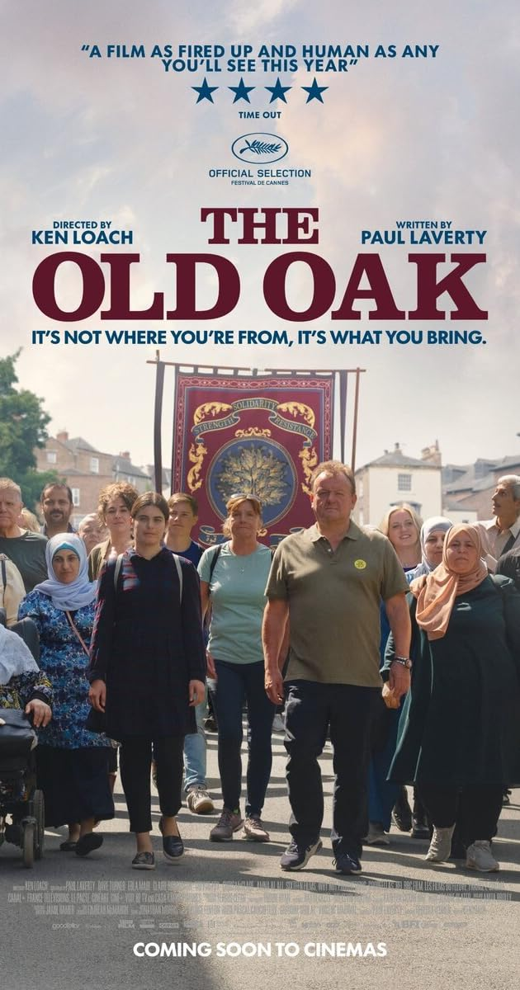
The Old Oak (113 min) Drama
Directed by Ken Loach

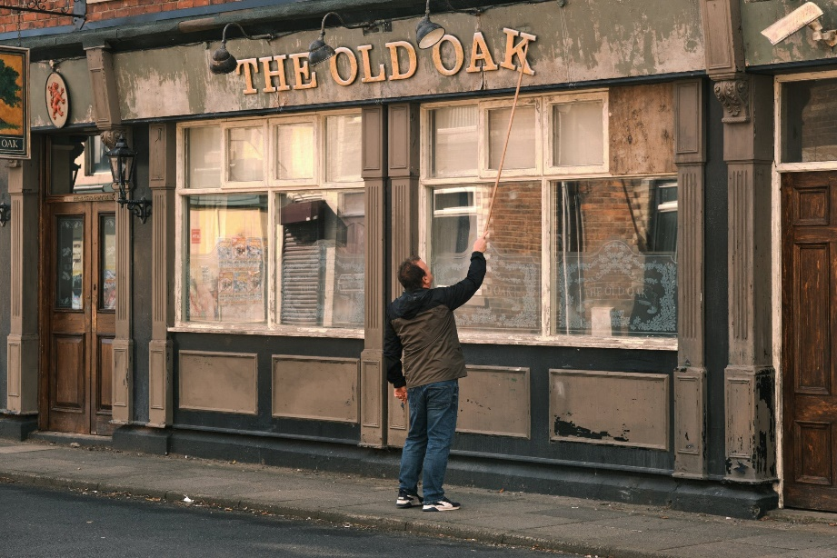
The Old Oak is the last pub standing in a once thriving mining village in northern England, a gathering space for a community that has fallen on hard times. There is growing anger, resentment, and a lack of hope among the residents, but the pub and its proprietor TJ are a fond presence to their customers. When a group of Syrian refugees move into the floundering village, a decisive rift fueled by prejudices develops between the community and its newest inhabitants. The formation of an unexpected friendship between TJ and a young Syrian woman named Yara opens new possibilities for the divided village in this deeply moving drama about loss, fear, and the difficulty of finding hope. Last film by legendary director Ken Loach. https://www.youtube.com/watch?v=Fwb0c5zqsyM

