Sunday, Nov. 12
Teaneck Cinemas, 503 Cedar Lane
11:30 am Alam (109 min)
2:15 pm Cinema Sabaya (91 min)
4:35 pm Four Winters (90 min)

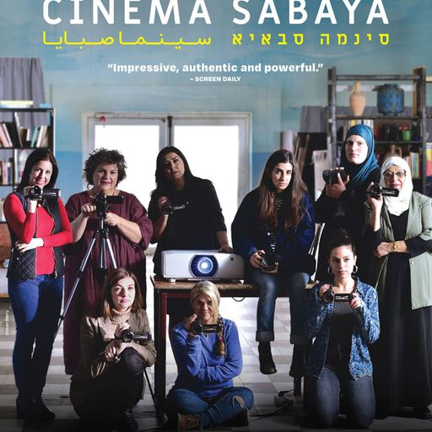
Cinema Sabaya (91 min) Drama
Subtitles – Hebrew, Arabic
Directed by Orit Fouks Rotem
Moderator: Sandee Brawarsky
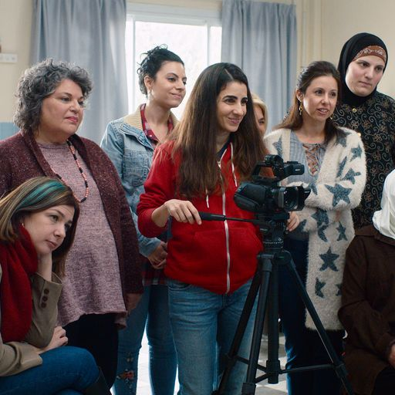
A group of Arab and Jewish women attend a video workshop at a community center run by Rona, a young filmmaker from Tel Aviv, who teaches them to document their lives. As each student shares footage from her home life with the others, their beliefs and preconceptions are challenged, and barriers are broken down. The group comes together as mothers, daughters, wives, and women living in a world designed to keep them apart, forming an empowering and lasting bond as they learn more about each other... and themselves.

Trailer: https://www.youtube.com/watch?v=kaOyHdSSGAg

