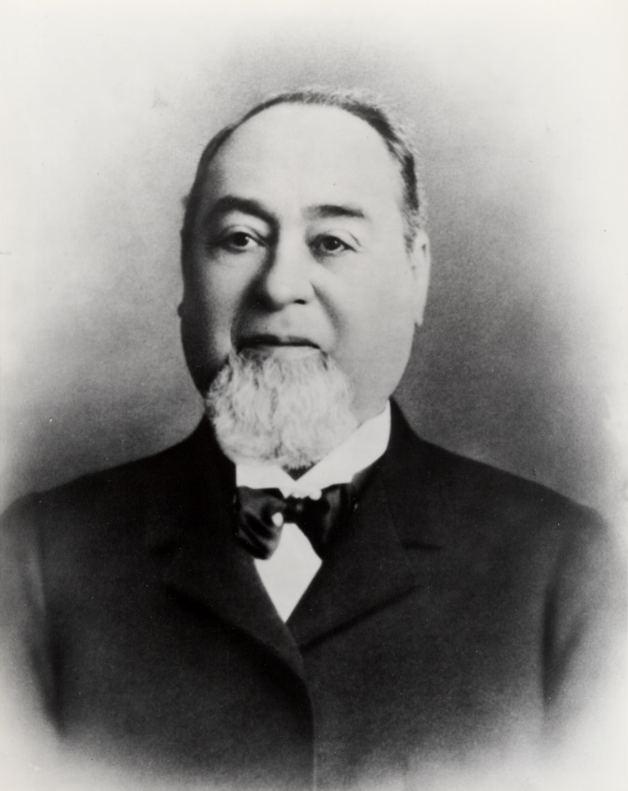
Virtual
Jews of the Wild West (80 min) Documentary
Directed by Amanda Kinsey
Talkback with Amanda Kinsey; Eric Goldman, Jewish film critic, educator, and historian
Moderator: Eric Goldman
Jewish pioneers of the Wild West are a largely forgotten chapter in US History. Yet, they played a definitive role shaping the expansion of the United States. By 1912, it is estimated that more than 100,000 Jews had migrated to the Wild West. This documentary tells a positive immigration story and highlights the contributions Jewish Americans made to shaping the Western United States.
Levi Strauss Trailer: https://vimeo.com/662305186
