Sunday, Nov. 12
Temple Emeth, 1666 Windsor Road
11:00 am Vishniac (93 min)
1:20 pm The Devil’s Confession: The Lost Eichmann Tapes (115 min)
4:10 pm Commitment to Life & Unexpected (115 min + 18 min)
7:30 pm Bella! (102 min) Closing


Bella! (102 min) Documentary
Directed by Jeff L. Lieberman
Sponsored by Women of Wisdom (WOW); National Council of Jewish Women Bergen County Section; Former NJ State Senator Loretta Weinberg; League of Women Voters of Teaneck; Teaneck Women Together; YWCA Northern New Jersey
Talkback with Jeff L. Lieberman; Former NJ State Senator Loretta Weinberg
Moderator: Judy Distler
In 1970, when the United States was ruled by men, Bella Abzug challenged the status quo, running a successful campaign from the streets of Manhattan that elevated her all the way to the halls of Congress. With her trademark hat and Bronx swagger, Bella entered Congress swinging, battling for credit cards for women, equality for the LGBTQ community and trailblazing a path for leadership that reflected the broad diversity of the country.
Trailer: https://www.youtube.com/watch?v=Ygwhi2cL78E

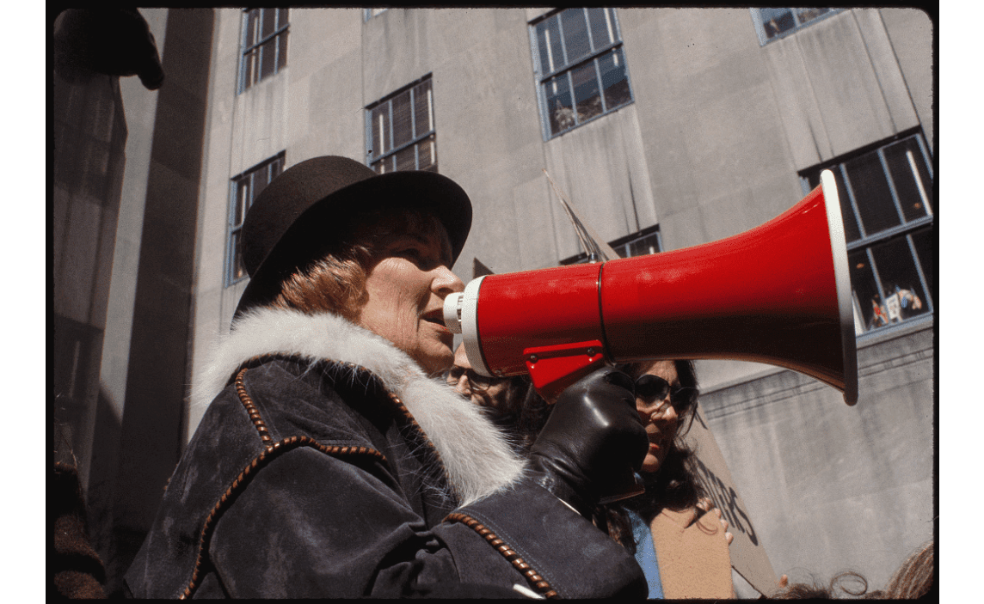

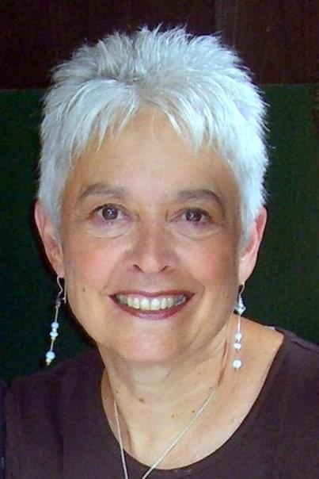

Loretta Weinberg Judy Distler Jeff L. Lieberman

