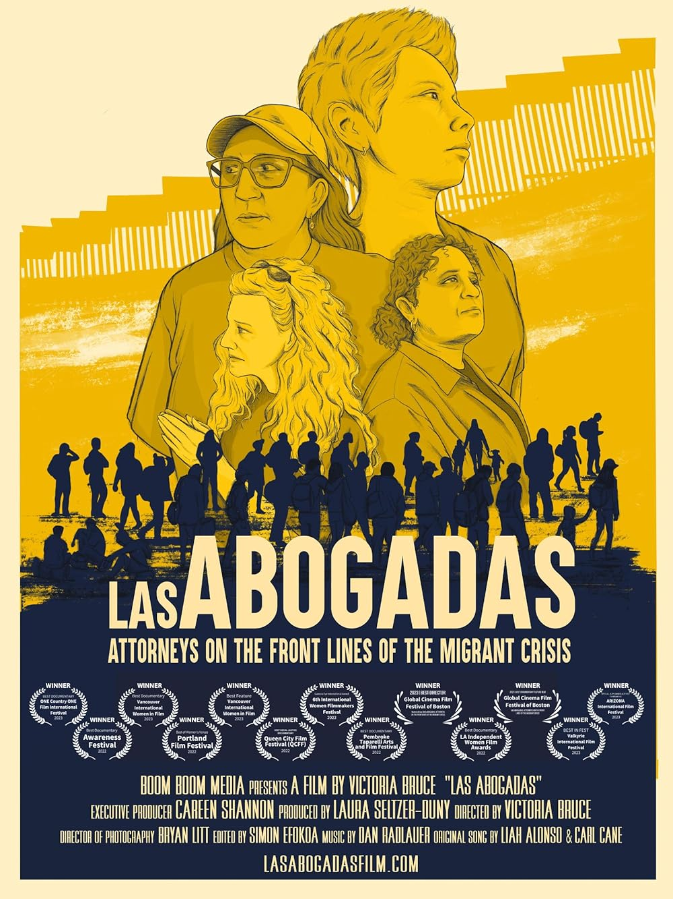
Virtual
Las Abogadas: Attorneys on the Front Lines of the Migrant Crisis (94 min) Documentary
Directed by Victoria Bruce
Sponsored by Nachman, Phulwani, Zimovcak (NPZ) Law Group, P.C.
Talkback with Victoria Bruce; Rebecca Eichler, subject of film; Cynthia Rosario, NPZ Law
Film follows four immigration attorneys over a multi-year odyssey as the U.S. Government under President Trump upends every law meant to protect those fleeing from persecution, violence, and war. Trailer: https://vimeo.com/790109998
