Sunday, Nov. 12
Temple Emeth, 1666 Windsor Road
11:00 am Vishniac (93 min)
1:20 pm The Devil’s Confession: The Lost Eichmann Tapes (115 min)
4:10 pm Commitment to Life & Unexpected (115 min + 18 min)
7:30 pm Bella! (102 min) Closing

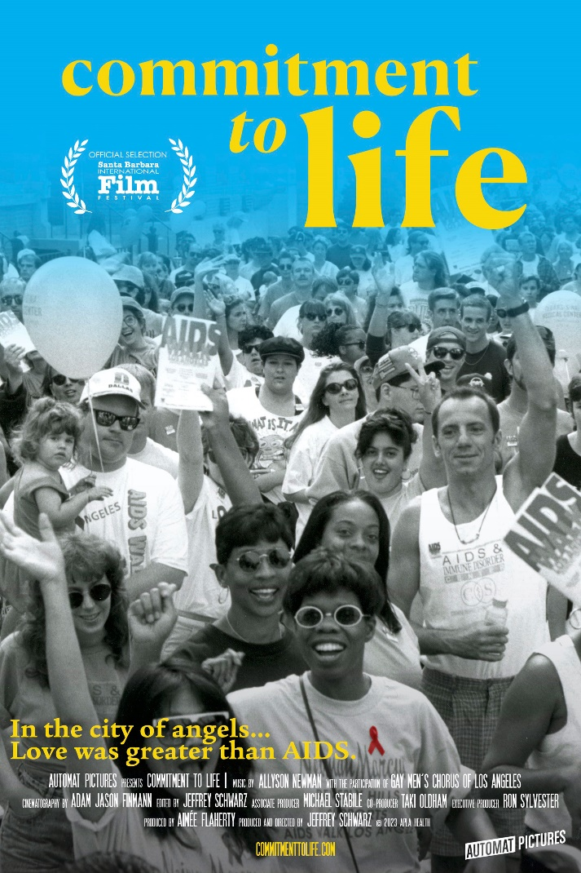
Commitment to Life (115 min) Documentary
Directed by Jeffrey Schwarz
Sponsored by LGBTQ+ Health and Wellness at Bergen New Bridge Medical Center; National Coalition of 100 Black Women, Inc. Bergen / Passaic Chapter; Vivian Scott Chew, in memory of her brother Lawrence Eric Murphy; YWCA Northern New Jersey

Talkback with Dr. Christopher Awwad and Finn Schubert of LGBTQ+ Health & Wellness Center at Bergen New Bridge Medical Center
Moderator: Jeremy Lentz

In the early 1980s, a young doctor at UCLA reports a strange immune disorder among gay men -- the world's first warning sign of the epidemic to come. A committed group of activists helps care for the sick and dying while at the same time lobbying those in Hollywood to contribute to the fight.
https://www.youtube.com/watch?v=bAuPmENai_A

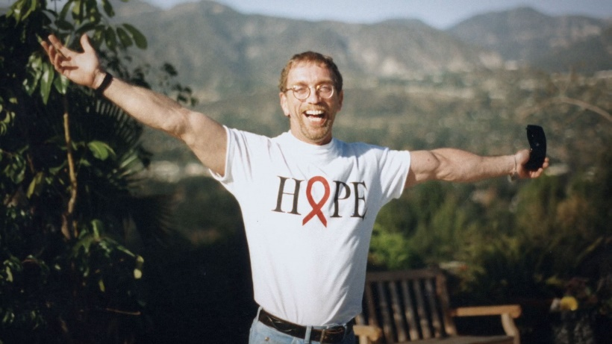

Unexpected (18 min) Documentary
Directed by Zeberiah Newman
Sponsored by LGBTQ+ Health and Wellness at Bergen New Bridge Medical Center; National Coalition of 100 Black Women, Inc. Bergen / Passaic Chapter; Vivian Scott Chew, in memory of her brother Lawrence Eric Murphy; YWCA Northern New Jersey
Talkback with Zeberiah Newman
Follows Masonia Traylor and Cici Covin as they produce self-care packages for pregnant women recently diagnosed with HIV and offer them to be part of a safe network of support and services.

