Thursday, Nov. 9 OPENING NIGHT
Teaneck Cinemas, 503 Cedar Lane
7:30 pm Invisible Beauty (115 min)

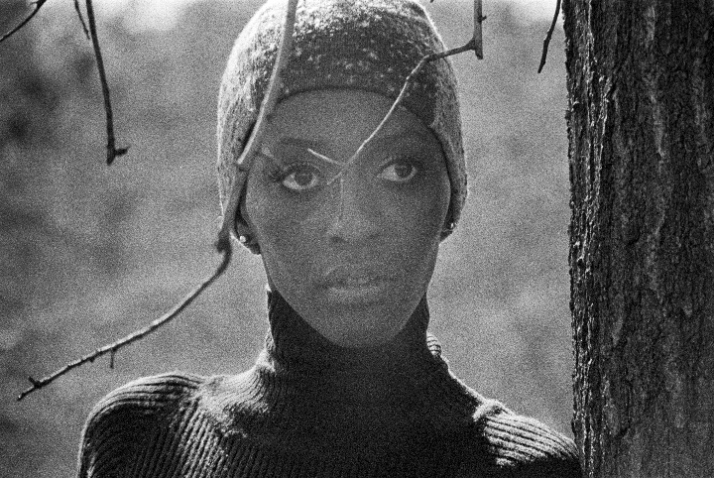
Invisible Beauty (115 min) Documentary
Directed by Bethann Hardison and Frederic Tcheng
Sponsored by National Coalition of 100 Black Women, Inc. Bergen/Passaic Chapter
Talkback with Kyle Hagler, No Smoking LLC, Fashion Consultancy Mgt.

Fashion revolutionary Bethann Hardison looks back on her journey as a pioneering Black model, modeling agent, and activist, shining a light on an untold chapter in the fight for racial diversity. The film features Tracee Ellis Ross, Naomi Campbell, Tyson Beckford, Zendaya, Iman, Whoopi Goldberg, Fran Lebowitz, and Kadeem Hardison. Trailer: https://www.youtube.com/watch?v=l08OW_-lYIw

