Sunday, Nov. 12
Temple Emeth, 1666 Windsor Road
11:00 am Vishniac (93 min)
1:20 pm The Devil’s Confession: The Lost Eichmann Tapes (115 min)
4:10 pm Commitment to Life & Unexpected (115 min + 18 min)
7:30 pm Bella! (102 min) Closing

Vishniac (90 min) Documentary
Directed by Laura Bialis
Sponsored by the Jewish Standard
Talkback with Linda Levi, JDC Archives Global Director
Moderator: Sandee Brawarsky
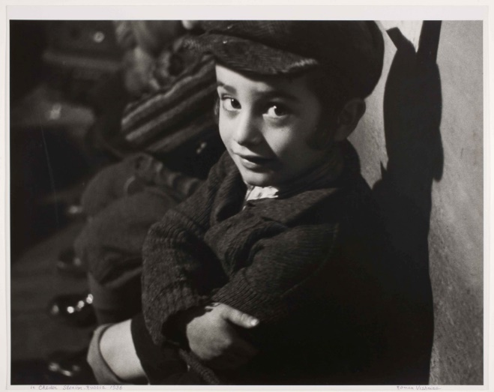
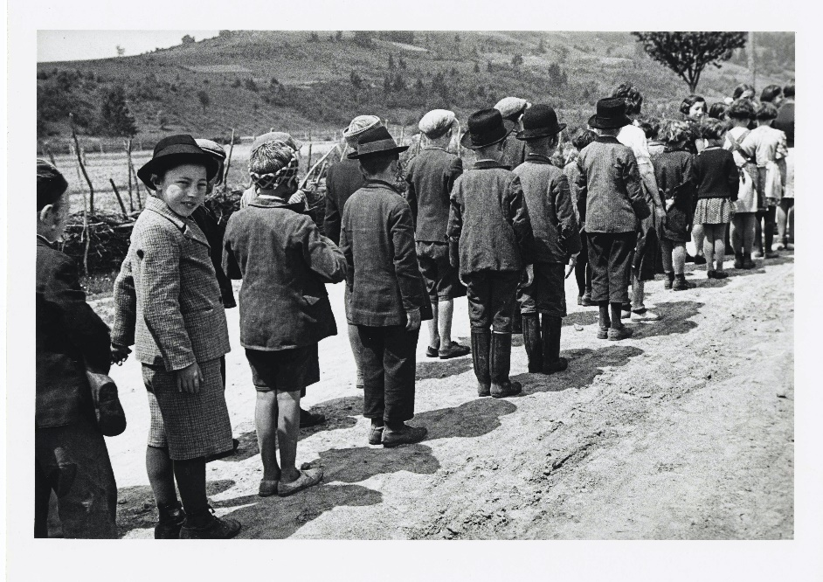
Roman Vishniac is best known for having traversed Eastern Europe from 1935 through 1938, on assignment for the American Joint Distribution Committee, to photograph Jewish life in Eastern Europe. The purpose of the photographs was to raise funds for impoverished Jewish communities. Few predicted that less than a decade later, these communities would be wiped out, and Vishniac's photographs would provide the last visual records of an entire world. But those photographs comprise only one chapter of his remarkable life. Vishniac was an avid scientist, and made considerable contributions in the field of microscopic photography. His “Living Biology” series, funded by the National Science Foundation, were some of the first films depicting life through a microscope. He is credited as one of the founders of this field. Now, for the first time, Vishniac’s life and work is explored in a feature-length documentary.
Trailer: https://www.youtube.com/watch?v=a35SB438NHc

