📋 Charge Conference 2025 – Brief Overview
You may now enter the date of your Charge Conference in Unity and begin creating your paperwork.

🏛 In-Person Charge Conferences – 2025 Schedule
(all conferences begin at 3:00 p.m.)

- October 19, 2025 – Bethany UMC (Purcellville) – Loudoun & Fauquier Counties
- October 26, 2025 – Kernstown UMC – Clarke, Frederick, City of Winchester
- November 9, 2025 – Dayton UMC – Augusta, Rockingham, City of Harrisonburg
- November 16, 2025 – Woodstock UMC – Page, Shenandoah, Warren
📌 Note: If the assigned date and place for your area does not work for your church, you may attend another location. Please notify the District Office if you plan to do so.

💻 Charge Conference Tutorial (Zoom)
For those needing help with processing Charge Conference paperwork in Unity, or simply a refresher, Debbie will zoom with you:
📅 Tuesday, September 9, 2025 – 10:00 a.m.
🔗 Join Zoom Meeting: Click Here
Meeting ID: 987 5942 9463
Passcode: 206165
☎ One Tap Mobile: +1 301 715 8592,,98759429463# (Washington, DC)
Toll-Free: 855 880 1246,,98759429463#

✨ What’s New for 2025
- Trustees Report – Question 6g
A new question has been added regarding termite insurance. Since termite damage is often not covered by standard property insurance, churches may need to research whether they are protected.
- Church Ministry Inventory
A new module with 35 Yes/No questions about your church’s ministries (e.g., Food Pantry, Shelter, Preschool, etc.).
  - For each Yes response, you may provide additional details (and brag a little!).
  - In some cases, a follow-up question will appear.
  - The goal: to help the district and conference offices understand available resources and encourage collaboration across churches.
- Nominations Help Page
New “Help” Forms Available
On the Charge Conference page (where forms are located), you will now find a guideline form to assist you as you prepare and confirm your committee members for 2026.
Pre-Filled Report Option
If you first enter your committee members in the “Church Membership” section of Unity, the Pre-Filled Report will automatically populate those names. This completed report can then be uploaded under “Nominations and Leadership Development Committee” (located just above this section).
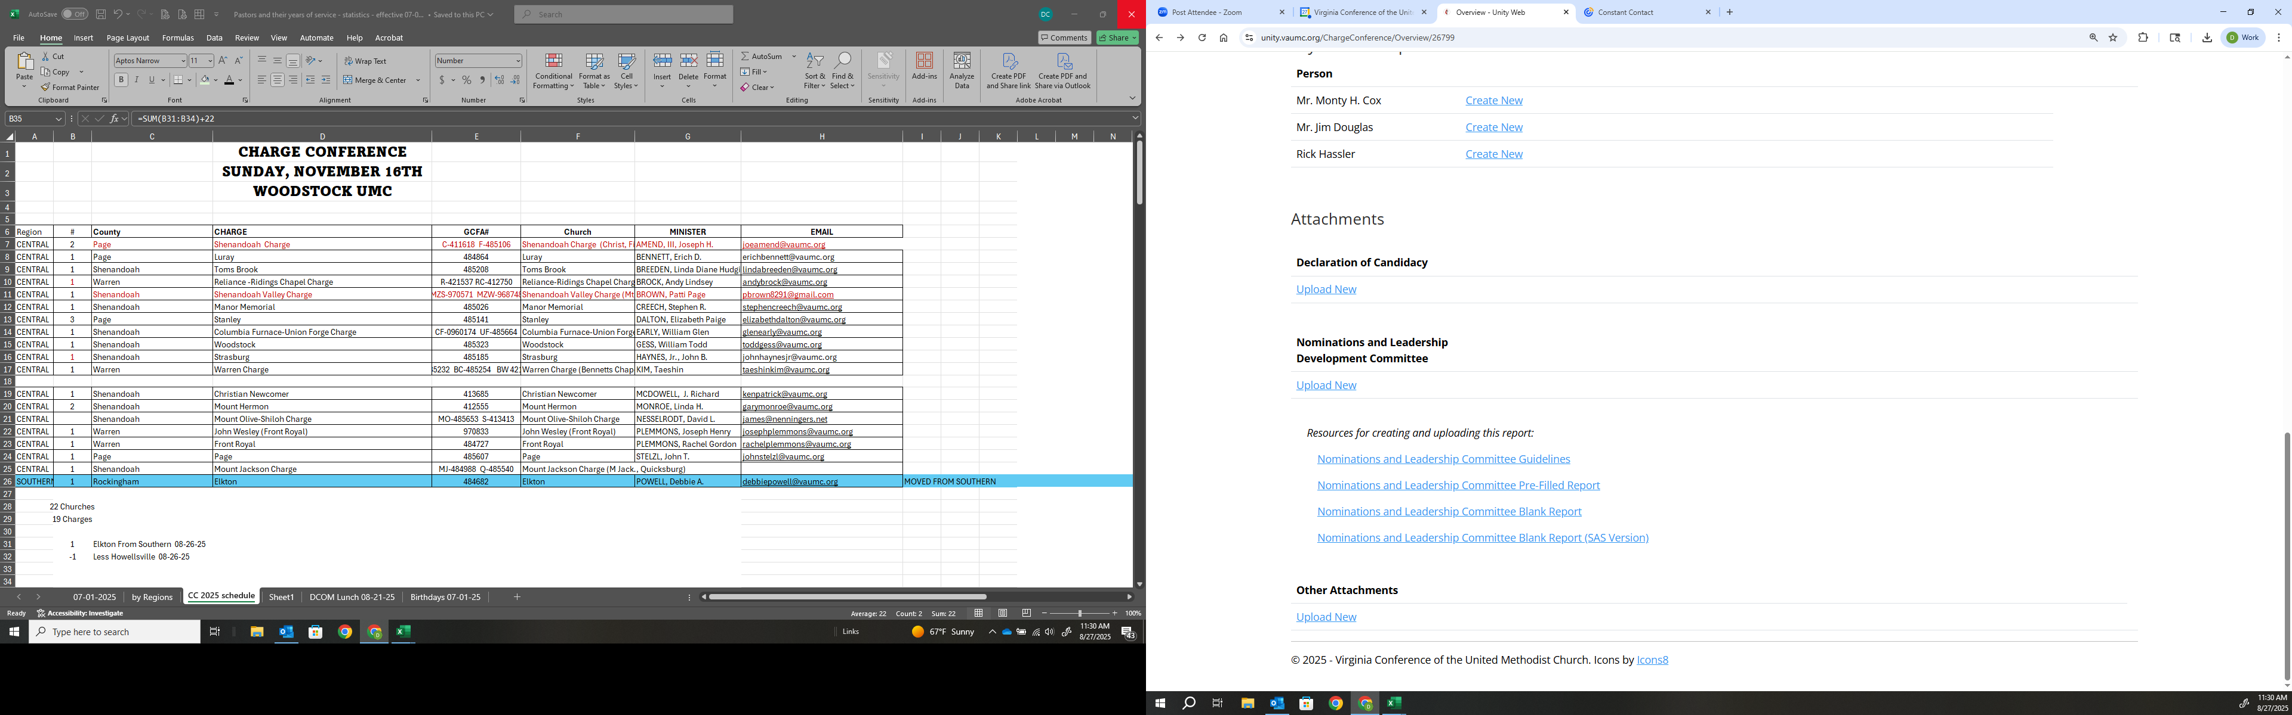

📞 Need help? Contact the District Office — we’re here to support you!

Don’t forget! Your paperwork has to be completed in Unity 10 days before the date of your charge conference to give us time to review your information BEFORE your charge conference.
We will discuss obtaining signatures on the forms at the September 9th Zoom!

