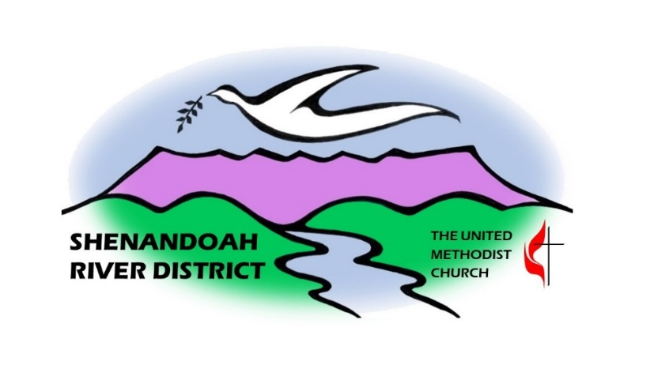

SHENANDOAH RIVER DISTRICT CALENDAR
Saturday, September 6th – 10:00 a.m. to 3:00 p.m. – VAUMC Discernment Day at Main Street UMC, 212 E. Main Street, Bedford, VA 24523
Sunday, September 7th - 2:30 p.m. - Installation Service for new District Superintendent, Rev. Dr. Kyungsuk Cho, at Front Royal UMC. The event will also be live-streamed
Tuesday, September 9th – 10:00 a.m. – Charge Conference Tutorial Zoom – preparing charge conference paperwork
Saturday, September 13th – begin at 9:00 a.m. - Fall District Lay Servant Academy at Macedonia UMC
Saturday, September 13th – 9:00 a.m. - Southern area UWF District Prayer Breakfast at Bridgewater UMC
Monday, September 15th – 11:00 a.m. - District Discipleship Team Meeting via Zoom
Tuesday, September 16th through Monday, December 1st – In Person Clergy One-On-One Sessions with DS Cho at designated places
Friday, September 19th 6:00 p.m. through Saturday, September 20th to 4:00 p.m. – Young Women’s Retreat at Camp Overlook
Saturday, September 20th – 4:30 p.m. to 7:00 p.m. – Latin Fundraiser for Just Neighbors at Braddock Street UMC
Thursday, October 2nd – 10:00 a.m. to 5:00 p.m. – Leadership Watch Party at Evergreen United Methodist Church, 19619 Evergreen Mills Road, Leesburg, VA 20175 (Space is limited to 20 participants)

Saturday, October 11th – 1:00 p.m. to 3:00 p.m. - Shenandoah River District United Women in Faith Racial Justice Retreat at Laurel Ridge Community College, Middletown campus
Monday, October 13th – 5th Annual Golf Classis sponsored by the VA United Methodist Foundation
Saturday, October 18th – 9:30 a.m. to 3:30 p.m. - UWF District Spiritual Life Retreat at Braddock Street UMC. “Tikkun Olam: Repairing the World through Story, art and Humor
Sunday, October 19th – 3:00 p.m. – Charge Conferences for the Eastern Location (Counties of Loudoun and Fauquier) at Bethany UMC (Purcellville)
Sunday, October 26th – 3:00 p.m. – Charge Conferences for the Northern Location (Counties of Clarke, Frederick and the City of Winchester) at Kernstown UMC
Saturday, November 8th – beginning at 9:00 a.m. - Work Day at Camp Overlook
Saturday, November 8th – 10:00 a.m. – Shenandoah River District Conference at Camp Overlook
Sunday, November 9th – 3:00 p.m. – Charge Conferences for the Southern Location (Counties of Augusta, Rockingham and the City of Harrisonburg) at Dayton UMC
Sunday, November 16th – 3:00 p.m. – Charge Conferences for the Central Location (Counties of Page, Shenandoah and Warren Counties) at Woodstock UMC

Articles for Downriver Devotion, Mission Central, Equipment for Caring, Kingsway Prison and Family Outreach, Randolph Macon Academy are now printed in our Bi-Monthly Eblast! Don’t forget – if you have a good news story to share, please email your article to DebbieCreech@vaumc.org.

