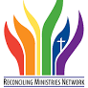
Where are the Reconciling Ministries in the VA Conference?
You can narrow the search to Reconciling Campus Ministry, Reconciling Church, Reconciling Community and Regional Reconciling Community. Altogether there are 43 groups.
https://rmnetwork.org/find-a-reconciling-ministry/

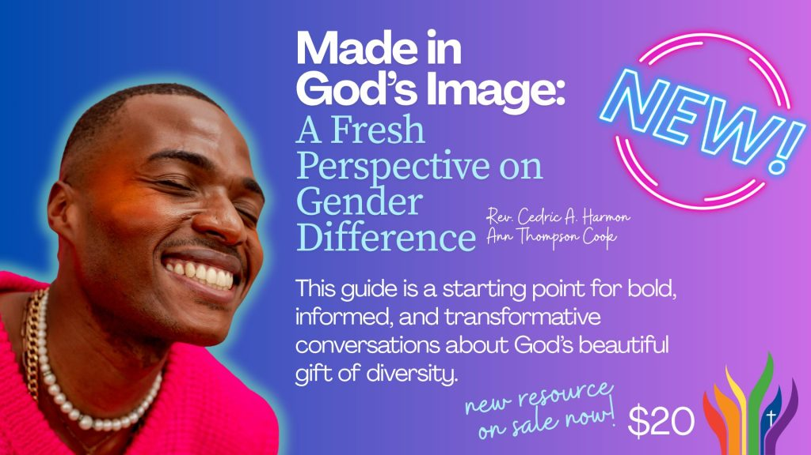
New Resource: Made in God’s Image: A Fresh Perspective on Gender Difference Author: Rev. Cedric A. Harmon & Ann Thompson Cook Resource: Link to purchase on the RMN website:
https://rmnetwork.org/resources/made-in-gods-image/
About this resource: Price: $20 | Print-on-demand PDF download Audience: Congregations, Ministries, LGBTQ+ advocates, pastors, and congregations seeking inclusive theological resources. A note from the authors: You, like many of us, may have questions about gender and wondered where to turn. We offer this guide as an introductory resource to help you begin finding answers.
We hope it will provide you and your church, family, neighbors, and communities an opportunity to engage in informed, bold, and transformative conversations about God’s wonderful gift of diversity.
Laura Douglass, DFC-retired lauradouglass@vaumc.org

