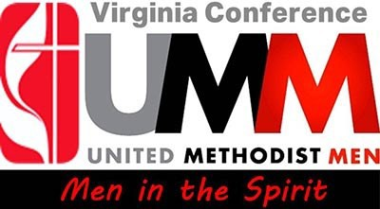

**$10.00 PER MAN PER YEAR**

**The Virginia Conference United Methodist Men seek to support:**

**Heart Havens**

**Grace Inside**

**Scouts**

**All God’s Children Camp**

**Black Methodists for Church Renewal**

**Asian American Ministries Association**

**Camp Rainbow**

**Native American Caucus**

**Society of St. Andrews**

**Latino/Hispanic Caucus**

To accomplish this, we are asking **each man** in the Virginia Conference to donate

**$10.00 per year**. With your help, this would provide sufficient funds to send each

of these ministries a generous donation!

***What a great way for the men of our Conference to join in support!***



4 DONATION OPTIONS:

Mail a check to our treasurer

Gary Lupton, 1661 Hawks Bill Drive, Virginia Beach, VA 23464

Please make your check payable to Virginia Conference United Methodist Men.

Text Giving

Text UMM2024 to 44-321 and you will be directed to our campaign.

Online Giving

[www.vaumc.org/umm-support](http://www.vaumc.org/umm-support)

QR Code Giving