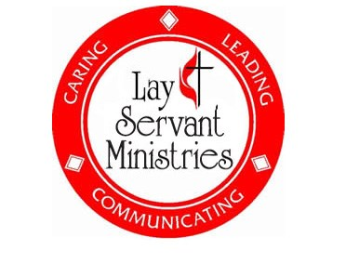
LAY SERVANT REPORT
There’s good news—and more good news—about the upcoming Shenandoah River District Lay Servant Academy, scheduled for Saturday, September 13 at Macedonia United Methodist Church.
The first good news: More than thirty participants have already registered to grow in their discipleship and strengthen their spiritual gifts.
The second good news: There’s still time for you to register! The deadline is Friday, September 5. View the class lineup and register here:
👉 Lay Servant Academy Registration
If you sign up for the Basic Course, the District Lay Servant Ministries Committee has waived your $20 registration fee and reimburse you for the textbook. (Please email your receipts to debbiecreech@vaumc.org)

Schedule for the Day
- 8:15 a.m. – Check-in and breakfast in the sanctuary lobby
- 9:00 a.m. – Worship led by District Superintendent Kyungsuk Cho, including Holy Communion
- 10:00 a.m. – Class sessions begin
- 12:00 p.m. – Lunch (sandwich meal, free-will offering)
- 12:45–4:00 p.m. – Afternoon class sessions

A Few Important Notes
- Expect to hear from your instructor soon with details.
- Please purchase and read your book before class (some pre-class homework may be required).
- Certified Lay Speakers: Be sure to check when you last completed an advanced class so you can keep your certification current.

Wendell Cochran

