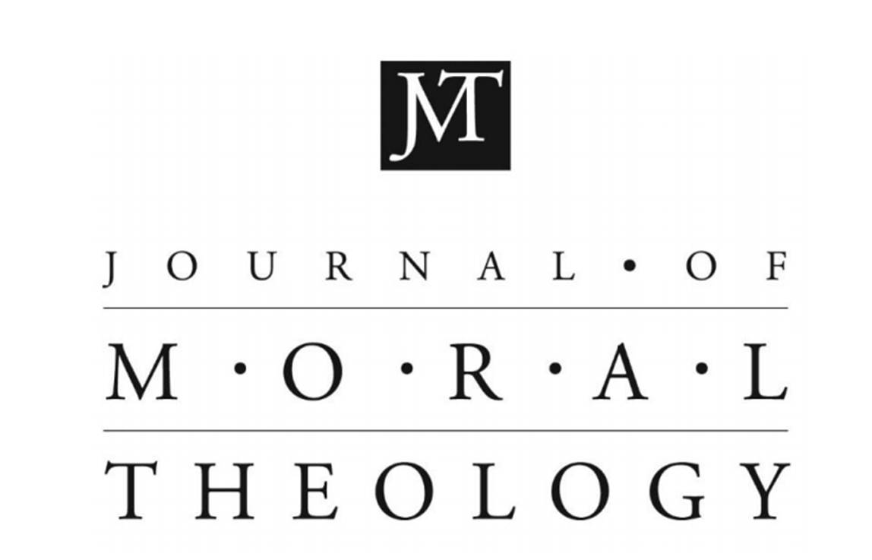
Call for Papers
The Journal of Moral Theology is looking for papers presented at concurrent sessions of the Third International Conference of the Catholic Theological Ethics in the World Church, help in Sarajevo 2018.

- The Journal of Moral Theology is looking for papers presented at concurrent sessions of the Third International Conference of the Catholic Theological Ethics in the World Church, help in Sarajevo 2018. This call is open until July of 2019.
- Typical papers for the journal are between 9,000-14,000 words. However, for this call, shorter papers between 3,000-5,000 words also will be considered.
- All papers are peer reviewed by the journal, but papers from the concurrent sessions of the CTEWC conference will be given extra consideration. Please note on the submission cover page that the papers come from the CTEWC conference.
- The journal is English language, so papers must be submitted in English.
- Please send submissions to Jason King, the editor, at jmt@msmary.edu. Any questions regarding submissions should be directed toward him as well.
- Submission information can be found on the Journal of Moral Theology website. Accepted papers would appear in subsequent issues of the journal, published every January and June. Papers may also be gathered in a single volume of the journal.
- The journal is a print journal but also online and open access. Thus, it is available to readers from around the world. More information on the journal and previous issues can be the found on the website of the Journal of Moral Theology. Previously published essays can also be found here.

