Report from the Indonesian Moral Theologian Forum
Dionius Bismoko
The meeting of seven (7) moral theologians in Surabaya (July 19-22, 2023) can be said to represent “most” of the (Catholic) philosophy-theology schools or faculties in Indonesia. There were 6 out of 10 representatives from schools or faculties could attend.
We began the discussion by sharing our experiences as moral theologians, from study assignments from our superiors or bishops to pursue Master's or doctoral degrees abroad, to moral theological interests that have developed until now. We found that our own moral theological interests extend close to what was studied when writing a thesis or dissertation. As Antonio Autiero shared, more or less, moral theology reflects our personal and intellectual autobiography. What we are concerned about grows out of our process of dialoguing with our personal experiences and moral-ethical issues that "move" or "bother" us (to borrow Irish moral theologian Enda McDonagh's term: "moral tugs") in our own societal-ecclesiastical context.
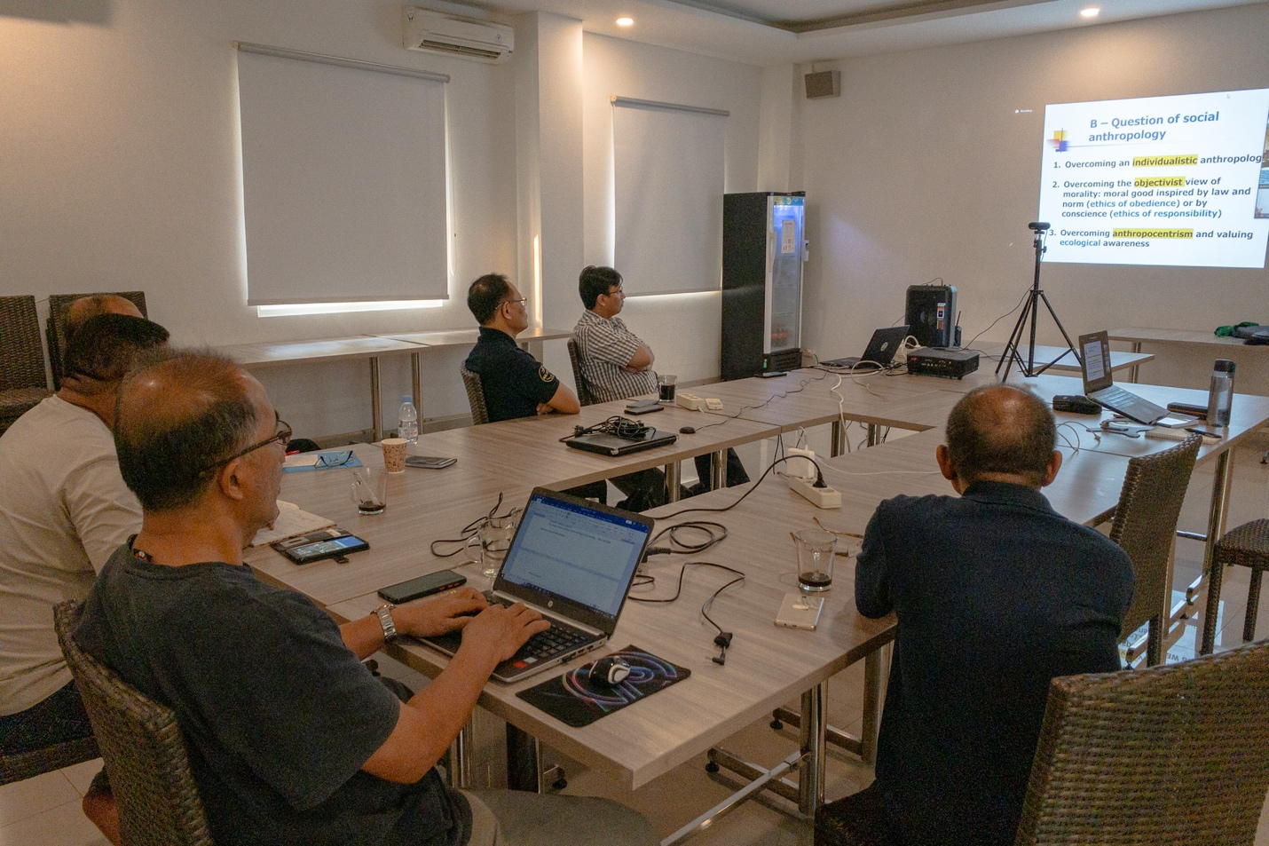
However, Indonesian moral theologians cannot just "occupy themselves" with responding to the Indonesian situation. To enrich perspectives, it is necessary to network with moral theologians from various parts of the world. Therefore, we invited Antonio Autiero, a senior moral theologian and professor emeritus from the University of Münster, Germany, to share his experience. Starting from the story of his academic "formation" as a moral theologian, Autiero then explored three major "trends" in moral theology (epistemological issues, social anthropology issues, and existential anthropology issues). These three "trends" become the "playgrounds" where moral theologians respond to moral-ethical issues. Finally, Autiero shared his experience of synodality in the context of the German Church.
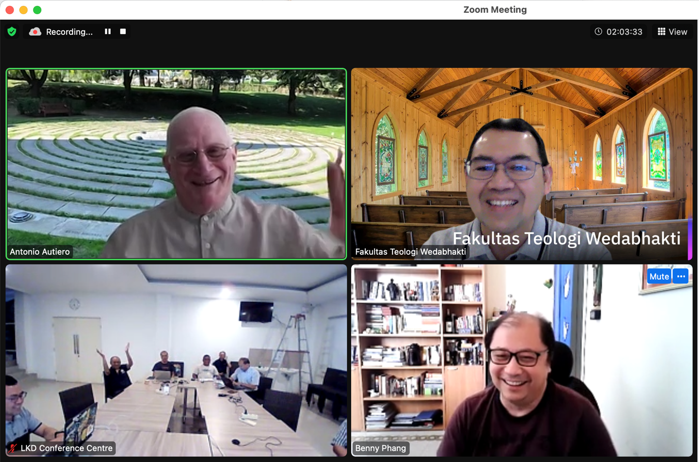
From sharing personal experiences, we then brainstormed ideas on how the dynamics of this moral theologian "club" could continue, involving other colleagues. This club is expected to support each other's struggles and intellectual growth and contribute to the Indonesian Church, especially as a journey companion for people in building (fostering) Christian life. A program for the next year was agreed upon to realize this goal.

