HEKIMA INSTITUTE OF PEACE STUDIES AND INTERNATIONAL RELATIONS
14 FEBRUARY 2020
2:00 to 4:30 p.m.

BOOK LAUNCH:
STREET HOMELESSNESS AND CATHOLIC SOCIAL ETHICS
(James F. Keenan and Mark McGravy, eds., New York: Orbis Books, 2019)

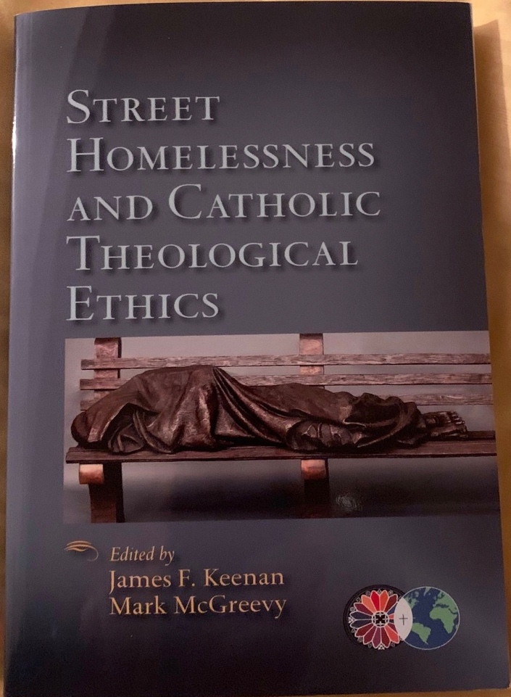
On behalf of the Institute of Global Homelessness (IGH) at DePaul University Chicago, the Catholic Theological Ethics in World Church network (CTEWC), and the Hekima Institute of Peace Studies and International Relations (HIPSIR), we would like to invite you to attend the launch of Street Homelessness and Catholic Theological Ethics. “This amazing and original collection shines a light on a problem so pervasive we no longer see it, much less regard it as an emergency” (Lisa Sowle Cahill). The launch will take place at HIPSIR, on Riara Road, in Nairobi, Kenya on the Friday, 14th February 2020 from 2:00 to 4:30 p.m.
Program
MC: Dr. Elisee Rutagambwa, S.J.
2:00 p.m. Registration
2:30 p.m. Opening Prayer by Rev. Fr. Dr. Kifle Wansamo
2:35 p.m. Word of Welcome by Dr. Elisee Rutagambwa
2:40 p.m. Presentation by Rev. Sr. Dr. Wilhelmina Tunu
3:10 p.m. Dr. Elias Opongo, S.J., Catholic Social Teaching in context
3:40 p.m. Discourse session. Rev. Toussaint Kafarhire, S.J.
4:10 p.m. A Word by Dee Mansi (AIC member/Systemic Change

Commission member).

4:25 p.m. Vote of Thanks by Sr. Ann Achieng
4:30 p.m. Closing Prayer by Rev Dr. Peter Knox, S.J.
Followed by Group Photo

For Contact and Inquiries: Dr. Toussaint Kafarhire, S.J. Africa Coordinator of the Catholic Theological Ethics in World Church. Tel: +254 705397133; Email: kafmurhula@gmail.com

ALL ARE WELCOME

