Demystifying Academic Life: What No One Tells You
Friday, February 27 | 12:00 PM Eastern Standard Time
Live on Zoom | FREE
Academia comes with a hidden curriculum. This webinar pulls back the curtain.
Demystifying Academic Life: What No One Tells You focuses on the realities of publishing, service and leadership expectations, balancing research and teaching, and navigating promotion and tenure. Designed for doctoral students, early-career scholars, and faculty seeking greater clarity, this conversation offers practical insight into what it truly takes to build and sustain an academic career.
Panelists:
K. Jurée Caper
Associate Professor & Director of the Master’s Programs | Georgia State University
Cullen Merritt
Associate Professor & Research Director, Institute for Public Leadership | University of Maryland
David Van Slyke
Dean, Maxwell School of Citizenship and Public Affairs | Syracuse University
Nicole Diggs
Assistant Professor | North Carolina Central University
Register here:
https://us02web.zoom.us/webinar/register/WN_njGSCbpyS5GmsdCvj2e1hg#/registration
Scan to register:
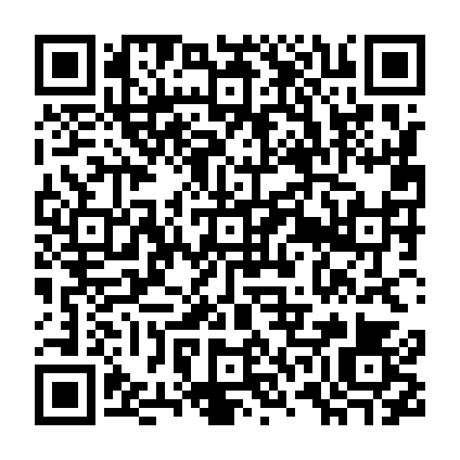
Join us for an honest, practical conversation about the parts of academic life no one formally teaches—but everyone needs to understand.

