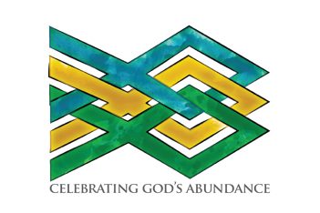
From the Transition Committee:
Meet and Greets
and Collecting Questions for the Candidates

The Transition Committee has planned three “Meet and Greets” at the beginning of November to allow delegates to the convention (to be held November 14-15) and other interested members of the Diocese to meet and hear from the three individuals presented as candidates for Bishop of Western Massachusetts.

During the Meet and Greets, a variety of questions will be asked of the nominees so that attendees may get to know them. We are currently soliciting questions to be used at these events. Questions may be submitted via the link on the Bishop Search and Transition page on the Diocesan website, found at https://www.diocesewma.org/bishop-search-and-transition

Meet and Greets are scheduled as follows:
Tuesday, November 4
All Saints Episcopal Church, 10 Irving St., Worcester, 6:00pm
Wednesday, November 5
St. Stephen’s Episcopal Church, 67 East St. Springfield., 6:00pm
Thursday, November 6
Christ Church Cathedral, Pittsfield, 6:00pm
A casual reception at 5:30pm will give lay delegates to the convention an opportunity to meet the candidates. The formal program will begin at 6pm. Clergy will soon receive an invitation to a separate opportunity to meet the candidates in an informal setting.

All venues are handicapped accessible and have ample parking.

A video recording of the question and answer portion of the November 4 Worcester event (with closed captioning in English and Spanish) will be available on the Search and Transition webpage shortly after the Meet and Greets.

A livestream of the November 5, Pittsfield event will be available through the diocesan website.

ASL and Spanish simultaneous interpretation will be available at the November 6 Springfield event.

For more information see our Frequently Asked Questions page.

All are welcome!

The Rev. Samuel J. Smith The Rev. Mary Rosendale
Rector, All Saints’ Church, Worcester Rector, St. Stephen’s Church, Westborough
Chair, Transition Committee Chair, Meet and Greets

