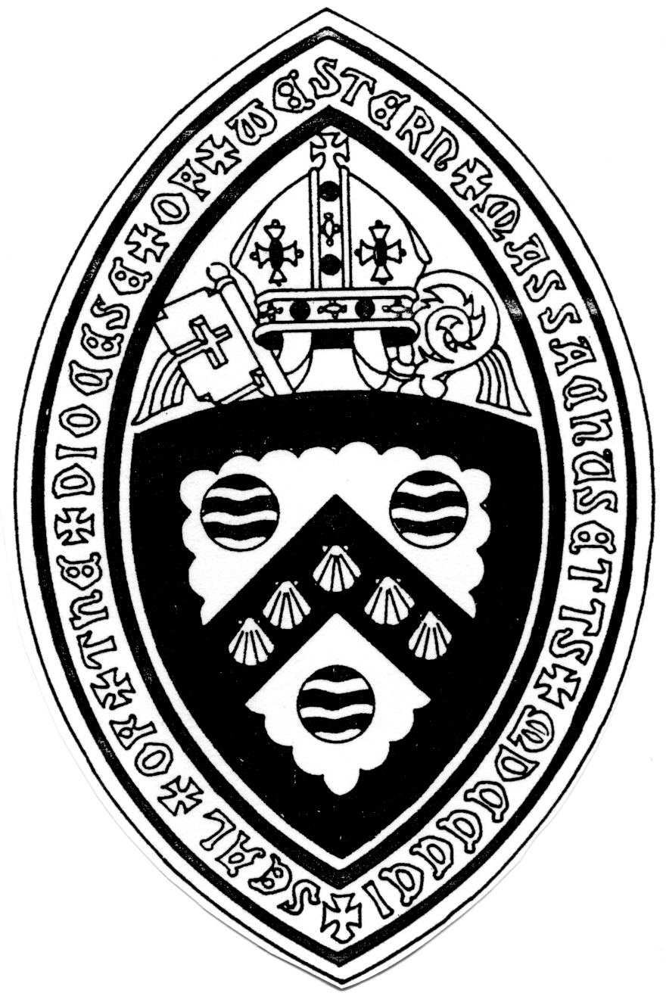
The Bishop’s Easter Message
A few weeks ago at the Grammy Awards, Jon Batiste won several awards. In his acceptance speech he said: “For me, music is a spiritual practice. Music reaches people when they need it most. It’s like a song is made and has radar to find a person when they need it most.”
What a beautiful statement. I’ve been reflecting on that going into this Easter. In the four gospels we are blessed with several different stories about the Resurrection of Jesus. There is no “one way” to describe this reality. Let’s look at a few of these accounts and as we do see which is the one you most need for Easter 2022.
John’s gospel has several resurrection stories. In the first one we are told “Early on the first day of the week, while it was still dark, Mary Magdalene came to the tomb.” While it was still dark, Mary Magdalene took the faithful action of going to the tomb and when she gets there she is confused that the tomb is empty. She asks the gardener where the dead body of Jesus is.
We live in difficult times. Our country is divided. The sin of racism is very much with us. We don’t seem to be doing anything to stop climate change or gun violence. The war in the Ukraine reminds us every day of evil in our world. In difficult times Mary stayed faithful and into the darkness comes the Risen Jesus offering new possibilities. Maybe that is God’s song that we need to hear now.
Or maybe it is the story later that day in John’s Gospel. The disciples are gathered but Thomas is not with them. The Risen Jesus appears offering the fearful apostles peace. When the disciples tell Thomas of this visit, he insists he will not believe until he can touch the wounds of Jesus. You see, Thomas doesn’t want a transcendent , angelic Jesus. He wants a Jesus who will take the wounded of the world with him. And when he sees the Risen Jesus with his wounds, he speaks from his soul with the words “My Lord and my God.” Do you need to hear this year that our Lord, our God embraces the wounded of this world?
Still, another Resurrection story from John that might be speaking to us this year. After the Risen Jesus has been with the disciples for a while, Peter is feeling guilty. Remember on the day of crucifixion Peter denied knowing Jesus three times. Now Peter is having a hard time sharing in the joy of new life because he is holding the guilt of the old life. So Jesus asks Peter three times if he loves him. And Peter responds “yes” three times. Could it be that Jesus is freeing Peter from his guilt? If we need to be forgiven, really forgiven, and to be set free to be truly alive, this story could be the one we need to hear this Easter season.
There are so many stories of the Resurrection in Mathew, Mark, Luke and John. Let’s check in on just two more to see if those are the ones written for us this Easter.
In Luke’s gospel the women go to the tomb to anoint the body. The body of Jesus is not there but two men in dazzling clothes are. The women are terrified. The men say tell them Jesus is risen just like he told you he would. “Remember how he told you, that the Son of Man would be handed over to sinners, and be crucified and on the third day rise again.” And the women remembered and went to tell the disciples.
Is this Easter a time we need to remember? To remember all the grace there has been in our lives. All the amazing grace? Sometimes in sermons I do an exercise my spiritual director has taught me. I ask the congregation to close their eyes and envision everyone who ever loved them - living and dead- including pets. Imagine them all looking at you with love. Maybe the gift of this Easter is to remember that. And while we are at it, know, really know, that love is stronger than death.
Ok. Last one - from Mark. There is no appearance of the Risen Jesus in Mark. The last story in the original text is the women going to the tomb, the body is not there, a young man in a white robe tells them don’t be afraid. Jesus is risen. Go and tell the disciples. Don’t be afraid. Tell the disciples. The last line of the gospel as it was written in the original Greek is “They we are afraid and said nothing to anybody because…”
No period at the end of the sentence. The readers are left hanging. And then we remember the very first sentence in Mark’s Gospel. “The beginning of the good news of Jesus Christ, the Son of God.”
Mark is brilliant. The good news of Jesus begins and it never ends. The Jesus Movement begins and invites us all - the fearful, the wounded, the sinners who don’t feel forgiven, those who don’t remember how blessed they are - everyone is invited to the newness of life offered by the Risen Jesus. Amen.

