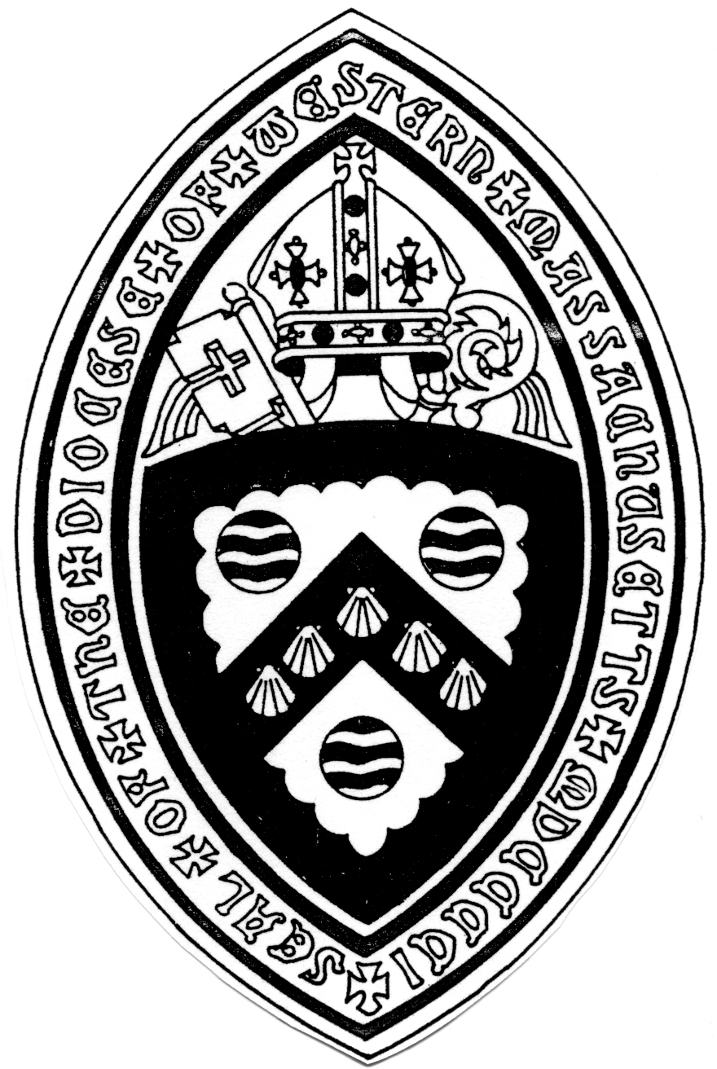

The Bishop’s Address to the 119th Diocesan Convention

November 7, 2020

The mission continues. Let us run with endurance the race that is set before us.

At our Convention last year (which seems like 100 years ago), I told a story about Michael Curry. We were in Providence for a large national gathering of deacons. Michael was giving the keynote address and he was preaching about St. Paul. He said "wherever St. Paul went there was a revolution, a revolution. When he went to Corinth there was a revolution. When he went to Phillipi, there was a revolution." And then Michael started pointing out bishops in the crowd. He would say the bishop's name and then he would say "what would it look like if there was a revolution in your diocese” And he would name the diocese. He did this four times. Name of the bishop and what would it look like if there was a revolution in your diocese? Then he calls me out. "Doug, what would it look like...oh, wait, there is already a revolution going on in Western Massachusetts."

I was never so proud of our Diocese!

Now a year later. We find ourselves in the midst of a pandemic. Stress and anxiety are everywhere. Clergy and lay leaders feel it. As do health care workers, teachers, parents of school age children, owners of small businesses, the unemployed and so many others. The pain I felt the most has been our inability to be with our loved ones when they were dying and then having to severely limit the number of mourners who could attend the funeral. The Episcopal Church is far from perfect but something we are really good at is pastoral care for the sick and the beautiful Prayer Book burial where we say that “life is changed not ended” and “into your hands, O merciful Savior, we commend your servant.”

And there is so much about church that we miss. Like seeing each other in person. Holy Communion. Choirs.

Add in an election that does not seem to end. In a deeply divided country with two vastly different visions for our future.

So what does a revolutionary diocese like Western Massachusetts do in this deeply challenging time?

The revolution, the Jesus revolution, always begins with a radical commitment to faith. I have three "go to" prayers in these days. One comes from the Prayer Book for use on All Saints Day. But I use it every day.

"In the multitude of your saints you have surrounded us with a great cloud of witnesses, that we might rejoice in their fellowship and run with endurance the race that is set before us. And together with them, receive the crown of glory that never fades away."

We didn't pick this race. But it is the race that is set before us. We don't run it alone. We are surrounded by the great cloud of witnesses that testify to the faith and to staying faithful. Who is in your cloud of witnesses? Bring them to mind. They are running this race with you.

My other go-to prayer is from Dr. Martin Luther King Jr.

"God, we thank you for the inspiration of Jesus. Grant that we will love you with all our hearts, minds and souls, and love our neighbor as ourselves, even our enemy neighbors. And we ask you God, in these days of emotional tension, when the problems of the world are gigantic in extent and chaotic in detail, to be with us in our going out and our coming in, in our rising up and in our lying down, in our moments of joy and sorrow."

Dr. King preached over and over again about “blessed assurance.” “Blessed assurance” that God is always present. And he felt that presence most clearly and deeply in the most fearful, anxious moments of his life.

And here's one more. "Never be afraid to trust an unknown future to a known God." We boldly proclaim we know God in the person of Jesus. Jesus who forgives, heals, feeds, lifts up, blesses, dies and rises. Never be afraid to trust an unknown future to a known God. You are more resilient than you think because you are in the hands of a death conquering God. Resurrection is not just for the end of life. Resurrection happens throughout life when we fall and get up again.

The revolution will mean love of neighbor. We did a survey of our churches asking how they are addressing the needs of their neighborhoods during the Covid-19 pandemic. 39 of our 51 churches responded. Here is what love of neighbor looks like:

* 37 congregations have assisted their local food bank
* 28,000 meals were prepared, served and delivered by our congregations
* 22 congregations collaborated with mission partners by giving financial support totaling $138,000
* 8 people were sheltered
* 1,200 care packages for people experiencing homelessness
* 105 backpacks were made for those leaving prison
* Rector's discretionary funds accessed for the vulnerable - $40,000
* Over 1600 masks were made and donated
* Over 50,000 diapers and hygiene products given away
* Hundreds of gift cards to local grocery stores given away
* Several parish halls used for Wi-Fi by students who do not have that at home
* Home repairs for 5 families
* A farmers market that served 6400 customers
* 50 blankets for babies in neonatal care at Baystate
* 200 school uniforms for children in Haiti

That is all done by individual churches. On a diocesan level through Human to Human we are supporting lunches for veterans, Walking Together in Worcester, laundry love and recovery programs. Living out Matthew 25 is part of the revolution in Western Massachusetts.

The revolution demands racial justice and dismantling white supremacy. For several years now we have had a very active Beloved Community Commission here. The tragic events of 2020 have shone a light on 400 years of racial injustice and made their work more important than ever. More than ten of our parishes have actively engaged in education programs such as Sacred Ground. We offered a webinar to our clergy and lay preachers about how to preach racial justice. Early on in the pandemic, Laura Everett, the Executive Director of the Mass Council of Churches said she feared that at the end of this, only the white wealthy churches would be left standing. She started a One Church fund to help black urban churches from a variety of denominations. Our Diocese donated $15,000. And there is so much more to do. Come Holy Spirit.

Next week I will ordain two transitional deacons. Both are people of color.

And we have doubled down on our commitment to starting new Episcopal Latino faith communities. There will be more about this later in the Convention.

I spoke before about the great cloud of witnesses running this race with us. One of them is a local saint. Jonathan Daniels, born and raised in Keene, New Hampshire. He went to the Virginia Military Institute and there heard a call to ordained ministry. He went to Episcopal Divinity School in the 1960’s. Dr.King invited clergy from the north to come and work with him in the south. With other students, Daniels went to Alabama as a volunteer for a few days. At first he was not particularly moved by the experience but he missed the bus going back to Boston. It meant he had to stay another week and in that week he recognized the injustice of segregation and the Jim Crowe laws. When he returned to the seminary he asked for a year off to work in Alabama. He did great work integrating an Episcopal Church in Selma. With others he was arrested at a protest and jailed in Haynesville Alabama. They were released after a week and went to buy sodas at a local store. A man with a gun stopped them and aimed his gun at a black teenager named Ruby Sales. Jonathan realized he was going to shoot so he threw himself in front of her, taking a bullet that killed him. A martyr at 26. His writings include this: “I began to know in my bones and sinews that I had been truly baptized into the Lord’s death and resurrection...with them, the black men and the white men, with all life, in him whose Name is above all names that the races and nations shout...we are indelibly and unspeakably one.” Jonathan is with us now in the great cloud of witnesses.

In 2020 we have witnessed unprecedented climate events showing us that climate change is not in the future. It is now. Because of the prophetic voice of Margaret Bullit-Jonas and others, our diocese has long been a leader in Creation Care. That work is urgent.

During the pandemic, more guns have been purchased than in any six month time frame since records have been kept. Bishops United Against Gun Violence continues to work diligently for gun safety through legislation and inviting gun manufacturers to become part of the solution.

I have said often in 2020 “although most of our church buildings are closed, the mission of the church is wide open.” I am so inspired by our clergy and lay leaders who have adapted over and over again to provide pastoral care and worship. I get how hard this is. And there are more challenging months to come. Thank you for your resilience. Your commitment to doing the most loving and safe thing. Whatever the tragic toll of this virus will ultimately be, the numbers will be less because of you.

Learning the technology of getting together for worship on zoom or YouTube live or video streaming is so challenging. Thank you for engaging that challenge. And to help you in that effort, we are starting a new financial initiative. From diocesan funds, we will reimburse any parish that upgrades their digital communication capacities up to $2000. We want to encourage you in proclaiming the Gospel with the best resources available.

And the revolution is continuing in our diocese through the development of lay leaders. Jane Griesbach and Meredyth Ward are teaching 40 people how to lead Morning Prayer. Rich Simpson and a team are training 12 new lay preachers with another class of 12 or follow. Jenny Greg has led the Loving the Questions program for several years now. It is an in-depth process to help participants discern how they are called to serve. Most years there are 5-10 people in this program. In 2020 there are 26. And I'm grateful to Pam Mott who has promoted the training of coaches in our diocese. We all need coaches to help us make decisions in this ever changing environment and now they are available as a holy resource.

We live in hard times. But the Church has gone through hard times before. The church was born in hard times. St. Paul describes it in his second letter to the church at Corinth:

“We proclaim Jesus Christ as Lord...For it is God who said ‘Let light shine out of darkness,’ who has shown in our hearts to give the light of the knowledge of the glory of God in the face of Jesus Christ.”

“But we have this treasure in clay jars, so that it may be made clear that this extraordinary power belongs to God and does not come from us. We are afflicted in every way, but not crushed; perplexed, but not driven to despair; persecuted, but not forsaken; struck down but not destroyed. Always carrying in the body the death of Jesus, so that the life of Jesus may also be made visible in our bodies.”

I’ll end this Convention address with one more Saint and what the early church did in tough times. It is at the end of the fourth chapter of The Acts of the Apostles. A man named Joseph of Cyprus joined the apostles. And the apostles renamed him. They gave him the name Barnabas, which means “son of encouragement.” You see, the apostles knew what they needed. They needed a son of encouragement.

We live in challenging times. What would happen if everyone here at this Convention promises to be a son or daughter of encouragement in our churches, in our communities, in our families? It might be revolutionary.

The mission continues. Surrounded by the great cloud of witnesses my we run with endurance the race that is set before us and with them receive the crown of glory that never fades away.

Amen.