Directions and Parking Suggestions

[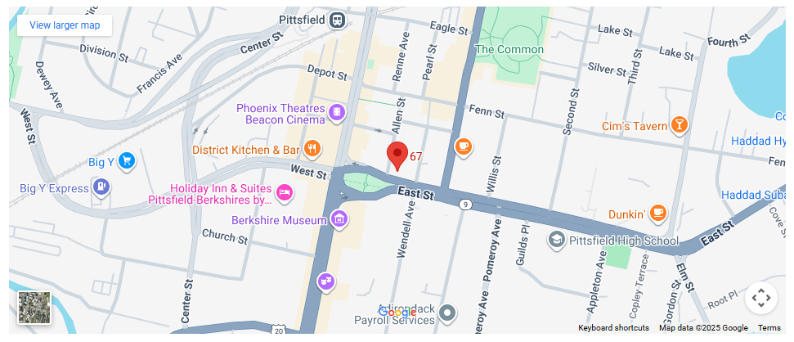](https://www.google.com/maps/place/67+East+St,+Pittsfield,+MA+01201/@42.448548,-73.252401,16z/data=!4m6!3m5!1s0x89e74e4784f95791:0x778a4cfa03f3b093!8m2!3d42.448548!4d-73.2524006!16s%2Fg%2F11snnll5hl?hl=en-US&entry=ttu&g_ep=EgoyMDI1MTAwMS4wIKXMDSoASAFQAw%3D%3D)

Some Parking Options

* **Around Park Square**: In front of the former Berkshire Athenaeum and Patrick’s Pub (south), Old Town Hall (west), and Otto’s (east). There are several spaces here, but they fill up fast. Payment is required on weekdays from 8 a.m. to 4 p.m.
* **On-street parking**: around the block on Allen Street, Federal Street, and Wendell Ave extension. A few spots are also available on Fenn Street. All but Allen Street require payment on weekdays from 8 a.m. to 4 p.m. Allen Street spaces, though free,  do have a 90-minute limit on weekdays from 8 a.m. to 4 p.m.
* **The large parking lot across from Pittsfield Commons**: Drivers can enter from First Street, Fenn Street, or Pearl Street. Most spots have 90-minute limits, some 3 hours – no limits or payments on Saturdays/Sundays/Evenings.
* **City of Pittsfield’s interactive parking map**: visit [this resource](https://www.google.com/maps/d/u/0/viewer?mid=1uBaG4O9iboZYDp9HvzibOYsvisc&ll=42.45087284558242%2C-73.25250148280331&z=17) for additional information.