**Hello and welcome to my homepage last**

**updated February 28, 2021**

Hi, I'm **Ernie Barsamian** and thanks for dropping by my homepage. As you can see, I am a novice at creating a webpage but it has been a fulfilling experience nonetheless.

**So who is Ernie Barsamian ?? (and who really cares???)……………**

I was born and raised in **West Roxbury, MA**andgraduated from the **Roxbury Latin School**in 1977 and the **University of Pennsylvania** in 1981 (BSE in Chemical Engineering but don’t ask me any thermo questions). At Penn, I was a member of **Sigma Nu fraternity**. Following Penn, I worked in Sudbury, MA, Enfield, CT, Keasbey, NJ and Danbury, CT for the Union Carbide Corporation. I was in their Linde Division which is now its own company è Praxair. During my time with them in NJ, I played semi-pro football for the New Jersey Oaks. Following all of that fun getting dirty in the plants and on the football field, I went back to graduate school and received an MBA in Financial Management from the **Wharton School of the University of Pennsylvania in 1987**. After all that nonsense, I was married to Jeanine Hearne in 1988 and we now have 3 sons ages 30, 29 and 26.

Since then I was employed with**Hess Corporation** in a variety of different functions. One of the most interesting was a 2-year stint at their refinery in **St. Croix, USVI** shortly after we were married!  I recently retired from Hess after a 28 year career.  Now I have my own company:

[www.thetanktiger.com](http://www.thetanktiger.com/)

Let me know what you think about it!

**I invite any fellow alums, former worker buddies and old friends to drop me a line and let me know what you're up to.**

**All in all, it’s been great so far!**

***So what do I do for fun …here are some of my Hobbies and Interests:***

* Weight Training è Personal best on October 9th, 2006 with a bench press of **385 lbs**.  I can still rep out at 315 lbs.  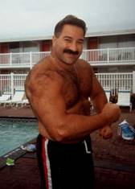
* Check out the video: [55th birthday - 315 lbs x 5 reps - YouTube](https://www.youtube.com/watch?v=GPRTKCcnagk)
* Golf (I shoot around 100, play only 3 times a year but I usually average one beer per hole).
* College football investing
* Gardening …Vegetables..if you can’t eat it, I don’t grow it
* Drinking beer.
* Music, mostly ***Bruce Springsteen.*** I've seen him in concert 60 times:
* ***My first concert was August 1978 in Providence, RI***
* ***Born in the USA Tour August 1984 at the Meadowlands***
* ***Tunnel of Love Tour May 1988 at Madison Square Garden***
* ***HT/LT Tour August 1992 at the Meadowlands.***
* ***Reunion Tour July 29, Aug 6 and Aug 9, 1999 at the Meadowlands, August 21, 1999 in Boston, Sept 15 and Sept 25, 1999 in Philadelphia, May 7, 2000 in Hartford, June 17, 22, 26 and July 1, 2000 at Madison Square Garden.***
* ***Special Shows: December 17, 2000 in Asbury Park. May 27, 2001 at the Stone Pony, August 18, 2001 at the Stone Pony and December 6, 2001 in Asbury Park.***
* ***Rising Tour:  I attended the rehearsal show on July 30, 2002  in Asbury Park and the August 7,2002 show at the Meadowlands and Philly Oct 6, 2002 and Atlantic City March 7, 2003.  The Rising summer was the summer of Bruce...I was at 6 shows at Giants stadium...7/15, 7/18,  7/27, 8/28, 8/30 and 8/31 and at the Philadelphia show on 8/8.   I also went to the Shea Stadium finales on October 3 and 4th  AND in Asbury Park for the Christmas Shows December 5 and 8th!***
* ***Vote For Change: In 2004 I went to the October VFC shows in Philly and in NJ.***
* ***Devils & Dust In 2005 I was at the 2nd Asbury rehearsal and at the Meadowlands shows on  May 19, 2005 and November 16, 2005.  I was also at the tour finale in Trenton on November 22, 2005 and the Seeger Sessions Tour April 26 in Asbury Park (final rehearsal).***
* ***September 28, 2007 Magic Rehearsal at Continental Arena and the October 10, 2007 show there as well.***
* **The three Giants Stadium shows in the summer of 2008!**
* **April 28th and 29th in Philly.**
* **May 21st, 23rd and 30th, 2009 at the Meadowlands (Izod Center)**
* **September 30, October 2 and October 3rd 2009 and October 9th at Giants Stadium..."the last blast!".  And the Spectrum on October 20th.**
* **Wrecking Ball Tour...so far I have seen the Meadowlands, Philadelphia and Newark shows...bring on your Wrecking Ball!  Attended the Philly show on Sept 2nd ,the MetLife show on Sept 19 and the Houston show on May 6th.**
* **The River Tour - Newark and Philly shows in 2016 plus the summer 2016 Meadowlands and Philly shows as well.**
* **Springsteen on Broadway - November 10, 2017**

**OTHER HOBBIES**

* Backyard astronomy..
* Coin collecting (pennies, nickels, dimes, quarters, halves, dollars – all US).
* **Sports Fan**: **New England Patriots**, Boston Red Sox , Boston Celtics, Ivy league football and Ivy League basketball ***(Let's Go Quakers!).***
* This is a YAZ, the best clutch hitter of all time**:**

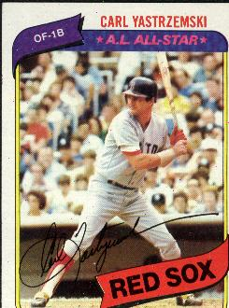

* Coaching sports and watching my kids participate:   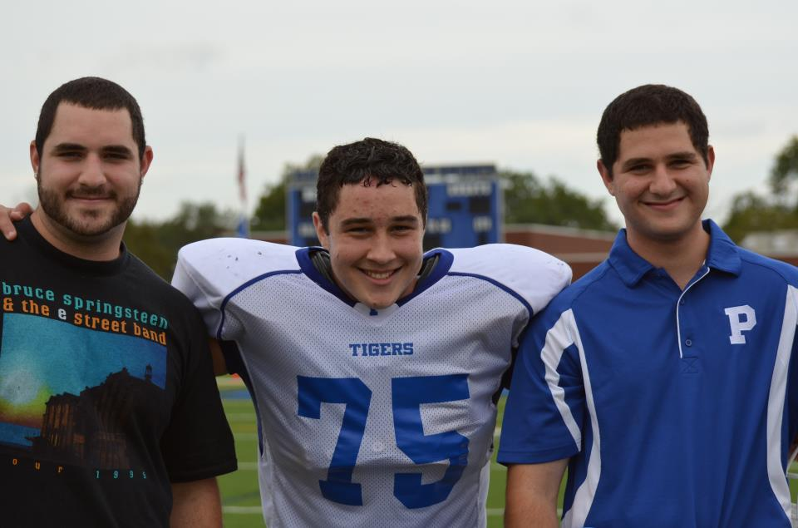

* playing with my wife, Jeanine, => look she’s happy! 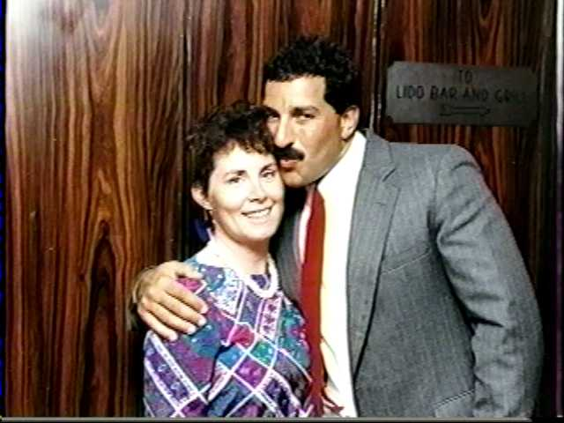

===============================================================================

**The one hobby that has turned into an addiction is :**

**$$$ INVESTING $$$**

**….$$$ My Worthless Commentary $$$ ….**

**First of all, I’m just another investor like you. I’m not a licensed securities professional or a financial advisor (nor do I want to be) so in no way should this be construed as me providing information to anyone. This is not investment advice, just a reflection of what I’m doing presently in the market. So take it for what it’s worth => PLEASE è everyone looking at this website should do their own homework. Anyway:**

**Here are all of, what will be, my 14 open positions for stocks that I bought using my quantitative investment model which I describe below, I will be adding to the  open positions during the course of the year.  Read more about $$$MR. MARKET$$$ here:**[**www.mrmarketishuge.com**](http://www.mrmarketishuge.com/)



**Wow! Is that *28 CONSECUTIVE* profitable closed trades in excess of 15%?    That's ridiculous.  I am amazing.  I am HUGE!!    I am unconscious!! I am $$$MR. MARKET$$$.**

**The market is very volatile right now but you have to believe that the odds favor some upward movement once all uncertainty shakes out. No matter what happens in the market, there are HUNDREDS of stocks setting new highs every day. Pay attention to earnings earnings earnings. Drop me a line if you want to share some investment ideas or if you want to hear about my latest hot stock pick.**

**HOW MY STOCK PICKING MODEL WORKS**

**I developed a stock-picking model when I was in graduate school to take advantage of the bullishness the market was exhibiting at the time. The premise was to invest in high beta stocks while trying to limit my downside exposure in the event of a stall or downturn. By using the quantitative steps in the model, stocks are selected that are experiencing sustainable price momentum. Over the years, my model has evolved to make it more effective and easier and easier to use by anyone.  The model is a multistep screening and high-grade process that goes something like this:**

1. **First, create a universe of about 200 stocks that have demonstrated strong price appreciation and earnings growth in the last 12 months. You can find some pretty good free and easy to use screening tools on the Internet.  I use Fidelity's screener.    On the day I run my quantitative model, I use the following screening criteria to build my universe of stocks:**

**Screen #1: Stocks making new highs with IBD EPS rating of 90 or higher**

**Screen #2: Stocks within 2% of their 52 week high with a 52 week price appreciation > 300%**

**Screen #3: Stocks within 5% of their 52 week high with a 52 week price appreciation > 150% and EPS growth of 25%**

**Screen #4: Stocks within 5% of their 52 week high with a 52 week price appreciation > 125% and P/E < 50**

**Screen #5: Stocks within 5% of their 52 week high with a 52 week price appreciation > 50% and P/E < 15**

**Screen #6: Stocks highlighted on IBD's "screen of the day".**

**Screen #7: Stocks with Investors Business Daily Ratings greater than 95 EPS and 95 RS (from the previous Friday publication weekly review).**

**Screen #8: Stocks with Investors Business Daily Ratings greater than 90 RS and PE less than 20 (from the previous Friday publication weekly review).**

1. **Each screen will yield about 10 – 50 stocks.   List the tickers of all of the stocks in an Excel database.  Delete duplicates as there will be overlap between the 8 screening criteria.**
2. **Copy and paste the ticker symbols into a Yahoo portfolio that you create (maximum 200 symbols).   During bull markets, you'll have more than 200 symbols and you'll have to devise your own method to cull down to 200.  During bear or sideways markets, you'll usually have fewer than 200 symbols.**
3. **Print out the charts on all of the stocks using the "Detailed" view on Yahoo.  If you use the "small text" display on Explorer, you should get about 4 charts per page, with a total of about 50 pages.**
4. **Pick the 2 stocks (of the 4) on each page which have the highest r-squared correlation coefficient.   In essence, you are taking the 2 best looking charts with the straightest lines and least volatility, with respect to time.  Remember, based on the preliminary screens, all of the stocks should have charts where the stock prices are climbing.  If none of the charts on any one page don't look good to you, don't select any of them.  In the end, you'll end up with a total of about 75 - 100 stocks.**
5. **Re-enter the remaining 100 or so ticker symbols into an Excel spreadsheet.  You can use the "download historical prices" function in Yahoo so you don't have to re-type them all.**
6. **Rank these stocks separately on both of the following criteria: Price Appreciation, Price Appreciation divided by trailing 12 month P/E.  Assign a ranking value (i.e. #1 stock gets a 100, #99 stock gets a 1) for each criteria.  Sum the two criteria and re-rank the all of the sums.  If you have 100 stocks in the database, the highest "score" any stock can have is "200".  This process favors stocks with more reasonable valuations and strong price momentum and weeds out those with no earnings.**
7. **Print out this list of stocks.**
8. **Starting from the #1 ranked stock, check to see if it has 3 years of revenue growth and 3 consecutive years of earnings growth.  Eliminate any stocks that do not pass this final screen.    I need stocks that have earnings power.  If a company is growing its earnings and revenues for 3 straight years,  it is unlikely that its earnings will decline.   If its valuation is still reasonable, its stock price has room to grow as well.  Go down the list until you have 5 stocks.   This is the Top 5 which I publish on my**[**http://www.mrmarketishuge.com/**](http://www.mrmarketishuge.com/)**website.**
9. **For each of the Top 5 stocks, go to the**[**http://investing.quicken.com/research/**](http://investing.quicken.com/research/)**website and determine its numerical value on the Weiss and Hagstrom scales (assign a value of "1" for a "check" and a "-1" for an "x".  Use a value of zero if the stock is not covered by one of them (it will be covered by at least Weiss or Hagstrom).**
10. **For each of the Top 5 stocks, go to the**[**http://www.investors.com/member/checkup/checkUp.asp?t=&ss=YES**](http://www.investors.com/member/checkup/checkUp.asp?t=&ss=YES)**website and determine its numerical value on the Stock Checkup scale (value of 0 to 99).**
11. **For each of the Top 5 stocks, go to the**[**http://moneycentral.msn.com/investor/srs/srsmain.asp**](http://moneycentral.msn.com/investor/srs/srsmain.asp)**website and determine its numerical value on the Stock Scouter scale (value of 1 to 10).**
12. **Add up the values for "Hagstrom", "Weiss", "Stock checkup", Stock Scouter" and rank the Top 5 again.  The maximum value any stock could have would be 7 for Hagstrom, 8 for Weiss, 99 for Stock Checkup and 10 for Stock Scouter (total of 124).  Any stock with a value over 110 is usually very good.**
13. **Use your noodle.  You've put all of these great stocks through the ringer to figure out which one is the best.  Look at these Top 5 and decide which one you like the best, having taken all these factors into consideration, plus fundamental analysis associated with any events that may not be baked into these revenue, earnings or valuation numbers.**
14. **Buy the stock you like best. In a typical bull market, the stock will, on average, achieve a 15% gain within 4 to 6 weeks. Sell the stock and repeat the process. Why sell so soon? Well there are ever changing phenomena going on in the market that could make your selection criteria quite different a month after the signals told you to buy this stock. The theory here is that you are selling a potentially "tired" stock and trading it for a "fresh" one.**

**What this process is trying to do is to select a hot growth stock that has a little more juice left in it to get you that last 15% without being so hideously overvalued that it could drop like a rock. I don’t think I need to buy stocks with extended valuations to make a quick profit. There are stocks out there with good momentum that aren’t bad to hold if I make a wrong decision. I think my model finds them. My model has been successful in protecting me from real lemons. Preservation of capital is always important. Buying companies with real earnings protects me in the down markets. We all work hard for our money. It makes no sense to give it away. That’s why I believe it’s important to buy stock in companies with real earnings.**

***If you really like what you see, you may want to consider joining my free and fun investment discussion group and message board where we talk in detail about all of my hot stock picks.  Here is the link:***

[My Awesome $$$MR. MARKET$$$ site == Discuss $$$MR. MARKET$$$ hot stock picks!!](http://www.mrmarketishuge.com/)

**Tell me what you think of my model. I’d be happy to answer any questions about this process if you send me an E-mail.**

**Here is a link to my professional financial advisor…he’s really an awesome guy:**

[Here's Austin](http://www.austindutton.com/)

**The internet's all about communication. Now that you've had a chance to see the world's worst webpage, if you are an old friend, fellow alum, want to be a new friend or if you want to hear about my latest HOT HOT HOT stock pick**, ***how about sending me some***E-Mail===>> [CLICK on my head to talk to Ernie:[](mailto:ebarsamian2003@yahoo.com)](mailto:ebarsamian2003@yahoo.com)

Top of Form

  did you really like my webpage?  Good... now send me money ===>      ain't the internet great???

Bottom of Form

 Free counters provided by [Andale](http://www.andale.com/).