March 25, 2021
Dear Church,

This is a strange time in our lives, unlike anything that we have faced before. In many ways, it feels like we have lost the last year. Our plans have been canceled, days mixed up, and calendars have been thrown into a spin cycle. Fortunately, we are a community grounded in a liturgical year which helps. However, it is odd to record Easter worship – before we celebrate Maundy Thursday and Good Friday.

As strange as this chronological time is, we are also in a Kairos God moment in the life of the Church. When we are reminded that God finds all that is lost, God orders the chaos, God creates meaning out of the bizarre, God helps us celebrate even in grief. We have an opportunity to evaluate and assess where we are and where God is sending us a church. Our Stewardship of Time, Talent, and Treasure is one of the areas for our discernment.

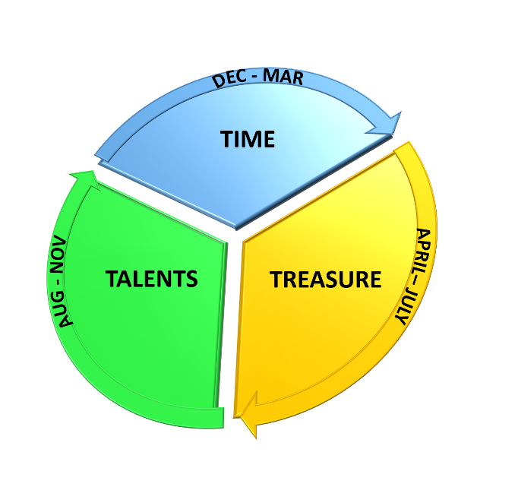
We ‘lost’ the traditional October Stewardship drive – but who says we need to pledge in the fall? Stewardship is year round and pledging our gifts in this season fits the scope of our Church calendar better than our fiscal year. Our Talents and Time, as a part of stewardship, fit better in different seasons.

We have spent our TIME together, dwelling in community, worshipping, praying, reflecting. We have given time to God and one another from Advent, through Christmas and Epiphany, and now into Lent. Our time is not only our volunteering, but also being present and committed to God’s church. Thank you!

As we enter the Easter season, we ask you to consider what financial gifts you have, and how you will share TREASURE with God’s ministry at Trinity. You have already discerned a plan for funding the ministry in 2021, and now is time to commit to this plan. What do you intend to give this year?
Please fill out the included “Statement of Intent” and return to Trinity by June 1st.
We will celebrate our financial intent during worship the first weekend of June.

As we move through the summer and into the Fall, we hope to be back in person, and we will celebrate! We will reestablish our community relationships. We will restart small group ministries in the congregation. We will ask you how your gifts and skills - your TALENTS – will be registered and used to God’s glory in the ministries around Trinity and into the neighborhood. Where is God calling you to share your unique skills?

Which will bring us back to new Church year, to Advent, where once again we will dwell together, share our time, pray, sing, worship together as another year approaches. THANK YOU for stewarding well the gifts of God in you and your families, as we also steward your gifts well in this setting and beyond.

Grace and Peace to you,
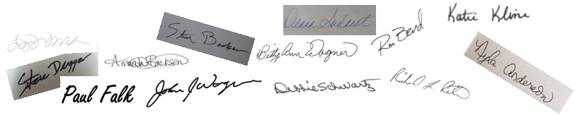
Pastor Rick Reiten
Deacon Katie Kline

