ALUMNA PROFILE

Life on the road to Olympic gold with the world’s best slalom ski racer

Lyndsay Young poses in front of a video display at the U.S. Ski and Snowboard Association's Center of Excellence in Park City. The video depicts Mikaela Shiffrin just after she crossed the finish line to win an Olympic gold medal in Sochi, Russia, in 2014. (Photo: Bill Keshlear/College of Health)
Alumna Lyndsay Young, class of 2014, PT, DPT, ATC, a resident of Park City, is physical therapist/athletic trainer for the U.S. Ski Team's top gold medal hopeful, Mikaela Shiffrin. Lyndsay, Mikaela, and the rest of the U.S. team have been focused on World Cup races since the end of October. Their attention will shift to the 2018 Olympics in Pyeongchang, South Korea, in February.
By Bill Keshlear, College of Health

A video focuses on Mikaela Shiffrin as she blasts out of the starting gate in Courchevel, France, and threads her way to another win on this year’s FIS World Cup circuit. The 22-year-old ski-racing phenomenon is all smiles as she hockey stops past the finish line.

The video then jumps from Shiffrin to capture a more subdued reaction. Lyndsay Young (Doctor of Physical Therapy, University of Utah, 2014; Bachelor of Applied Science, Athletic Training, University of Utah, 2010) is beaming. Young’s reaction reflects the sensibility of her profession: engaged, supportive, unobtrusive. Shiffrin’s success is also Young’s success.

Young, 30, is part of an elite team – including two coaches, an equipment technician, and Shiffrin’s parents – behind the development of the skier who won the overall World Cup title in March. Only four other Americans have won the title since its inception in 1967: Phil Mahre, Tamara McKinney, Bode Miller, and Lindsey Vonn. Among that group, only Vonn has won more races – one more – to claim the title (“Overall” season title goes to the racer who scores the most points across all five of the Alpine disciplines). Shiffrin could be the United States’ best bet for Olympic gold in Alpine competition in Pyeongchang, South Korea.

Young tapped her unique skills as part of that team on the night of Dec. 12, 2015. She stood at the top of a slope in Are, Sweden, while Shiffrin took a free-skiing warm-up run before a World Cup giant slalom. Her two-way radio squawked. Shiffrin had fallen. Young was the first responder.

“All of these things go through your head,” Young said. “This is her career. This is her life’s work that could be at risk. In those moments, you just have to remember your training.”

Young assessed Shiffrin’s injury, helped get her off the slope, activated the U.S. Ski Team’s Global Rescue medical evacuation protocol to get the ski racer back to the United States, and assisted in her recovery at home in Colorado.
A headline in the Denver Post a couple days later read “Mikaela Shiffrin ‘unlikely’ to resume racing this season after knee injury.” However, after what Shiffrin called “dawn to dusk rehab” on a medial collateral ligament tear, hairline fracture, and bone bruise in her right knee, she returned to winning form two months later.

No one else on Shiffrin’s team could’ve done what Young did.

Stronger, quicker, better

Young started working for the U.S. Ski and Snowboard Association out of its Center of Excellence in Park City as a student intern. Then she landed a full-time job after completing an advanced degree. The U of U-trained physical therapist (“physiotherapist” in Europe or just “physio”) and athletic trainer eventually became part of the “family,” traveling the world with Shiffrin, developing and constantly revising a balance, strength, agility, and flexibility regime to help her stay at the top of a sport in which the difference between winning and placing tenth is measured in hundredths of seconds.

“There are very few people in the world who understand what Mikaela needs in order to succeed from a balance and motion perspective and, at the same time, care as deeply for the sport as Lyndsay,” said Scott Ward, chairman of the College of Health’s Physical Therapy and Athletic Training Department.

Young analyzes the racer’s posture, movement, and stress on joints and muscles through thousands of twists and turns, flexes and gyrations on slopes even double-black diamond skiers would be anxious about and offers prescriptions to get stronger, quicker, better. It involves myriad techniques.

“On the day of the race with Mikaela, we’ll start with a really good warmup. She’ll do a 15-minute bike ride to get her heart rate up. Then we’ll do dynamic mobility exercises and some reactive work to make sure her nervous system is firing and ready to go,” Young said. “Right before the start of the race, we have a routine for balance, perception, strength, and visualization.”

Young has adopted various strategies to get Shiffrin to “live in the moment” instead of focusing on marketing, news media interviews, Olympic expectations, travel, or the possible career-ending, physically debilitating consequences of missing a pre-jump in a downhill race and being thrown into the air at 70 miles per hour.

“Last year, I had some trouble with nerves,” Shiffrin told the Denver Post in November. “So far I haven’t felt that anxiety yet. I don’t feel like I’m going to puke at the start.”

One day last season, Young stepped in to prevent a cameraman from shooting video of her vomiting before a race.

(It would’ve been easy for Shiffrin to be distracted as teammate Julia Mancuso, 33, donned a Wonder Woman ski suit, tied a red cape around her neck, then glided down the race course at the World Cup in Cortina D’Ampezzo, Italy, on Jan. 19. It was the final run of a 19-year career. “Super Jules” was gunning to race in her fifth Olympics, but hasn’t fully recovered from hip surgery that’s kept her out of most World Cup races over the past two seasons. “I felt like the crazier I would dress, the better and easier and less I would be emotional and cry,” Mancuso told the Associated Press. “I had to pull out the superpowers for today.” Shiffrin, meanwhile, placed third in that downhill event, but missed a gate in the super-G and failed to finish. The next week, in Kronplatz, Italy, Shiffrin fell during the giant slalom and again failed to finish.)

In 2016, Shiffrin posted a video on her Instagram page of a tap-dancing routine from summer training in Chile. Mikaela and Lyndsay were loosening up to Parov Stelar’s “Booty Swing,” choreographed by Young.

“So we put together a fun little dance in Chile this summer, and just finally edited it all together for ya. This was my @lyndsay.anne physio's first time editing a video. I think she did a pretty great job, don't you? oh ps ... she also choreographed the whole thing. #itshardtodanceinskiboots”

So far, the video has gotten 61,244 views.

A student open to possibilities

It’s doubtful whether Young picked up the subtleties of Euro electro-swing choreography in a PT course, but she was a good student at the U, open to possibilities. “Engaged” is a word Ward used to describe Lyndsay’s student career. That’s an understatement.

“I learned that if you put the work in, you can get where you want to go,” said Young. “The University of Utah helped me find a path toward a dream job. I didn’t even know it was a possibility.”

A ski racer who learned the turns at tiny Ausblick ski area in Sussex, Wis., but spent family vacations in Park City, Young was a coach at Rowland Hall’s Rowmark Ski Academy in Salt Lake City for much of her academic career.

Young also was class vice-president (Doctorate of Physical Therapy); senior class president (Athletic Training Education Program); sophomore and junior vice-president (ATEP); Associated Students of the University of Utah, 2009-2010; president of Athletic Training Student Association; Rocky Mountain Athletic Trainers’ Association student representative; and recipient of the Bill Bean Most Outstanding Student Athletic Trainer Award.

She received numerous clinical internships working as a student physical therapist. In one, she gained experience with patients by participating in their rehabilitation from strokes, brain injuries, or spinal cord injuries. In another, hands-on, patient-centered care focused on manual therapy, neuro re-education, and individualized exercise programs for a wide range of patients from professional athletes to elderly.

University of Utah Health Sciences provided opportunities with the University of Utah football and softball teams. She worked at Utah Olympic Park with the U.S. Freestyle Ski Team, Juan Diego Catholic High School with basketball, wrestling, lacrosse teams, and Westminster College with athletes in a range of programs.

“It was cool to have these opportunities and get out of the classroom,” Young said. “I was really involved in the University of Utah. I was really busy.”

“Man, I don’t how I did all that,” Young said, suggesting with a wink and a nod in her voice that maybe the pressure cooker called the FIS ski circuit – which begins at the end of October and doesn’t let up until March, with close to 40 races across Europe and North America and the Olympics sandwiched in – was by comparison a glide down a bunny slope at Ausblick.

Q & A with Lyndsay Young
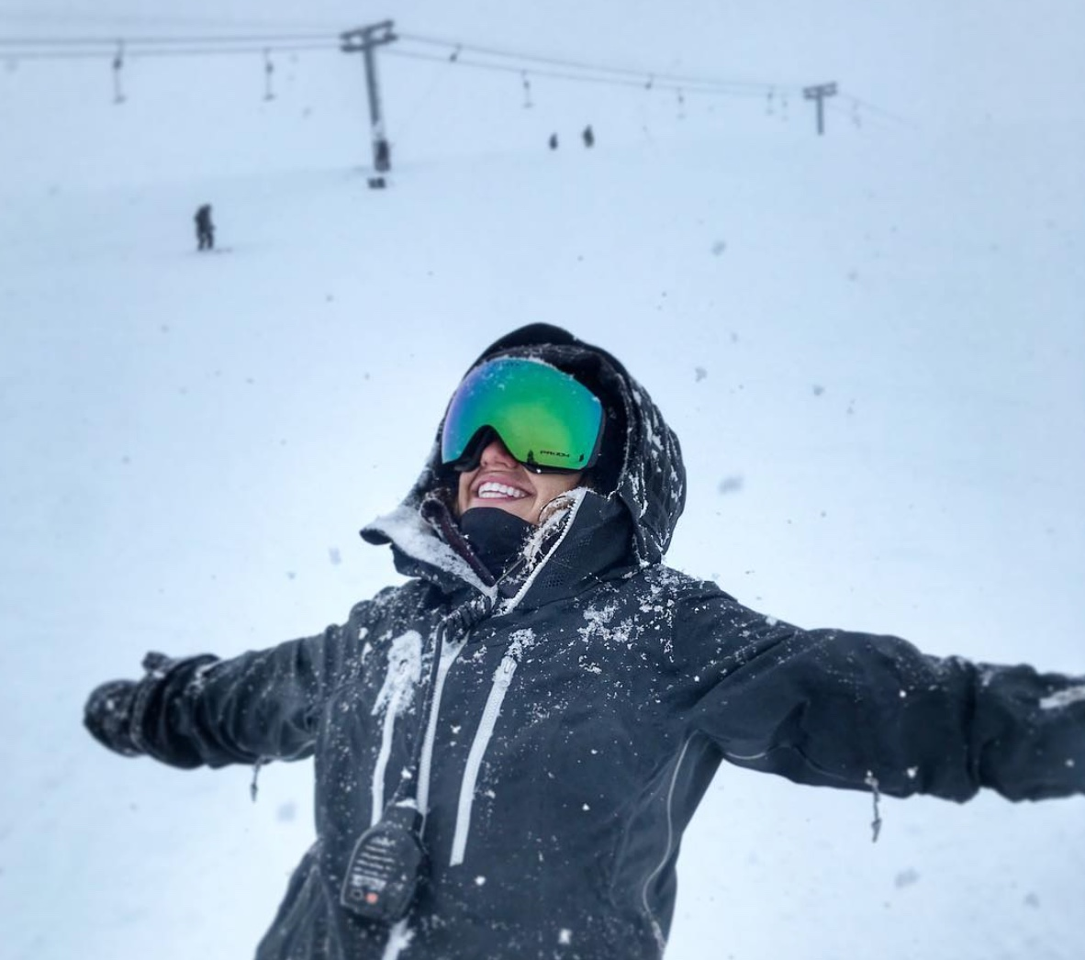
(Photo: Lyndsay Young)

Q: What’s the toughest part of your job?
A: I love to travel, but we’re on the road a lot. I’m in Park City for about 30 percent of the year. We have our training camp in July in New Zealand, come home for two weeks for a training block, then go down to Chile for two weeks, come back and train for another month. Then I travel with Mikaela and her team to Europe beginning in October and stay in Europe until mid-November, come back to North America for a couple of races, and then we’re back in Europe for the rest of the season until mid-March. And this year, we’ll be in South Korea for the Olympics in February.

Q: How do these skiers handle pain through the course of a season?
A: These elite athletes are willing to suffer an insane amount, and I think that’s part of how they’ve achieved this much. Luckily, Mikaela and I have a relationship where if she has any sort of tweak, she’ll tell me. She knows it’s in her best interest for me to watch and determine if she’s compensating for it. It’s hard to get to that point because athletes don’t want to admit they have an injury (In December 2015, Shiffrin tore her MCL. Young worked with her every day and had her back in competition within five weeks).
Q: What does the future hold?
A: The Olympics are coming up, so I am focused on that. But starting a family and physical therapy business back in Wisconsin might be possibilities. My goal is to help young athletes and weekend warriors be active, have fun, and just get out there.

