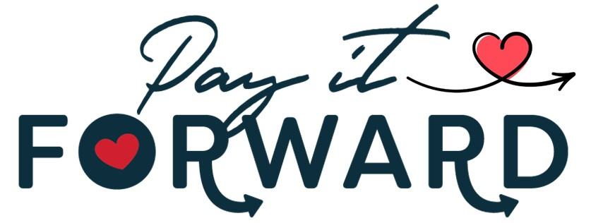

2022 Pay It Forward Project Application
Deadline to Submit: August 22nd
(Event Date: August 25, 2022)

Nonprofit Organization: ___________________________________________________

Contact Name: __________________________________________________________

Email Address: ___________________________________________________________

Mailing Address: __________________________________________________________

Phone Number: (______) __________- __________

Name of your project: _______________________________________________________

Please describe your project? (Please attach additional sheet and/or pictures, if needed): ____________________________________________________________________________________________________________________________________________________________________________________________________________________________________________________________________________________________________________________

Has your organization applied for any funding through the Wetzel County Chamber of Commerce in the past? If so, were you awarded funding and the amount? (This does not affect your eligibility to compete in this year’s event) __________________________________________________________________________________________________________________________________________________________

If voted a winner, how would you use the money from the WCCC Pay It Forward Program? Be Specific: _________________________________________________________________________________________________________________________________________________________________________________________________________________________________________________________________________________________________________________________________________________________________________________________________

Is this a new project or ongoing project? ________ New _____ Ongoing Project

What is the time frame for the project? Start date / projected completion date. If ongoing, when did project begin? ______________________________________________________________________________________________________________________________________________________________________________________________________________________________________________________________________________________________________

How many volunteers will be working on this project? How many paid employees will be working on this project?
____________________________________________________________________________________________________________________________________________________________________________________________________

Signature of Contact Person for Organization Date

_________________________________________ _____/_____/20____
Be sure to attach:
IRS Determination letter to show Nonprofit status

Please return this completed application to:

Wetzel-Tyler Chamber of Commerce
P.O. Box 271
New Martinsville, WV 26155

Email: Brian@WetzelTylerChamber.org

Fax: (304) 455-3637

