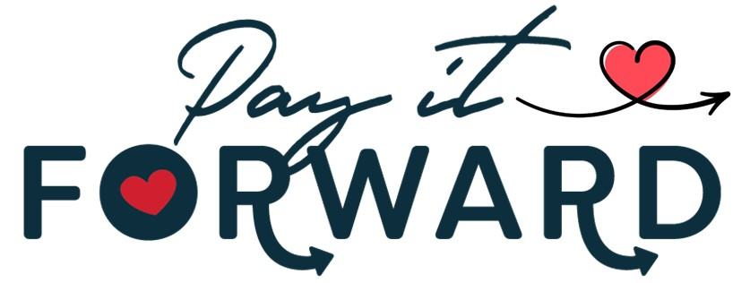

Thursday, August 25th at 5:30 PM
RULES AND INSTRUCTIONS

Please read carefully
Eligible participants:
- Must be nonprofit organization
- Must have offices in Wetzel Co. WV, Tyler Co. WV or Monroe Co. OH
- Must submit IRS letter of determination with completed application

Eligible projects:
- Project must positively impact a community in Wetzel Co. WV, Tyler Co. WV, and Monroe Co. OH.
- Cannot benefit an individual or single organization
- Application must be received by Chamber Office no later than Monday, August 22nd.
- Projects can range from art installations, memorial benches, landscaping, community signage, fixing potholes, providing meals, training, or anything else that will directly affect the wellbeing of our community.
Applications:
- Download at https://wetzeltylerchamber.org/event/pay-it-forward-2022/ or pick one up at the Chamber Office, 132 North Street, New Martinsville.
- Return Completed applications to:
  - Emailed - Brian@WetzelTylerChamber.org
  - Mailed - Wetzel-Tyler Chamber of Commerce, P O Box 271, New Martinsville, WV 26155
  - Faxed - 304-455-3637
Upon receipt of your applications, it will be reviewed by a panel to ensure that all requirements have been meet. Once this review is complete, your organization will be contacted with additional questions or to inform you that your application has been accepted. Once the application process is complete, you will be invited to join us at Klug Hall, 21 Rosary RD, in New Martinsville on August 25th, 2022.
Attendees at this event, including those individuals who are presenting, will be asked to donate $5. This money will be added to other moneys to be awarded at this event. In exchange for their $5 donation, each attend will receive a ballot to vote for the project they feel is the most deserving of funding. Ballots will be limited to one per attendee. Ballots will be collected after each applicant has had an opportunity to give their presentation.
At this event, applicants will be provided with a table to set up visual aids and hand-outs to help explain the details of their program to those in attendance. Table setup will begin at 5PM and the public will be allowed to enter the venue beginning at 5:30 PM. You will have 30 minutes to speak with those attending to spread understanding of your project.
At 6 PM, lots will be drawn to determine the order in which applicant will give their presentations. In order, each applicant will be given 5-minutes to present their project to the assembled crowd. A time keeper will help monitor the time of each presentation. Following each presentation, a panel of moderators will be given some time to ask questions submitted by those in attendance.
Once all presentations have been complete, there will be approximately 15 minutes for attendees to directly ask questions of any presenters they still have questions for and to submit their ballots. Once the ballots are in, they will be counted and winners will be announced.
Photos and information will be gathered to feature and share online. Any information shared on your application, at your table or during your presentation may be shared on the Chamber’s website, social media or by other means. This may include any financial data provided but will not include your organization’s FEIN.

