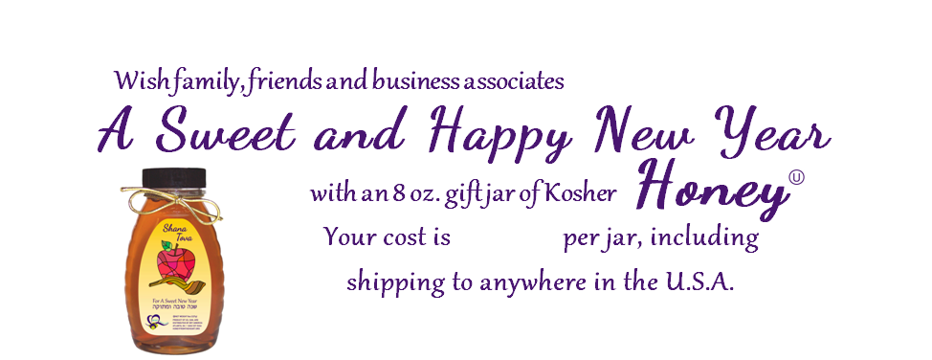
To order online, go to https://orthoney.com/RTF/ by August 8th to avoid a $7.00 per jar shipping surcharge. If you are unable to order online, complete this order form with your payment information or a check made payable to RTFH – Women’s Connection. Mail to the Reform Temple of Forest Hills, 71-11 112th St., Forest Hills, NY 11375, Att: Women’s Connection.
ORT is no longer accepting checks directly so WoCo will place the orders internally. If paying by check, you MUST send your order form and a check for the full amount of your order payable to RTFH Women’s Connection to Temple. Put Attention WoCo on the envelope. Please be prompt. Please have all order forms and checks in the WoCo mailbox by THURSDAY, AUGUST 1, 2024. This will allow ample time for us to place your order.

Att: Women’s Connection

PLEASE CLEARLY PRINT OR TYPE ALL INFORMATION
Your Name
Address |  |  |  |  |  | City |  |  |  | State |  | Zip
Email |  |  |  |  |  |  |  | Phone | ( )
We take your privacy seriously and guarantee that your personal information will only be used for communications regarding your honey order.
ORDER SUMMARY: |  |  | PAYMENT
# of Jars Ordered  # of Jars Reordered  Total Jars Ordered  X $14.00  Shipping Fees  Order Total |  | _________  + _________  _________  = _________  + _________  $ _________ |  | Select one:  [ ] Amex  [ ] Discover  [ ] MC  [ ] Visa | Account # ______________________________________________________________________  Name on card ___________________________________________________ Exp ____________  Signature ______________________________________________________________________  Billing address (if different from address above):  _______________________________________________________________________________

Send to: | Gift cards are preprinted with: Shana Tova - Wishing you a Healthy and Happy New Year  Personalize this gift card:  1) Choose: [ ] Love, [ ] From, [ ] Fondly, or [ ] No Signature  2) Name(s) to be signed (maximum 50 characters):
Address:
City State: Zip:

Send to: | Gift cards are preprinted with: Shana Tova - Wishing you a Healthy and Happy New Year  Personalize this gift card:  1) Choose: [ ] Love, [ ] From, [ ] Fondly, or [ ] No Signature  2) Name(s) to be signed (maximum 50 characters):
Address:
City State: Zip:

Add $8.00 for shipping to APO/FPO/DPO military addresses.
$8.00 per jar shipping is added to all orders received after [your mail order deadline].
$14.00
Send to: | Gift cards are preprinted with: Shana Tova - Wishing you a Healthy and Happy New Year  Personalize this gift card:  1) Choose: [ ] Love, [ ] From, [ ] Fondly, or [ ] No Signature  2) Name(s) to be signed (maximum 50 characters):
Address:
City State: Zip:

Send to: | Gift cards are preprinted with: Shana Tova - Wishing you a Healthy and Happy New Year  Personalize this gift card:  1) Choose: [ ] Love, [ ] From, [ ] Fondly, or [ ] No Signature  2) Name(s) to be signed (maximum 50 characters):
Address:
City State: Zip:

Send to: | Gift cards are preprinted with: Shana Tova - Wishing you a Healthy and Happy New Year  Personalize this gift card:  1) Choose: [ ] Love, [ ] From, [ ] Fondly, or [ ] No Signature  2) Name(s) to be signed (maximum 50 characters):
Address:
City State: Zip:

Send to: | Gift cards are preprinted with: Shana Tova - Wishing you a Healthy and Happy New Year  Personalize this gift card:  1) Choose: [ ] Love, [ ] From, [ ] Fondly, or [ ] No Signature  2) Name(s) to be signed (maximum 50 characters):
Address:
City State: Zip:

Send to: | Gift cards are preprinted with: Shana Tova - Wishing you a Healthy and Happy New Year  Personalize this gift card:  1) Choose: [ ] Love, [ ] From, [ ] Fondly, or [ ] No Signature  2) Name(s) to be signed (maximum 50 characters):
Address:
City State: Zip:

Send to: | Gift cards are preprinted with: Shana Tova - Wishing you a Healthy and Happy New Year  Personalize this gift card:  1) Choose: [ ] Love, [ ] From, [ ] Fondly, or [ ] No Signature  2) Name(s) to be signed (maximum 50 characters):
Address:
City State: Zip:

Send to: | Gift cards are preprinted with: Shana Tova - Wishing you a Healthy and Happy New Year  Personalize this gift card:  1) Choose: [ ] Love, [ ] From, [ ] Fondly, or [ ] No Signature  2) Name(s) to be signed (maximum 50 characters):
Address:
City State: Zip:

