Saskatchewan farmers challenged to invest in the future of their farms with Acres for Education campaign

Saskatoon, SK – October 25, 2023 – Agriculture in the Classroom Saskatchewan’s (AITC-SK) is excited to announce the launch of its groundbreaking Acres for Education campaign, an initiative aimed at providing educational opportunities for today’s youth to connect with agriculture.

The Acres for Education campaign highlights the importance of education in igniting a passion and interest in agriculture. The next generation of consumers and agriculture leaders, innovators, and employees are in classrooms today, and AITC-SK has identified students as the key to a sustainable and resilient agriculture future. By engaging students in agriculture education initiatives, AITC-SK strives to inspire them to care about our food system, build understanding and support for modern farming practices, and expose students to the diversity of careers in an exciting and rewarding industry.

“Students today will soon graduate and begin making decisions related to their career pathway,” says Sara Shymko, Executive Director of AITC-SK. “It is crucial that they have agricultural touchpoints throughout their education journey, to inspire understanding of our food system and support for our producers.”

The campaign’s unique approach challenges farmers to donate 10 cents per acre of land they farm to agriculture education, boasting the catchy tagline of “10 cents makes sense, invest in the future of agriculture.” The challenge empowers individuals from around the province to contribute to the vitality and success of their farms and ranches by investing in the education of youth today. To kickstart this ambitious campaign, Saskatchewan farmers have already donated and committed to helping build a strong future for agriculture through positive student experiences.

"There is a lot of talk about the looming labour crisis in agriculture, and now we need action. We can't leave it up to others to solve this problem. As producers, we need to get involved in finding solutions," says Kristjan Hebert, President of the Hebert Group. "One way we can do that is to donate monetarily, but just as important, is connecting with your local schools so kids can visit your farm and have memorable experiences that may impact future career choices."

Acres for Education has an ambitious goal of $250,000 which represents 2.5 million acres of Saskatchewan farmland being donated. An initial goal of $150,000 provides funds for AITC-SK to keep up with the current teacher demand. This includes replenishing stock of the organization’s highly sought-after learning kit resources and having the capacity to fulfill program requests. The aspiring $250,000 campaign goal would amplify AITC-SK’s impact to the next level with new initiative development to capture even more opportunities throughout a student's education journey to connect to agriculture. The goal may seem bold but with over 37 million acres of farmed land in the province, donations for approximately 7% of the acres would transform the agriculture education landscape for our youth.

To be a part of the solution for a strong agriculture future, donate to the Acres for Education campaign by visiting aitc.sk.ca/acresforeducation. A charitable receipt will be issued with all donations. Saskatchewan agriculture can come together to cultivate a brighter future for tomorrow's leaders through education. Follow along on social media with #AcresForEducation.

About Agriculture in the Classroom Saskatchewan

Agriculture in the Classroom Saskatchewan (AITC-SK) is building a foundation for future success by inspiring the next generation of big thinkers and decision-makers to grow into our agricultural leaders of tomorrow. As a registered charity, AITC-SK partners with the agriculture and education communities to connect kids and agriculture through innovative, experiential, and curriculum-based programs and resources. Last year AITC-SK provided 259,460 student experiences to 72,653 students from 618 schools in 247 communities in the province.

  To learn more, visit www.aitc.sk.ca or follow our story:
  ‌ ‌ ‌ ‌

About Hebert Grain Ventures (HGV):

HGV is a progressive 30,000-acre grain and oilseed farm in Moosomin, SK. Part of The Hebert Group family of agricultural businesses, HGV is built on the belief that it leaves the land, the community and the financial statements in a better state for future generations. You can learn more about the Hebert Group at www.hebertgroup.com.

For more information, contact:

Sara Shymko Chandra Gusikoski
Executive Director, AITC-SK﻿ Communications, AITC-SK ﻿
sara@aitc.sk.ca chandra@aitc.sk.ca
306.291.7574 306.260.3560

Organization Overview:

Agriculture in the Classroom-SK is a nonprofit charitable organization dedicated to agricultural education. Every year, it inspires more than 70,000 youth in Saskatchewan to gain a deeper understanding of and develop a stronger connection to the food production system, while also fostering their aspirations of joining the industry in the future.

Agriculture Affects us All, Every Single Day
Since 1994, Agriculture in the Classroom Sask Inc. (AITC-SK) has played a pivotal role in educating youth about agriculture through hands-on activities, engaging programs, and inquiry-based educational resources.

Serving All of Saskatchewan
Our curriculum-linked initiatives are available for Kindergarten to Grade 12 teachers and students across Saskatchewan at no cost. Teachers can easily incorporate agriculture in their classrooms with our over 100 resources, including storybooks, learning kits, websites, downloadable lesson plans, and more. Our programs offer students in- and out-of-school opportunities to experience agriculture up-close and hands-on. These meaningful experiences include farm tours, classroom presentations, agriculture events, school gardens, food farms, and more.

What We Do
By encouraging teachers to embed agriculture into their classrooms, AITC-SK cultivates an understanding and appreciation of the food and fiber system we rely on daily.

We know that to drive change, youth need to have multiple positive agriculture learning experiences throughout their education journey. Every student should go on a farm tour, grow a garden, learn how to read a food label, talk to a producer, sit in a tractor, feed an animal, and learn about the abundance of career opportunities in agriculture. To create a cohesive learning journey, we strategically provide experiences at different grade levels, each building upon the previous one.

Our Vision And Everyday Purpose
We have a vision of a Saskatchewan community that understands, appreciates, and respects agriculture.

The agriculture industry is made stronger by the trust, support, and involvement of well-informed consumers. Continuing to improve our food system is imperative to a sustainable future, and we want to motivate and inspire the next generation to be changemakers and innovators in agriculture.

Our Mission And Promise to You
Our mission is to connect kids and agriculture through innovative, experiential, and curriculum-based programs and resources.

We promise to:
- Share Saskatchewan's incredible food story through accurate, balanced, current, and science-based information about food and agriculture.
- Bridge the gap between the agriculture and education communities by creating opportunities for students and teachers to meet the people involved in producing their food.
- Support teachers with innovative, experiential, and memorable agricultural learning opportunities that enable students to make more informed decisions related to food and agriculture.

Executive Biographies and Contact Information:

Sara Shymko  Executive Director  sara@aitc.sk.ca  306.291.7574 | Leah Hermanson  Fund Development Manager  leah@aitc.sk.ca  306.381.5324 | Chandra Gusikoski  Communications Manager  chandra@aitc.sk.ca  306.260.3560
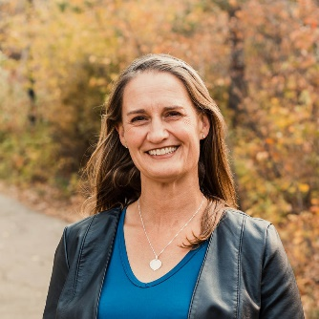  Sara is a passionate leader who gets energized by new ideas. She was raised on a mixed farm near Jasmin, SK, and still returns to the farm to help out as often as possible. Sara is a graduate from the University of Saskatchewan with a Bachelor of Science in Agriculture Economics. Before joining AITC-SK, she was fortunate to have the opportunity to live and work in Uganda and Australia. Sara is the proud mother of two lovely, high spirited daughters, Alexandra & Jordyn, and is delighted they share her love of gardening and football! |   Leah has always had a love of agriculture which was fostered from a young age on her family’s Seed Farm in Kamsack, SK. She has a Bachelor of Science (Crop Science) and a Master of Science (Weed Biology) from the University of Saskatchewan. Leah and her husband live in Lumsden, SK with their lively, loving and wonderful daughters, Clara, Elyse and Miriam. Leah enjoys gardening, running, hiking, cooking and helping out on the farm. |   Chandra has immense pride in being raised on a grain farm near Cudworth, SK. She attended the University of Saskatchewan and obtained a Marketing Degree through the College of Commerce. Chandra is passionate about sharing agriculture knowledge through communications, inspiring youth to get excited about agriculture all around us. Chandra and her husband live in Viscount where they keep busy with community involvement and volunteering.

Acres for Education Campaign

Education For a Strong, Resilient Agriculture Future
The future of farming and agriculture depends on today’s youth. Grade 12 students will soon be graduating and choosing a career, what foods to buy, and which policies to support. In 5 years, they could be writing their very first briefing note for PMRA or writing a media article on sustainable agriculture practices. In 15 years, students in Grade 2 will be doing the same. What do you want them to know about agriculture?

Education is key in igniting a passion and interest in agriculture and its impact on our daily lives. By engaging students in agriculture education initiatives, we are:
- inspiring them to know more and care more about where their food comes from and who produces it,
- building understanding and support for modern farming practices and the choices farmers make to produce food in a safe and sustainable way, and
- opening students' eyes to the variety of careers in an exciting and rewarding industry that is helping to feed our world.

Invest in the Future of your Farm
You have the power to ensure the vitality and success of your farm in the future by investing in the education of youth today. With each agricultural experience we provide during a student’s education journey, we are building the pathway to agriculture literacy, and a stronger future for us all.

10 Cents Makes Sense
We are challenging farmers in Saskatchewan to donate 10 cents an acre to agriculture education. Consider the cost of inputs you invest into your crops, would adding 10 cents make a significant difference? Likely not. But 10 cents an acre in Saskatchewan classrooms will make a deep and meaningful impact. Our goals:
- $150,000 - Since the pandemic, demand for our hands-on, in-person learning experiences has grown beyond our capacity. Every time we say no to a teacher, we are missing the opportunity for a classroom of students to learn more about food and how it’s produced. This goal enables us to meet the current demand from teachers and classrooms.
- $250,000 - But we don’t want just to meet the demand, we want to exceed it. Creating new initiatives will capture even more opportunities throughout a student’s K-12 journey to connect them with agriculture. This goal will take agriculture education to a new level of growth and impact in our province.

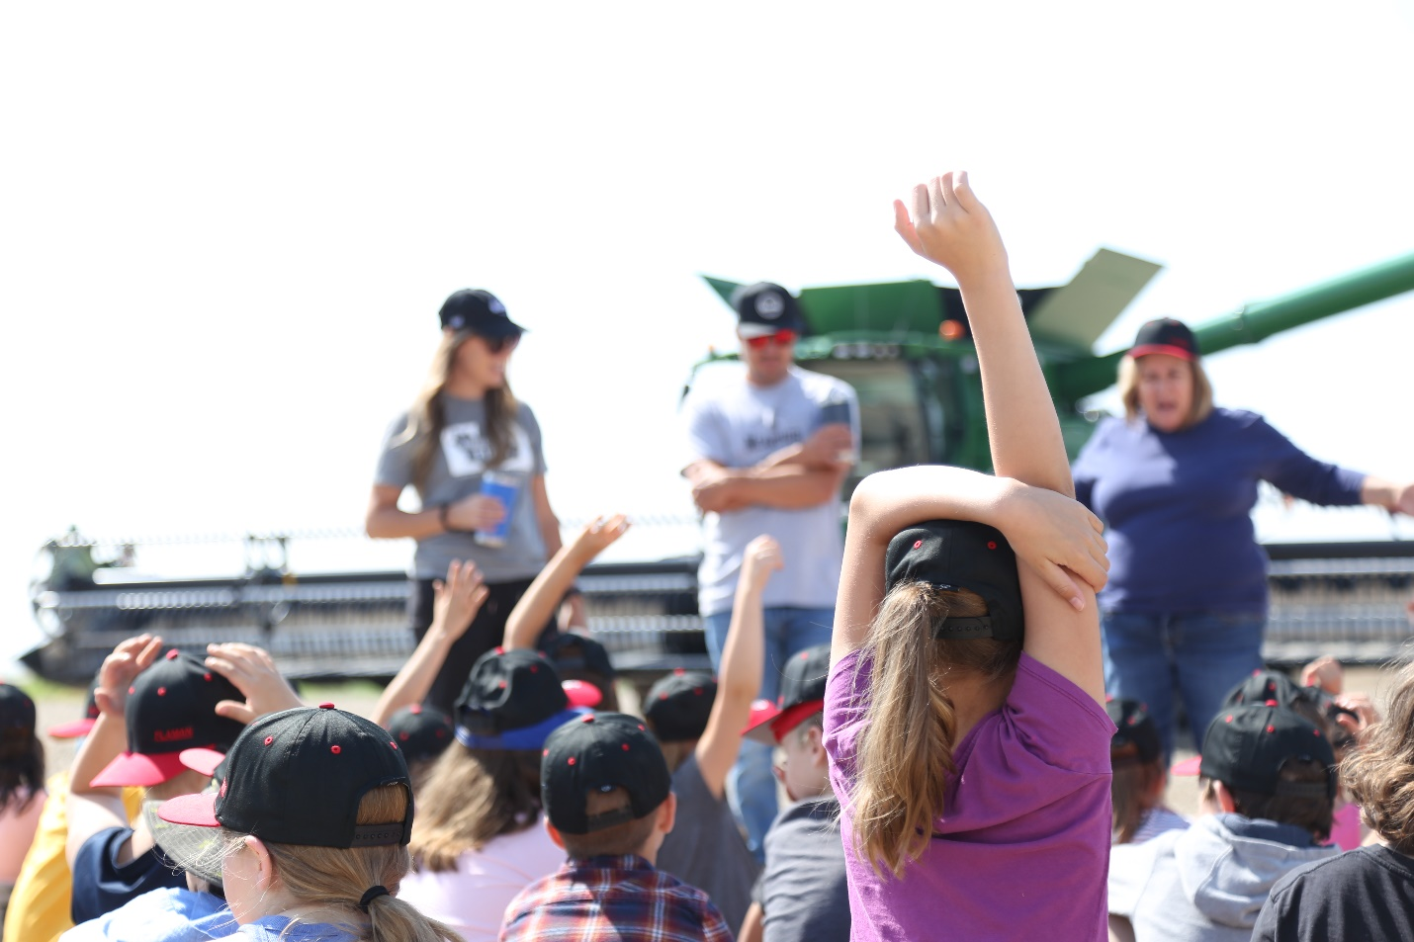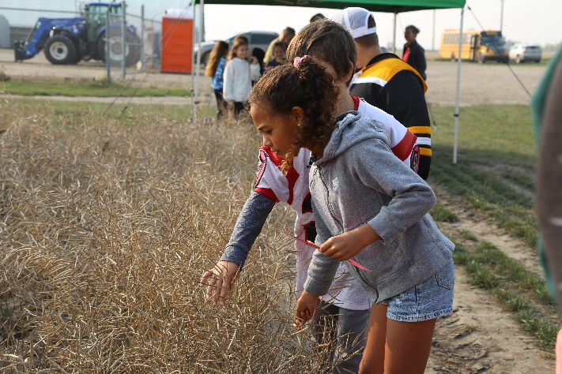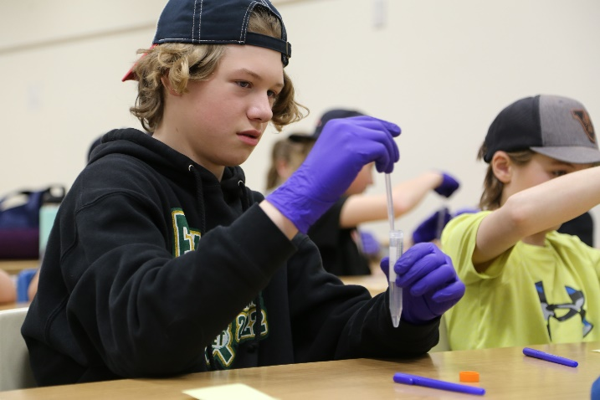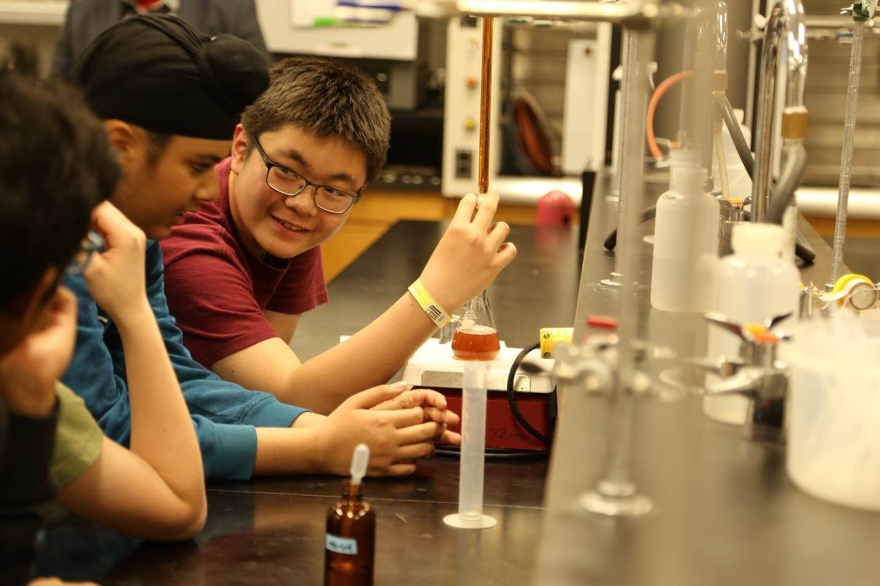
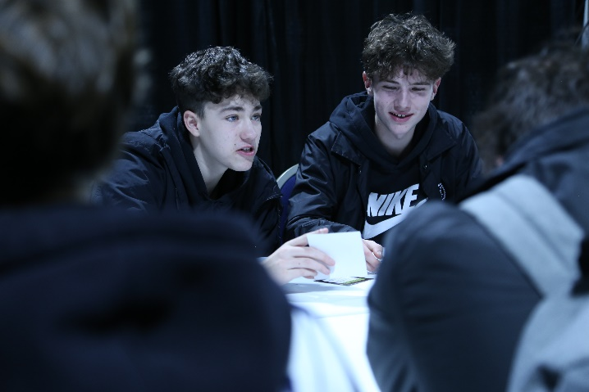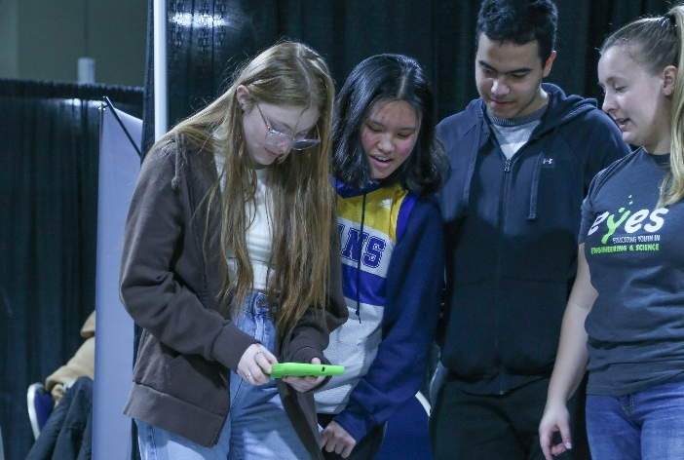

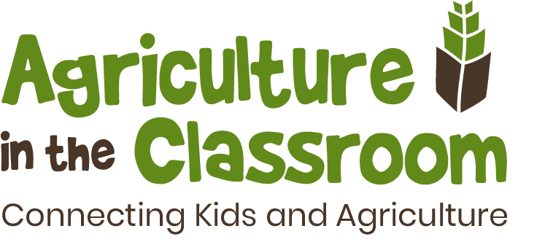

10 Years of Food Farms
The Food Farm program connects students with agriculture by participating in hands-on, engaging, and fun activities and presentations from local industry volunteers. Students plant seeds in the spring and then return in the fall to harvest their crops, experiencing the full cycle of farming. During each half-day visit, students learn about different aspects of agriculture, making it a memorable learning experience like no other! AITC-SK works with partners that host the Food Farm at their business or farm.
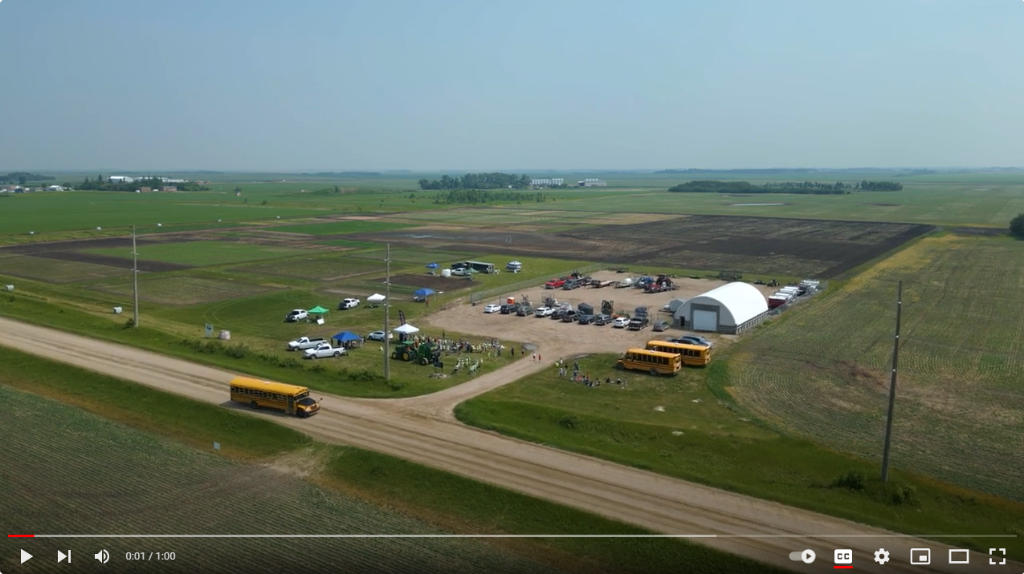
Watch Video

Teacher and Student Testimonials:

“The field of agriculture encompasses so many different occupations – ANYONE can get involved!”
-Grade 10 student, Career Case Presentation

“22 out of 27 of my students were never on a farm before. This was a great way for my students to connect to agriculture in an experiential and real way.”
-Shawn Lewandoski, St. Anne School, Farm & Ag Tour

“An engaging day for my grade ¾ students filled with learning and experiences tied to our curriculum that I couldn’t’ given them in the classroom. Thank you!!”
-Shelane Goettler, St. Philip School

“This is a wonderful hands on way to learn about living things. It enhances our understanding of where food comes from and the process of growing and harvesting.”
-Jennifer Woodard, St. Michael School, Regina, Little Green Thumbs

“The best part was seeing the cows!”
-Ashton, Grade 5 student, Sask Food Story

“Students have a better understanding of where their food comes from and the experience encourages them to question and want to learn more about agriculture long after the day is over.”
-Carla Olson, Sturgis Composite School

“The YRHS looks forward to attending this event every year. To be totally honest its on of the best days of the year.” -
Roby Sharpe, Yorkton Regional High School, thinkAG Career Expo

“I am so glad you can be in the classroom again! And thank you for making your program free for educators, it makes a huge difference and it provides a wonderful learning opportunity for the students.”
-Grade 4 teacher, P.J. Gillen School, Classroom presentation

Recent Media Coverage:

MooseJawToday.com – September 30, 2023
Students visit farm to learn about fall ag practices — and hold cute baby chicks
https://www.moosejawtoday.com/local-news/students-visit-area-farm-to-learn-about-fall-ag-practices-7624196

Golden West Broadcasting – September 28, 2023
AITC-SK celebrates 10th Anniversary of "Food Farm"
https://discoverestevan.com/articles/aitc-sk-celebrates-10th-anniversary-of-food-farm

MooseJawToday.com – September 13, 2023
Donation in memory of local farmer helps connect youths with agriculture
https://www.moosejawtoday.com/local-news/donation-in-memory-of-local-farmer-helps-connect-youths-with-agriculture-7537983

SARM Rural Councillor Fall 2023 – September 7, 2023
Building the Future: Why Rural Communities Must Prioritize Agricultural Education
https://sarm.ca/category/rural-councillor/

Kristjan Hebert Blog – August 29, 2023
How can we deepen the roots of agriculture education?
https://kristjanhebert.com/blog/how-can-we-deepen-the-roots-of-agriculture-education/

Growing the Future Podcast – August 25, 2023
Ag in the Classroom
https://www.youtube.com/watch?v=nUMAYNfgZfw

Social Media Links:

https://www.facebook.com/aitcsk
https://twitter.com/aitcsk
https://www.instagram.com/aitcsk/
https://www.linkedin.com/company/agriculture-in-the-classroom-sk/
https://www.youtube.com/channel/UCqaimgTTR4b775STDFMZEWA

Acres for Education Media Event:

Media is invited to join one of AITC-SK's experiential agriculture programs in Saskatoon to witness the next generation of consumers, innovators, and decision-makers learning about our food system through hands-on learning experiences.

WHO: Grades 5 to 8 urban students
WHAT: Sask Food Story Program
WHEN: Wednesday, November 1st at 9:30 am to 11:40 am
9:30 - 9:45 Registration
9:45 - 11:30 Student groups rotate through three learning stations.
11:30 - 11:40 Wrap Up
WHERE: Rayner Dairy Research and Teaching Facility
101 E Rd, Saskatoon, SK S7N 5C1
WHY: Capture photos and video of urban students learning about food security, dairy production and technology, and careers in agriculture through fun, engaging learning experiences at a working dairy barn.

This is an opportunity for Media to observe and experience the memorable, experiential learning at an AITC-SK program. Sask Food Story is just one of over 30 program initiatives that AITC-SK hosts or partners with throughout the year, engaging thousands of students in agricultural education experiences. At this event, media will have the opportunity to witness students connecting with agriculture, learn about the impact and value of AITC-SK from teachers, engage with partners of the Acres for Education campaign, and meet the staff behind AITC-SK.

