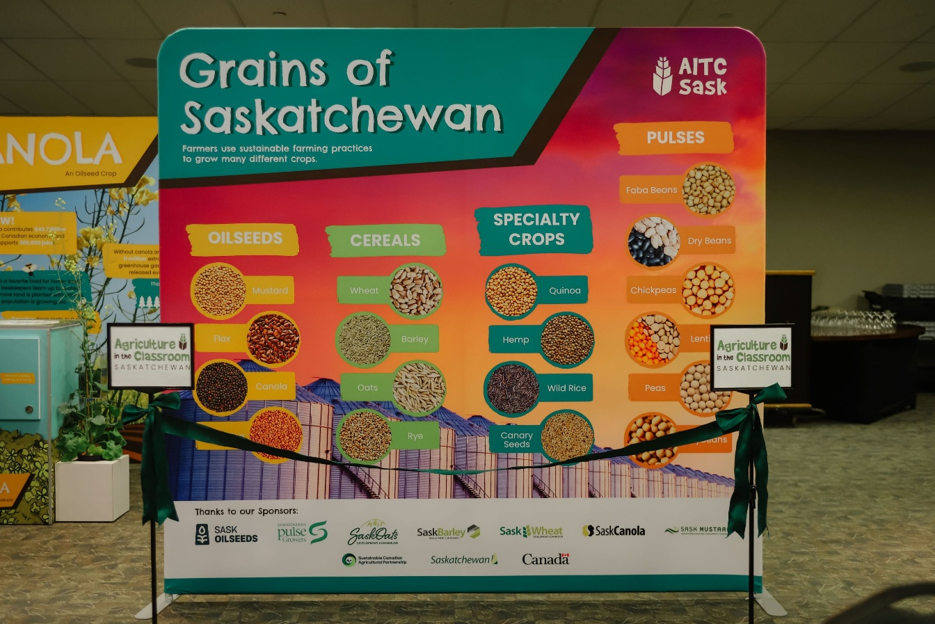
The new Grains of Saskatchewan display features visually compelling materials, including five large banners highlighting the most commonly grown crops. 
The banners reveal crop byproducts, interesting facts, and the impact of the crop on our province’s economy and in feeding the world.
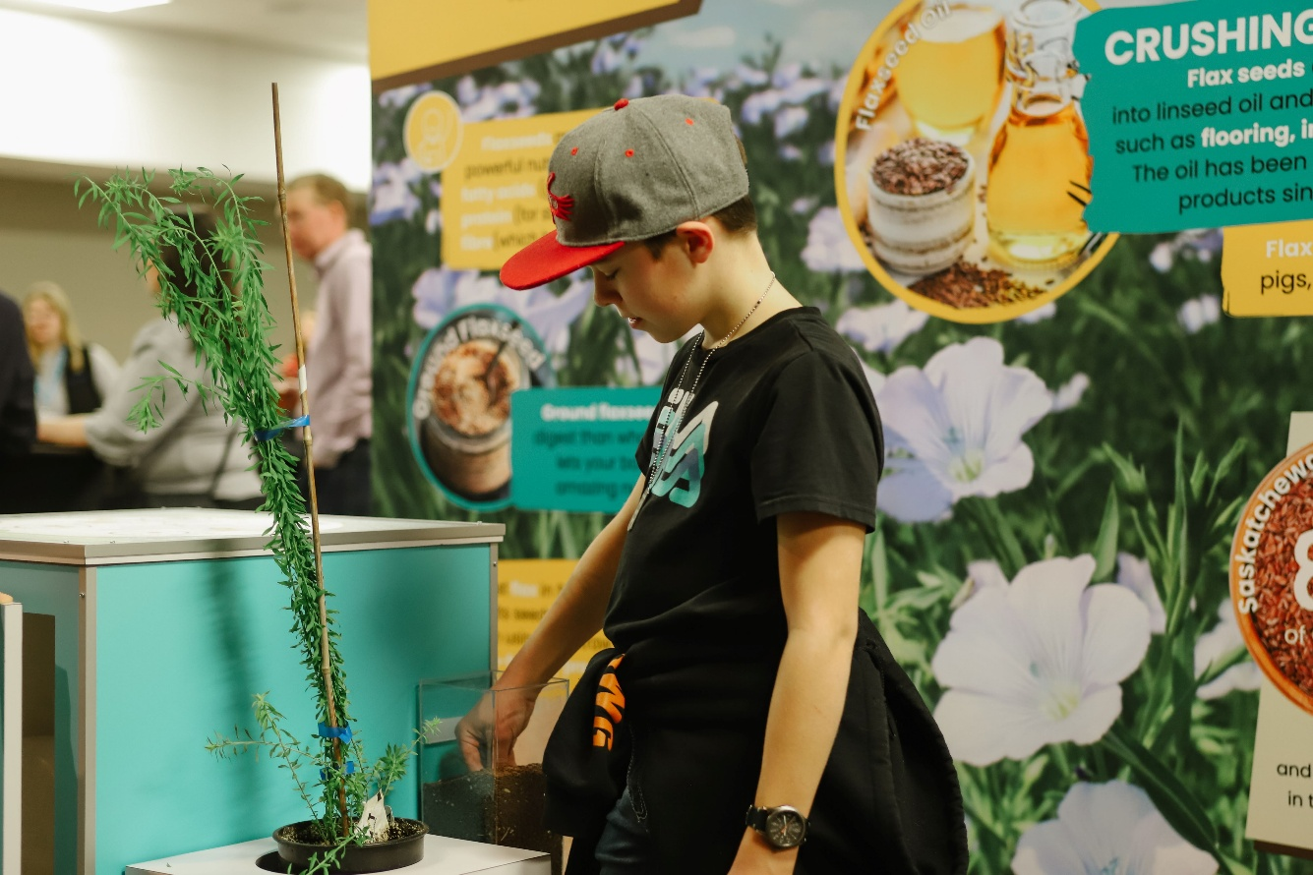
The exhibit brings the story of grains to life, featuring fully grown plants and seeds for visitors to view up close and feel.
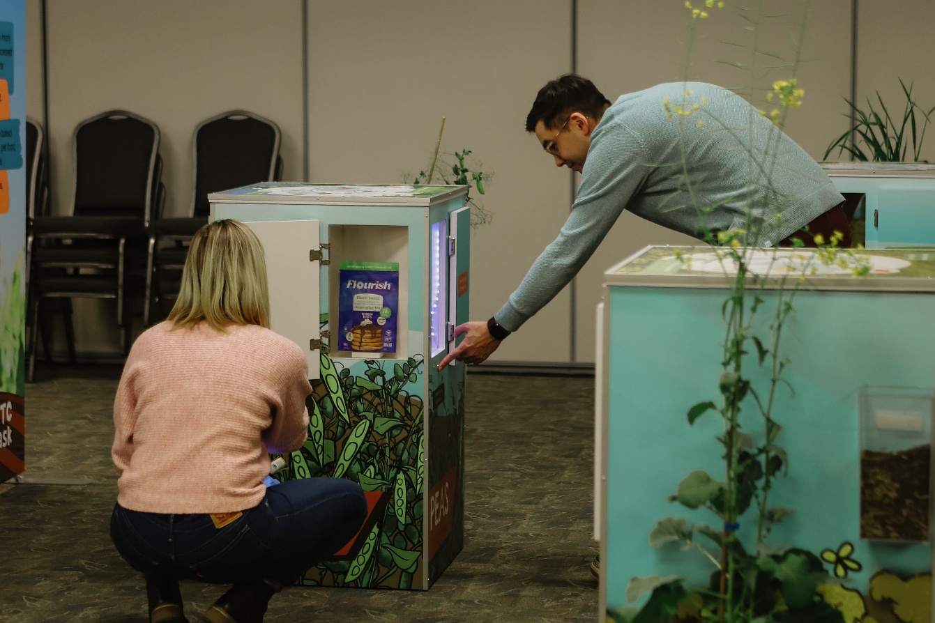
Crop byproducts are revealed with a door and light feature, creating a fun and engaging learning experience.
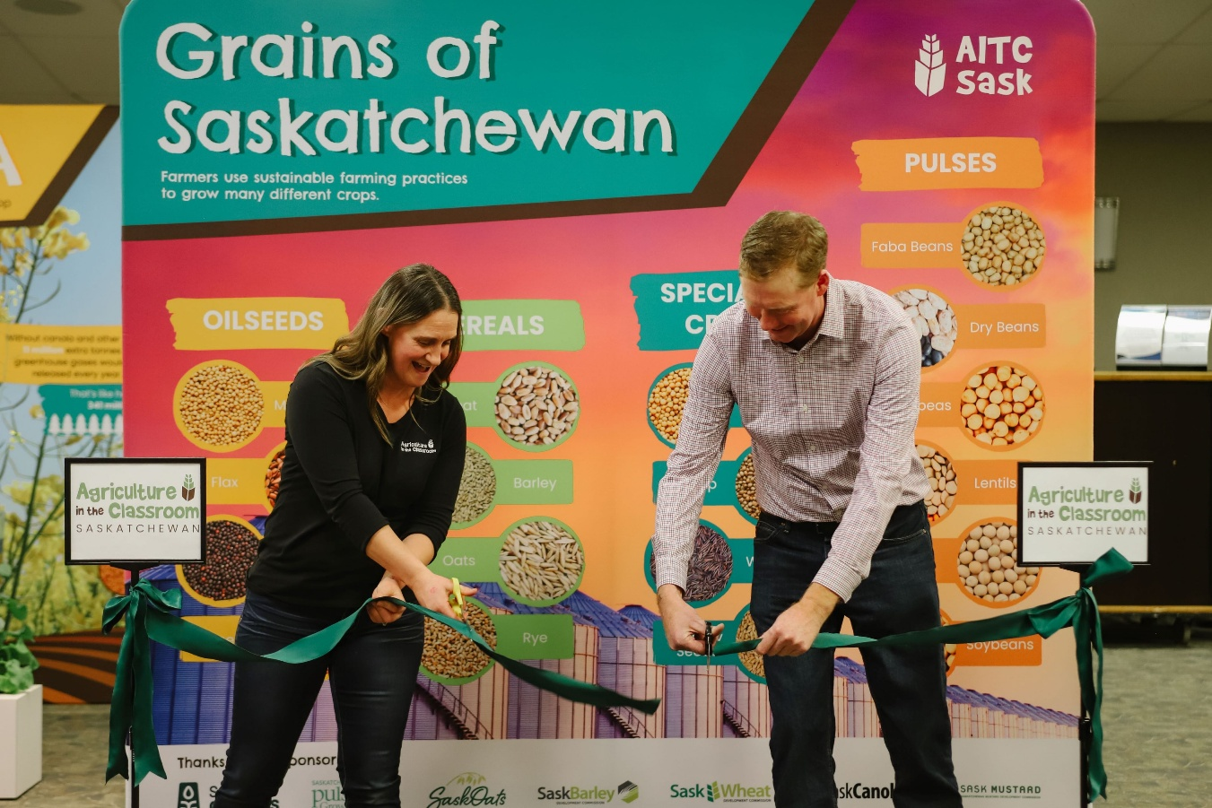
The Grains of Saskatchewan display was officially launched at the Western Canadian Crop Production Show on January 16th, 2025, and is estimated to reach around 15,000 students each year.

