Spirit Wear Shirt
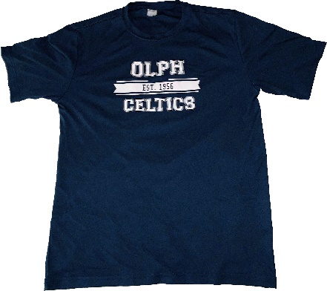
Order your new OLPH Spirit Wear Dri-Fit T-Shirts. Students can wear on Fridays and parents can show their spirit too!

Spirit Wear Order Form
2019-2020 School Year
Student Name: __________________________________ Homeroom: _________________
Parent Name: ____________________________________ Phone Number: ______________
Email:

Item Description | XS | S | M | L | XL | XXL | Total QTY | Price Each | Total
Youth Dry Fit Shirt |  |  |  |  |  |  |  | $15.00 | $
Adult Dry Fit Shirt |  |  |  |  |  |  |  | $20.00 | $
Total Amount Due |  |  |  |  |  |  |  |  | $

Please attach check or cash in envelope to this form and route in your student’s folder or turn into front office
by November 1, 2019. Spirit Wear will be delivered to your child’s homeroom within two weeks.
If you have any questions, please email odonnellje@hotmail.com.

THANK YOU FOR SUPPORTING YOUR OLPH BOOSTER CLUB!

