2020 Harkins Gift Package
Order Form
Perfect gifts for teachers, coaches, service providers…
Order Deadline November 29
-Limited Quantities Available-

Package Deal
2020 Loyalty Harkins Cup Voucher, $25 Harkins gift card, large candy item & gift wrapped
Get soda refills all year long for $2.00 with your 2020 Harkins Loyalty Cup (first fill is FREE)

$35.00 x = $

Additional Cup Voucher (Retail $6.75) $ 6.00 x = $

Additional Harkins $10 gift card $ 10.00 x = $

Popcorn Perks Voucher (retail $30.00) $ 28.00 x = $ Receive a FREE medium popcorn with the purchase of a movie ticket and enjoy popcorn each time you go to the movies. Popcorn Perks are valid for up to a 12 month period or a maximum of 36 FREE Popcorn Awards, whichever comes first.

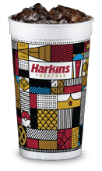
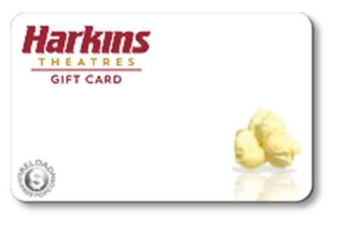
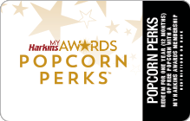

(Please make checks payable to OLPH) TOTAL = $

Your Name: Phone:

Packages will be ready for pick-up by Mid-December. You will be notified to pick up from front office or during scrip hours (Tues 7:45-9:00, and Fri 7:45-10:00) For questions, email scrip@olphaz.org

Posted
Check #
Filled

