For immediate release:

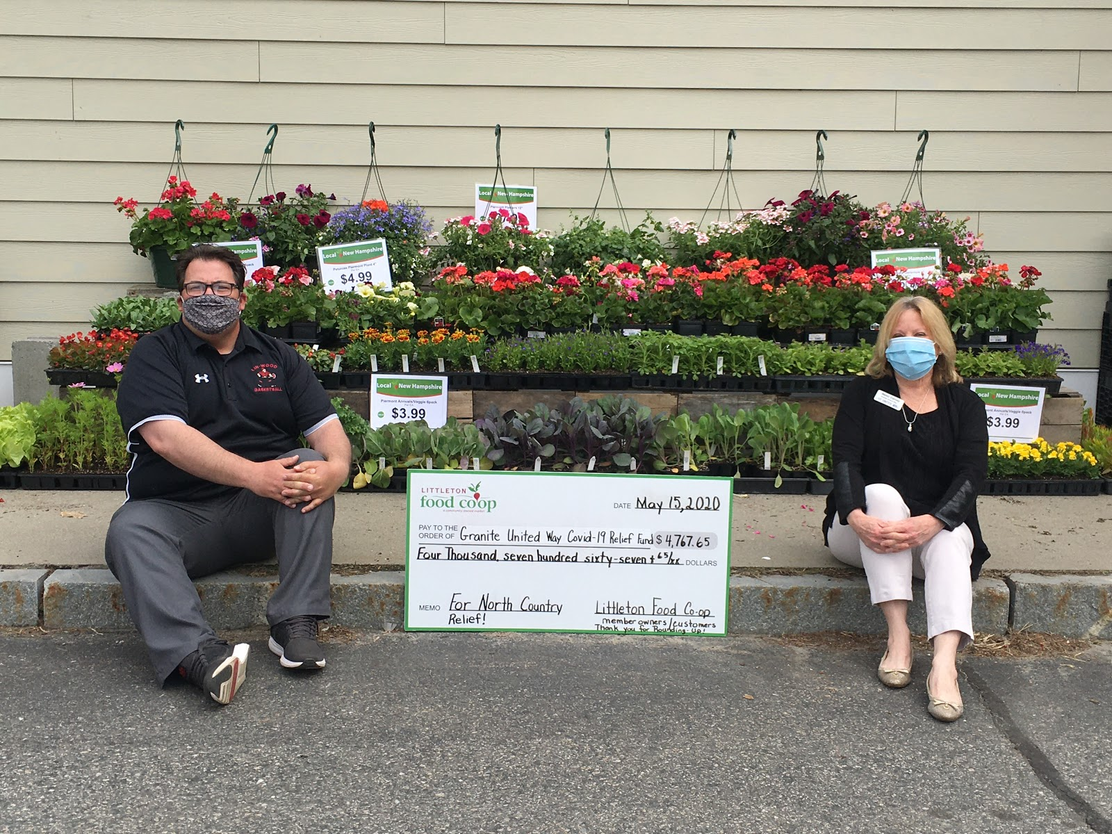

Nanci Carney, North Country Regional Director of Granite United Way, and Matt Manning, from AHEAD and North Country Hub Coordinator for the United Way, accept the donation given through the Partner of the Month Program at the Littleton Food Co-op. Funds were collected from member/owners and customers rounding-up on their grocery totals for the month of April to help the Granite United Way COVID-19 Relief Fund. All of the $4,767.65 donation is coming right back to the greater Littleton area. AHEAD, as the North Country Hub Coordinator, purchases food gift certificates and distributes them to area agencies so that they can provide food relief to their clients.This is the 3rd round of food gift certificate donations for the North Country! So far, 260 families and a total of 936 individuals here in the North Country have received relief aid to purchase food. Thanks to Nanci, Matt, Granite United Way, and AHEAD! We are stronger together!

A huge thank you must go to Ammonoosuc Habitat for Humanity for giving their April Partner of the Month slot to Granite State United Way so that much-needed COVID-19 relief funds can come to our area. Habitat for Humanity will be Littleton Food Co-op’s Partner of the Month in January 2021. They were planning to build a home in Bethlehem this summer, however due to COVID-19, that has been put on hold until next summer. Please try to round-up in January to help fund this building project. All proceeds will go to the Bethlehem Ammonoosuc Habitat house building project. Ammonoosuc Habitat is looking for Board members and will be looking for volunteers for next year to help with this building project. For more information, please contact Ammonoosuc Habitat at 603-616-2515 or by e-mail at ammonoosuchabitat@gmail.com.

May’s ‘Partner of the Month’ is White Mountain Mental Health. They are a Northern Human Services agency based right here in Littleton that offers an array of services, including outpatient therapy, mental health and substance use disorder therapies for individuals, groups, and families. They also provide case management, outreach services, psychiatric services, residential services, supported employment, and 24/7 crisis intervention. Their mission is to assist people affected by mental illness, developmental disabilities and related disorders in living meaningful lives. Everyone who needs their services can receive them, and they strive to meet ever-changing needs through advocacy, innovation, collaboration and skill. All proceeds will help ensure that they can continue offering services to those in need during this COVID crisis and beyond!

The member-owned Littleton Food Co-op serves the community by providing high quality food, offered at a reasonable price,with outstanding service. Everyone is welcome to shop and all are welcome to join. Located at the intersection of Cottage Street and Route 302 (exit 41, off I-93), the Littleton Food Co-op is open daily from 9 am-7 pm. Summer hours will start May 22nd and will be open daily from 9 am-8 p.m. For more information or to become a member, please visit www.littletoncoop.com, call 603-444-2800 or just stop by! See ya at the Co-op!

--
Becky Colpitts
Community Outreach Coordinator
Phone - 603-444-1430

