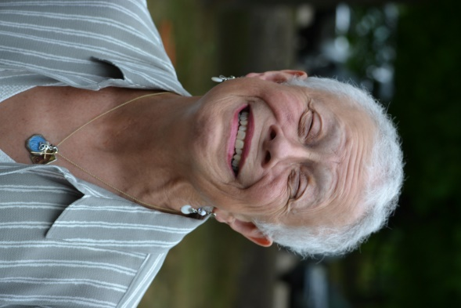
The 2023 Anna Willis Memorial Scholarship Award
This scholarship was created in honor of our founding leader, Anna Willis. A pioneer of education and family, she along with Claire Hamilton started The Upper Room in 1986. 37 years later The Upper Room, Family Resource Center continues to support families and children in their well being. In 2016, when Anna passed, the Board of Directors felt that a scholarship in her name would carry her legacy, and keep Anna connected to the everyday work of our agency.
This scholarship is being offered to a student who exemplifies character. The student must posses:
- leadership roles
- volunteerism
- academic strengths
The $500.00 scholarship will be available to a resident of NH where Anna lived and started the work of The Upper Room.
To Apply:
Complete application below using space to explain how volunteering benefits both the people who volunteer and the communities they serve in. Use examples from your own experience if possible.

Applications will be accepted through April 14, 2023, reviewed by our scholarship committee, and notification to selected applicant will take place by May 13, 2023 and presentation of award set up with individual receiving the award.



The 2023 Anna Willis Memorial Scholarship Application
Student Name: | Date of Application:
List the places you volunteer: | Other Activities you participate in:
College/post graduate plans for Fall of 2023: | How will this scholarship directly impact your educational plan?
How does volunteerism help our larger community? please take as much space as necessary
How are you familiar with The Upper Room? please take as much space as necessary
Please Submit this application, in Word or PDF format to:
Brenda Guggisberg bguggisberg@urteachers.org

