DRT Suggestions for Seeking Racial Justice April 2019

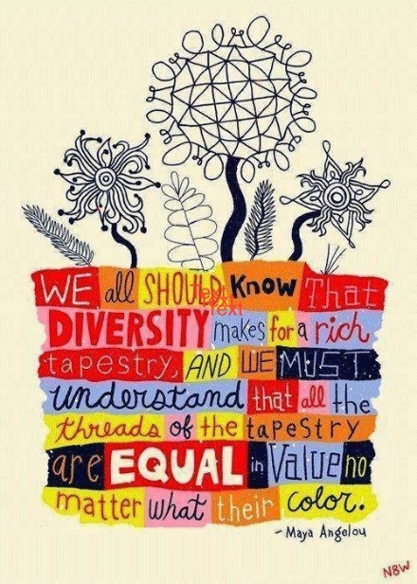
Friendly Forum: Please join us during the middle hour for the First Sunday Series, “Centering Black and Indigenous Voices", hosted by Dismantling Racism Team (DRT). We will hear, through video, the voices of BLUU, Black Lives of UU. For more information visit https://www.blacklivesuu.com.

New documentary illuminates 'Green Book' history from an African American perspective (Smithsonian Channel). https://www.colorlines.com/articles/new-documentary-illuminates-green-book-history-hollywood-tried-erase

Reparations and White Privilege - Trevor Noah, Between the Scenes/ The Daily Show – youtube https://www.youtube.com/watch?v=RjTu1NmQLP8

April 9 and16, 9-11pm on WETA. “Reconstruction, America after the Civil War” An historical journey to a time when African Americans achieved success in education, politics, and business, only to suffer backlash of white supremacy that is with us today. https://www.pbs.org/weta/reconstruction/home-preview/

April 15, (Weinberg Theatre); April 16 (Frederick Community College)
Frederick County Public Libraries Presents Frederick Reads: The Book of Unknown Americans by Christina Hernandez Ms. Hernandez brings to life varied human stories about immigration. FREE, but tickets are required.

April 27 beginning at 9 am, Volunteer for Hopehill UMC Cemetery Clean-Up Day! Join AARCH and the Church of Jesus Christ Latter-Day Saints to help maintain a piece of Frederick History. Contact Rick Smith at rhsmith@mcdaniel.edu.

April 27 1st Annual National Antiracist Book Festival On Saturday, April 27, American University’s Washington College of Law will host leading antiracist writers for panel discussions, workshops, and book signings at its first annual antiracist book festival, focusing mainly on authors of anti-Black racism and its intersections. For tickets: https://www.american.edu/centers/antiracism/

SPECIAL EVENT with the HALO Quartet: "Race and #Real Talk"
April 28, 2-4 pm at Evangelical Reformed UCC. HALO Quartet is quartet of African American women using barbershop singing (and listening) as a therapeutic tool to confront historic and contemporary issues of race. Led by Shana Oshiro, a music therapist, they not only share their amazing voices, but engage the community in learning, reconciliation and change. Visit www.haloquartet.org.

I Believe in Me’s 3rd Annual Basketball Tournament will take place on June 22nd and 23rd in Walkersville. The Tournament serves many purposes, including furthering the I Believe In Me (IBM) mission by reaching our youth where they are, engaging our youth in activities that address their physical, mental and social needs, and raising funds to support IBM’s year-long programming. Help us spread the word to your professional networks, friends, and neighbors to make that investment by sponsoring this event or forming a team!

UUs JOIN WITH COMMUNITY TO PROMOTE RACIAL EQUITY IN SCHOOLS:
Last Fall the school board proposed creating a Racial Equity Committee to address issues of racial disparity and inequity within FCPS. Community groups met with members of the FCPS policy committee to identify a path forward. When members of the committee later proposed to broaden the scope and include equity issues for other student groups, the NAACP, SURJ and members of UUCF held that this would weaken the original charge to specifically address issues of race. In coordinated messaging they appealed to the policy committee, and the school board, via emails and public comment at the school board meeting on March 27th. Several positive results ensued! The policy committee returned to creating a Racial Equity Committee.

They heard the united appeals to use the Racial Equity Committee to address:
(1) disparities in the suspension of students of color;
(2) hiring more minority teachers;
(3) addressing racial slurs and racially motivated behavior by students;
(4) and broadening the curriculum to include the heritage and life experience of all students.

This was brought about by a successful coalition, which can NOW move forward on this and other issues with unity and a greater impact. If you are interested in working on racial justice issues like this, please feel free to join the UUCF Dismantling Racism Team, SURJ, or the NAACP.

The UUCF Dismantling Racism Team works to build Beloved Community by accountably dismantling the racism and other oppressions in ourselves, our congregation, and the wider community. For more information contact Carol Antoniewicz at ecacres@comcast.net or Lynn Wagner at lwagner4@mac.com. Follow us on Facebook. Also: SURJ Frederick (info@surjfrederick.org); NAACP Frederick Co. Branch (www.naacp.org); AARCH (http://aarchsociety.org)

