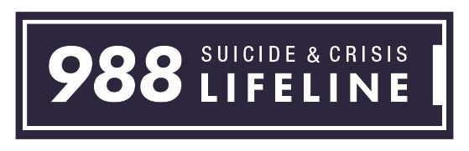
Too many people experience suicidal crisis or mental health-related distress without the support and care
they need. There are urgent mental health realities driving the need for crisis service transformation
across our country. In 2020 alone, the U.S. had one death by suicide about every 11 minutes—and for
people aged 10-34 years, suicide is a leading cause of death.

There is hope. The 988 Suicide and Crisis Lifeline – previously known as the National Suicide Prevention
Lifeline – is a national network of more than 200 crisis centers that helps thousands of people
overcome crisis situations every day.

- The 988 Suicide and Crisis Lifeline provides 24/7, confidential support to people
in suicidal crisis or mental health-related distress.

- New Nationwide Number: 988 is more than just an easy-to-remember number — it’s a direct
connection to compassionate, accessible care and support for anyone experiencing mental health-
related distress – whether thoughts of suicide, mental health, substance use crisis, or any other
kind of emotional distress.

- Provides Support: People can also dial 988 if they are worried about a loved one who may need
crisis support.

- FCC Rules: Under FCC rules, calls and texts to 988 will be directed to the Lifeline. Calls and
texts to 1-800-273-8255 (TALK) will also continue to reach the 988 Lifeline even after the
nationwide implementation of 988.

- Saving Lives: The FCC actions reflect its commitment to saving lives and connecting individuals
to necessary intervention services. Switching to the easy-to-remember 988 makes it easier for
individuals in crisis to access the help they need and decrease the stigma surrounding suicide and
mental health issues.

- Important Step: The 988 Suicide and Crisis Lifeline is an important step toward strengthening
and transforming crisis care in this country. It serves as a universal entry point so that no matter
where you live, you can reach a trained crisis counselor who can help.

- Help for Veterans: For calls, pressing “1” after dialing 988 will connect you directly to the
Veterans Crisis Lifeline which serves our nation’s Veterans, service members, National Guard
and Reserve members, and those who support them. For texts, continue to text the Veterans
Crisis Lifeline short code: 838255.

